- Download the ConfigLoader module (http://www.gridprotectionalliance.org/NightlyBuilds/Temp/SCANA/[2018-03-01]%20ConfigLoader.zip)
- Extract ConfigLoader.dll and copy the file to the openXDA installation folder (C:\Program Files\openXDA by default).
- Update the openXDA database to configure the system to load the ConfigLoader module from the openXDA installation directory.
INSERT INTO DataOperation VALUES('ConfigLoader.dll', 'ConfigLoader.LineFileLoader', 0)
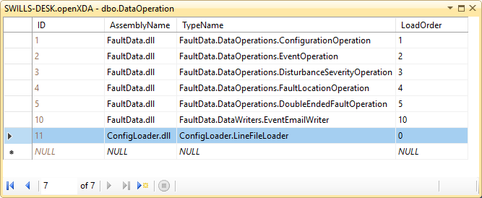
- Download the example DeviceDefinitions.xml file (http://www.gridprotectionalliance.org/NightlyBuilds/Temp/SCANA/DeviceDefinitions.xml)
- Modify the file to map every device’s R-number to the latitude and longitude of the device. Each device entry should look similar to the following (pulled from the example file).
<device id="R05">
<attributes>
<make>Siemens</make>
<model>SIMEAS R</model>
<name>Lake Murray</name>
<stationID>0005</stationID>
<stationName>Lake Murray</stationName>
<stationLatitude>33.95885</stationLatitude>
<stationLongitude>-81.05009</stationLongitude>
</attributes>
</device>
- Place the modified DeviceDefinitions.xml file in the openXDA installation folder and run the ldconfig.bat script also located in the openXDA installation folder.
- Create a folder in which to place the line group files. The openXDA service will need to have access to these files. The easiest way to ensure that it has access is to place the folder in the openXDA installation folder. Place the line group files into the folder you’ve created.
- Add the LineConfigurationDirectories setting to the Setting table in the openXDA database. The value of the setting should be the folder that contains the line files (this directory will be searched recursively).
INSERT INTO Setting(Name, Value) VALUES('LineConfigurationDirectories', 'C:\Program Files\openXDA\Config')
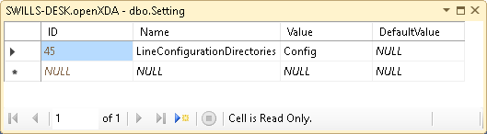
- Once this is complete, the system will automatically attempt to load configuration from the line configuration file and the data file simultaneously, before executing its usual processing routines.

