Scope Definition

for

Arizona Public Service Company (APS) Event Data Retrieval Pilot
APS Solicitation Number 210989
Prepared by Erika Wills, Senior Manager, Product Development
Grid Protection Alliance, Inc.
4/18/2024

Contents
1. Introduction 3
1.1 Purpose 3
1.2 Project Scope 3
2. Overall Description 4
2.1 Project Perspective 4
2.2 Operating Environment 4
2.3 User Documentation and Support 5
3. Requirements 6
3.1 GPA Response to APS Project Requirements 6
Appendix A: GPA Product Maintenance 7

Introduction

Purpose
This document outlines the scope and requirements of the Event Data Retrieval Pilot for Arizona Public Service Company (APS). The pilot includes installation and configuration of the openMIC application and the openXDA suite of tools to APS-hosted servers for testing during a pilot period.

Project Scope
The scope of this project includes:
- Installation of the openMIC software and openXDA suite of tools, including openXDA, System Center, Notification Pages, PQ Dashboard, PQ Browser, openSEE, and miMD.
- Configuration of installed applications to enable communication with APS-selected devices.
- Configuration of installed applications to generate notifications and reports.
- Any applicable patches to support bug fixes as necessary.
- Access to GPA support throughout pilot testing. See Appendix A for support definition.
This project does not include:
- Any GPA-procured hardware.
- Any GPA development beyond regular bug fixing.

Overall Description

Project Perspective
APS has requested that GPA provide software and support for an Event Data Retrieval system. This system would retrieve and analyze event data from remote microprocessor relays and alert engineers. The goal of this system is to expedite decision-making by getting the data in the engineers’ hands as quickly as possible.
GPA has been selected by APS to govern a pilot deployment of the openXDA suite of tools to provide these services. APS will test and evaluate the functionality of the suite.

Operating Environment
The system will be self-hosted by APS. APS will provide all infrastructure for the software, databases, and file shares.
Hosting requirements:
- Windows Server 2012 R2 or later, 64 bit
Pre-Installation requirements:
- .NET 4.8 or higher
- Database management system
  - SQL Server 2012 or later
Hardware requirements:
- openMIC:
  - System Memory
    - Minimum: 8 GB
    - Recommended: 16+ GB
  - CPU
    - Minimum: 2 cores, 2 GHz
    - Recommended: 4+ cores, 3+ GHz
  - Free Local Storage Space
    - Less than 2 GB
- openXDA:
  - System Memory
    - Minimum: 4 GB plus 1 GB per CPU core
    - Recommended: 16 GB
  - CPU
    - No minimum requirement
  - Free Local Storage Space
    - Up to 10 MB per day for log files
  - Database Storage Space
    - ~50 GB per year per 100 PQ meters
  - SMTP Server
Networking requirements:
- openMIC:
  - TCP 8089 for web admin
- openXDA:
  - TCP 8989 for web admin

Pilot Network Diagram

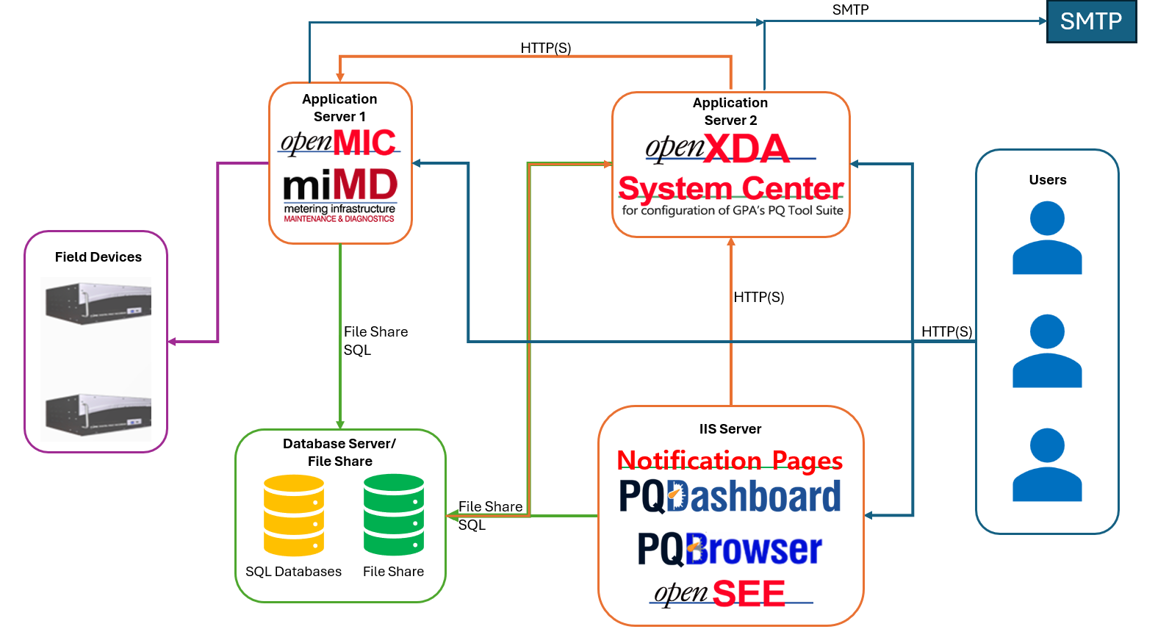

User Documentation and Support
APS will be provided maintenance and support for the duration of the pilot, in accordance with GPA’s business day support policy detailed in Appendix A.
APS project stakeholders will be provided with logins to GPA’s online support portal, where they can submit and track issues and requests and will find available documentation on the applications. Links and pdf copies can be provided upon request.
APS will also be provided with the dedicated support phone number and email address as additional avenues of communication.

Requirements

3.1 GPA Response to APS Project Requirements

Appendix A: GPA Product Maintenance

Annual Grid Protection Alliance, Inc., (GPA) Product Maintenance
With an annual product maintenance agreement, GPA agrees to:
- Provide support for all instances of the products specified in the associated quote including test, acceptance, and production.
- Provide notice of significant bug fixes and new product releases.
- Provide support for the application of patches or the migration to new versions of the product.
- Make GPA staff available for consultation and problem resolution.
- Provide access to a private, problem‐reporting web site (separate from GPA's public, open‐source problem reporting) to open maintenance tasks and allow tracking of these tasks to completion.
- Establish a process to escalate problem resolution, should it be necessary.
- Grant the maintenance contract owner a priority voice in establishing a ranking list for new features to be included in subsequent product releases.
- Provide the maintenance contract owner with two free registrations to the annual GPA User’s Forum, during the term of the maintenance agreement.
Business Day Support (10 hours x 5 days)
- GPA personnel will be available for e‐mail and telephone support during normal GPA business hours which are Monday through Friday, 8:00 a.m. until 6:00 p.m., eastern time, with the exclusion of six holidays ‐‐ New Year’s Day, Memorial Day, Fourth of July, Labor Day, Thanksgiving, and Christmas.
- During GPA business hours, GPA on‐call staff will respond immediately, whenever possible; but, in any event, GPA staff will reply within 30 minutes by telephone call or e‐mail to acknowledge receipt of a support request and initiation of work on the issue.
- A 24‐hours x 7‐days support telephone number will be provided for hours outside of those covered by the 10‐hours x 5‐days maintenance services. GPA will endeavor to provide this after‐business‐hours support (subject to the availability of GPA personnel) at 150 percent of GPA’s standard consulting rates with a 4‐hour minimum charge.

©Grid Protection Alliance, Inc. 2022

