

January 31, 2020

Thomas L. Kuhnert

Tennessee Valley Authority  
Supply Chain – Sourcing, MR 5F-C

1101 Market Street

Chattanooga, TN 37401

**Re: TVA Solicitation 99419, “Asset Data Aggregation and Condition Analytics Tools”**

Dear Mr. Kuhnert,

Attached is the Grid Protection Alliance, Inc. (GPA) response to the subject TVA solicitation.

GPA acknowledges, to the best of our ability and knowledge, the following:

1. All cost and pricing data submitted in the Proposal and any attachments or addendum are accurate, complete and current.
2. GPA agrees to fully cooperate with TVA during the course of any pre-award audit including providing documentation as requested by TVA.
3. TVA assumes no liability to pay GPA any direct, indirect or other costs incurred associated with GPA’s response to this solicitation.
4. GPA has strictly adhered to the terms, protocols and ethical standards established in the solicitation.

GPA hereby makes the certification set forth in the solicitation, subsection b.2 of the clause entitled “Lobbying” found at http://supplier.tva.gov/html/clauses.htm.

GPA has no exceptions to the contract terms and conditions as provided in the TVA solicitation.

GPA is looking forward to this project and in working with TVA to address any addition questions you may have.

Sincerely,



F. Russell Robertson

Vice President, Grid Solutions

Grid Protection Alliance, Inc.

Mr. Thomas Kuhnert

January 31, 2020

Page 2

Attachments:

The GPA Proposal to TVA Solicitation 99419

As Separately Submitted Documents to Power Advocate

Attachment 1: **GPA References** *(1-GPA References.pdf)*

Attachment 2: **GPA Prior Year Financials** *(2-GPA Financial Statements.pdf)*

Attachment 3: **GPA Resumes** *(3-GPA Resumes.pdf)*

Attachment 4: **GPA Detailed Staffing Plan** *(4-GPA Staffing Plan.pdf)*

Attachment 5: **GPA Response to the TVA Requirements Workbook**  
 *(5-GPA Functional and Technical Reqmts.xlsx)*

Attachment 6: **GPA Response to the TVA Work Requirements Document**  
 *(6-GPA Work Reqmts.docx)*

Attachment 7: **GPA Response to the TVA O&M Service Requirements Document**  
 *(7-GPA OM Service Reqmts.docx)*

Attachment 8: **GPA Project Schedule** *(8-GPA Project Schedule.mpp)*

Attachment 9: **Signed Solicitation Amendment Notices**  
 *(9-GPA Signed Ammendments.pdf)*

Attachment 10: **GPA Certificates of Insurance** *(10-GPA Insurance Certificates.pdf)*

Attachment 11: **GPA Proposed Costs** **– REQUIRED PROPOSAL**  
 *(11-GPA Proposed Costs – TVA Workbook REQUIRED.xlsx)*

Attachment 12: **GPA Proposed Costs** **– ALTERNATIVE PROPOSAL**  
 *(12-GPA Proposed Costs – TVA Workbook ALTERNATIVE.xlsx)*

Attachment 13: **GPA Proposal Overview Power Point**  
 *(13-GPA Proposal Overview.ppt)*

1206 Broad Street

Chattanooga, Tennessee 37402

(423) 702-8136

Response to Tennessee Valley Authority (TVA)

Request for Proposal

**Asset Data Aggregation and  
Condition Analytics Tools***for the*

**Transmission Asset Performance Center**  
  
TVA Solicitation Number 99419

**GPA Proposal**

**January 31, 2020**

The information contained in this document is the exclusive property of Grid Protection Alliance, Inc. and it is provided for the sole purpose of a response narrative to TVA’s Request for Proposal for the Asset Data Aggregation and Condition Analytics Tools solicitation number 99419. This document is confidential and proprietary and may not be reproduced or otherwise disseminated or utilized for any other purpose than that stated above without the specific written permission of the Grid Protection Alliance, Inc

(This page is intentionally blank.)

.

Contents

II. Executive Summary and Overview 2

Executive Summary 2

Proposal Overview 3

III. GPA Qualifications 8

Value of Open Source Software 8

GPA’s Open Source Products 9

IV. Business Solution 15

The GPA Proposed Solution -- openADI 15

1 Project Organization and Staffing 23

2 Functional Requirements 24

3 Technical Requirements 25

4 Work Requirements 27

5 O&M Support Requirements 28

6 Project Schedule 29

V. Certification Letter 30

VI. Proposal Pricing and Cost 31

VII. Small Business Contracting Plan 32

Appendix A: The MIT License 33

Appendix B: Visualization Using Grafana® 34

Appendix C: Alarming and Automated Notifications 36

Appendix D: The Value of Sandboxed Analytics 38

Appendix E: The GPA Gemstone Library 39

Appendix F: The TPS Information Model 40

Appendix G: GPA Standard Annual Maintenance Services 41

Attachment 13, **The GPA Proposal Overview**, is a power-point-based summary of GPA’s proposed solution.

# Executive Summary and Overview

### Executive Summary

This proposal from the Grid Protection Alliance, Inc. (GPA) meets TVA’s technical and business requirements for the Transmission Asset Data Aggregation portion of this RFP while minimizing first and on-going costs. In doing so, GPA is also providing a highly-performant and flexible information systems foundation to allow TPS&S to easily incorporate new tools and software components as well as to adapt the Transmission Asset Performance Center to meet changing business requirements without lock-in to GPA or any other vendor.

The GPA solution links and provides information from eDNA and Maximo and the other required sources of asset condition data and makes this data available to analytics through one of multiple interface options. This proposed data aggregation approach allows TVA to select among the multiple GPA data interface options, such that, the best solution can be selected for each analytic which assures that requirements are met at minimum total cost. As these analytics (some vendor provided and some TVA developed) produce results, the GPA solution also implements the necessary structure for housing these results so that they can be used by downstream systems such as copperleaf and display systems in the Transmission Asset Performance Center. In addition, as seen in Figure 1, the GPA solution includes automation for notifications and data validation as it retains the ability to incorporate results from ad-hoc investigations and studies by transmission asset subject matter experts.

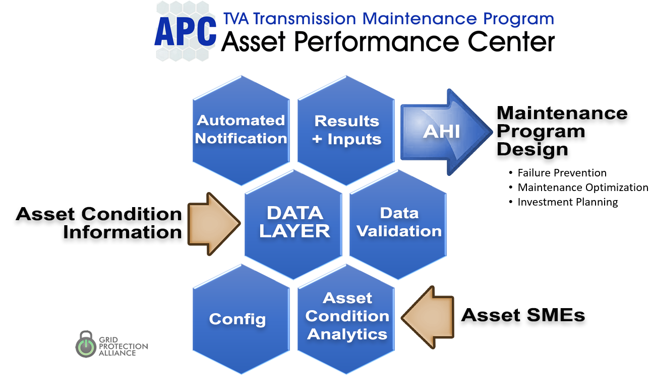

Figure 1. The GPA Asset Performance Center (APC) Solution

GPA has a strong project management model, incorporates the latest technology and tools in its solutions and has a dedicated team with a deep understanding of TVA systems and the proven ability to collaborate with TVA staff to implement solutions that are in the best long-term interest of TVA. GPA can meet the Minimum Viable Product installation milestone of October 1, 2020, and we are looking forward to working with TVA on this project.

### Proposal Overview

The Grid Protection Alliance is pleased to provide this response to TVA Solicitation 99419. GPA is providing this technical proposal and quote for the “Asset Data Aggregation” portion of the RFP only. GPA understands and values TVA’s desired approach for a transmission asset management solution that can flexibly support “best in class” maintenance models as these are developed by vendors, TVA, TVA’s utility colleagues and the utility research community.

This proposal is centered around meeting TVA’s functional and technical requirements for “Asset Data Aggregation” as detailed in Attachment 5 while minimizing first and on-going costs. GPA is also providing TVA a highly-performant and flexible architectural foundation to allow TPS&S to easily incorporate new technology and components as well as to adapt the Transmission Asset Performance Center to meet changing requirements.

*The hard 80 percent done better for less.* In this proposal, GPA provides the details as to why and how the GPA approach to data aggregation, i.e., the hard 80 percent, is better than other alternatives. We'll also show that TVA total costs should be lower using this GPA proposed solution.

GPA is not proposing to provide “Condition Analytics Tools” since GPA has no fully vetted transmission maintenance or condition assessment analytics. Having said that, once an analytic approach or technique has been identified, GPA considers implementation of these analytics to be a trivial extension to the hard part of assembling and assessing the quality of the source data for a condition-based maintenance program. GPA has implemented these automated condition determination analytics and notification systems at TVA using both synchrophasor and digital fault recorder data. In addition, GPA has researched and experimented with implementation of advanced statistical techniques such as machine learning, and we are confident in GPA’s ability to implement advanced statistical techniques and data science models as they are determined to represent a valid basis for a condition-based management program. Appendix D, The Need for Sandboxed Analytics, describes a reliable and secure method for incorporating new analytics into the Transmission Asset Performance Center that is already in production use at TVA.

#### General Architecture

While individual data sources will vary by asset and analytics type, the GPA generalized architecture includes five major components that align with the solicitation functionality requirements. As shown in Figure 2, these are Source Data, Data Layer, Analytics, Result Integration and down-stream higher level systems such as Copperleaf. This results in a Transmission Asset Performance Center that is the desired combination of (1) validated source data, (2) condition analytics and (3) individual asset health scores.

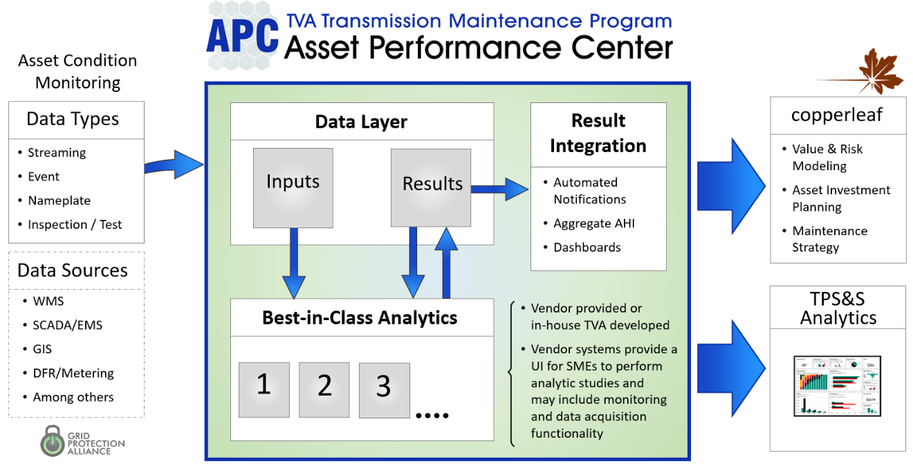

Figure 2. Transmission APC High-Level Data Flows

#### The Importance of the Data Layer

GPA believes that full TVA ownership of the Transmission APC data layer is critically important to achieving the solicitation objectives of (1) best-in-class transmission asset maintenance analytics and (2) easy harmonization of the Transmission APC with all desired data sources as well as with emergent larger-scale TVA enterprise IT initiatives. The architecture proposed allows TVA to easily plug in analytic components from multiple vendors as well as ones developed by TVA and the TVA-directed research community. It also allows specific source data systems, such as the work management system, to change independently of the Transmission APC. Importantly, it allows the results of one analytic to become the data source for another and for the automated asset health notifications to be based on the logical combination of results from multiple analytic sources. Finally, it allows the individual best-in-class analytics for each asset type to come together into a common annunciation and display system.

Within the context of the architecture shown in Figure 2, GPA proposes to provide all functionality for the Transmission APC other than that of the individual analytic components. By doing so, GPA is interpreting the solicitation requirements for an “asset data aggregation tool” to be the aggregation of all information necessary for the Transmission Asset Performance Center that is a function of an individual asset – source data and analytic results as well as asset heath notification logic.

Not included in the data flow diagram above (Figure 2) is measurement data acquisition. Consistent with industry best practice, GPA recommends that the Transmission APC lean on operational systems for acquisition of measurement data from assets – ideally returned as file-based data or in standard protocols, and on the Work Management System to return periodic and ad-hoc inspection and test data. Even so (and as noted in Figure 2), GPA recognizes that one-off analytic systems may need to be supported that have embedded data acquisition capability as likely be the case for vendor systems which by-pass TVA operational networks for data transport.

#### Custom Solution

As described in detail in Section IV of this proposal, GPA recommends that TVA build a custom solution called openADI (Asset Data Integration) to meet the RFP requirements. The proposed openADI Tool Suite has four components:

1. openADI Data Validation & Loader Service (a back-office, Windows service)

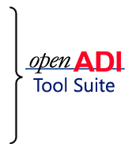

1. openADI Results Service (a back-office, Windows service)
2. openADI Database (based on MS SQL Server and the openHistorian)
3. openADI System Center (a web-browser-based application for configuration)

GPA believes that there may be no cost-effective alternative other than building something like the openADI Too Suite to fully meet TVA’s requirements. Data aggregation represents the “hard 80 percent” of a project not due to a lack of tools to support it, but because (1) building unique referential links among systems typically requires human attention – often lots of human attention – and because (2) the optimal methods for data extraction vary so significantly from source data system to source data system and from analytic to analytic.

The key functionality of GPA’s proposed openADI tool suite is the ability to:

Obtain Source Data -- A custom solution is necessary based on the diversity of inputs (See Figure 2) where the requirements call for the integration of information with more than 10 source data systems – some of which are legacy systems without natural points of integration. The GPA proposal allows the method for source data extraction to be flexible to fit the data source. If source data system includes APIs, then there are commercial tools, such as the TVA-preferred MuleSoft, that can be used to move data among systems. However, based on GPA experience these custom tools have overheads that make maintenance time consuming and, due to their general nature, can often not be sufficiently flexible to avoid integration activity on the part of the source data system owner.

Select Source Data Elements – The good news for the Transmission Asset Performance Center project is that TPS&S has a major jump start on the framework for linking data via the TPS Information Model (See Appendix F). TPS-IM includes an application to maintain the data links as assets come and go. There are, of course, numerous commercial tools that can be used to assist with this mapping as well. Even so, we believe that the custom solution is also preferred in that it may be too early to make the decision on the best information linking approach. It is possible that this linking will be straight-forward and easy for a data analyst to build in a relational system for the purpose of meeting the Minimum Viable Product date of October 1, 2020.

Provide Source Data Delivery Assurance -- A custom solution is also necessarily due to the requirement for “best in class” analytics -- with TVA seeking to develop some analytics internally. GPA is hopeful that the number of analytics vendors selected under this project will be small thereby simplifying the data aggregation effort, challenges and costs. Even so, the approaches to integration are certain to be different by major asset class. Having a custom dedicated data layer also provides a “data buffer” where this buffer is necessary to enable asynchronous interoperability with source data providers whose systems were not designed to be an on-demand data source.

Integrate and Share Analytic Results – As multiple vendor tools provide asset analytics and as TVA develops analytics (See Appendix D), a custom-built, common location to house results, will greatly simplify building dashboards and displays in the Transmission Asset Performance Center. This common results data store will also make results easier to share with other TPS&S and TVA enterprise systems such as Copperleaf and Microsoft Power BI. Importantly, as results are integrated it allows the Transmission APC to compute asset health based on the logical combination of asset health from multiple analytics and then to automatically provide notifications should this composite health index fall below acceptable levels (See Appendix C)

##### A Better Solution

The strengths of the GPA proposed solution are:

* Scalability – Given the nature of the effort where the number of analytics is unknown and the number of data sources may vary as new analytics come to play, the business construct proposed by GPA allows TVA to easily scale GPA activity to meet the specific requirements of each analytic to be implemented.
* Flexibility – GPA is proposing a broad range of integration options so that TVA can select the integration option that best matches business and technical requirements for a specific analytic or data source. In addition, the proposed business construct allows TVA to easily adjust the functionality and features to meet evolving business requirements. Finally, since no software license fees are part of this proposal, GPA has nothing at stake should TVA choose to purchase commercial tools to handle specific dimensions of the Asset Data Aggregation solution.
* Risk Reduction -- TVA will own all product delivered by TVA via the MIT License (See Appendix A). At any point, TVA can dismiss GPA and change vendors while retaining ownership of the work product delivered by GPA.
* Data Quality -- A proven, data validation component is provided to screen for bad or missing data source data.
* GPA Staff Availability – With GPA offices adjacent to TVA’s Chattanooga Office Complex, GPA staff can easily participate face-to-face with TVA without the need for travel expenses and the inefficiencies of scheduling around times when contract staff are in town.
* GPA Skills and Abilities – GPA had a proven capability to deliver high-availability, production-grade solutions for multiple utility clients.
* GPA Understanding of TVA – Perhaps the greatest value of selecting GPA on this RFP is the depth of our existing understanding of TVA information systems. GPA is in the process of implementing a system with similar data integration capability to support TVA’s Power Quality and Disturbance Monitoring systems. This system requires integration with Maximo, eDNA, FAWG, ESRI GIS, SIDA, and Billing, among other systems. GPA can begin work immediately without needing to be educated, indoctrinated or trained.

##### For Less

The GPA custom solution for Asset Data Aggregation is likely to have a lower total cost than other proposals to TVA given that:

* Open Source – GPA’s proposed solution is licensed as open source software under the permissible MIT license (Appendix A), which means there are no license fees associated with this software.
* TVA pays for what it gets – no more – The proposed solution will be developed by GPA specifically to meet TVA’s needs, and TVA will only pay for the functionality developed as part of this proposal.
* Small Business – GPA is a small business and our overheads are small. This means TVA is paying for enhancements and bug fixes rather than the burden associated with supporting larger companies.

#### Product Support

As a developer of open source software, one of GPA’s primary sources of revenue comes from supporting and maintaining our products. We believe we have a good track record at providing responsive, high-quality support for the GPA products currently installed at TVA. See Appendix G for a description of GPA’s standard product support services.

#### A Business Proposal That Manages Risk

GPA has submitted a fixed-price proposal and would welcome an agreement with TVA to move forward on this basis. However, GPA is asking that TVA consider an alternative proposal that is lower cost. This alternative proposal (See Attachment 12) is a mix of pure T&M deliverables for project documents and fixed-price software deliverables where TVA’s cost would be set at a negotiated fixed price once the functionality of a specific interface can be fully defined.

GPA will also consider other pricing models suggested by TVA or will re-evaluate the current fixed price proposal should more be known to reduce uncertainty and GPA financial risk.

# GPA Qualifications

GPA is a small business that builds collaborative efforts among electric utilities, government agencies, regulators, vendors, and generation owner-operators to advance the development and use of open source software to create a more secure, robust and smarter electric grid.

The strengths of GPA are:

* Expert transmission business process and technical knowledge
* Extensive experience in working with TVA information solutions including Maximo, eDNA, DFRs, Power Quality, Synchrophasors, SCADA among other operational system
* State-of-the-industry expertise at parsing and implementing substation communications protocols
* Experience in integrating operational (SCADA, disturbance and phasor data) with other transmission information systems
* Incorporation of the latest technologies and tools in GPA solutions (See Appendix E, The Gemstone Library)
* Experience in working with the TVA IT project management model
* Quality of relationships with commercial vendors and our ability to collaborate with them
* A reputation for delivery of products that operate reliability

### Value of Open Source Software

All GPA software provided under this project will be open-source software (OSS) that is made available to TVA without a license fee under the permissive MIT license (See Appendix A). This license provides TVA unrestricted access[1] to all open-source code to be used in this project – including code developed before the start of the project.

Open source software offers TVA the following business advantages.

##### No Vendor Lock-in

The user is free to move from one application to another, or from one source of support to another, and has access to the source code which can be maintained or enhanced in-house if desirable.

##### Lower Total Cost

Since there are no initial or annual licensing fees, there can be substantial savings in the acquisition and deployment of OSS applications. When enhancements are needed, development costs are limited to the task at hand and do not carry the burden of supporting a larger organization. Bug fixes and some broadly appealing enhancements are often donated, which further reduces the total cost of ownership.

##### Higher Quality

OSS applications must be of reasonably good quality to be successful in attracting community involvement, and engaging users. Once established, the community provides continuous review by “many eyes”, and there is no way to “hide” a bug. Additionally, the development capabilities are not limited to one company’s resources. The code base is maintained by a steward, that verifies any changes before they are distributed.

##### Assured Security

The code visibility provided by OSS provides the opportunity for wide review, and the flexible nature of OSS allows identified changes to be deployed rapidly.

##### State-of-the-Art

OSS is not bound by previous commercial investment, and it has the flexibility to use the latest techniques. It is often developed with intentional design for extension and enhancement, and the continuous community review avoids stagnation that can occur within the developers of a single company.

##### Promotes Collaboration

The absence of financial concerns around licensing fees, and the freedom to share code and ideas with a large community makes OSS an ideal vehicle for bringing together many participants from different entities such as research, academia, government, utility and vendors.

##### Enables Innovation

The collaborative aspect of OSS as described above eliminates the ‘Not Invented Here’ syndrome and provides developers more freedom to experiment. Community sharing of ideas and reviewing each other’s work fosters creativity.

##### Faster Delivery

The community environment of OSS allows direct application of the concept ‘many hands make light work’, and decreased restrictions combined with increased innovation and creativity result in decreased development time. No contract negotiations, and no financial incentive to install a new release to recoup investments in the previous version facilitates the more timely delivery of software.

### GPA’s Open Source Products

GPA currently has two major product lines or tool suites – one to handle synchrophasor data from collection through automated analytics and one to manage disturbance data from its collection from relays, DFRs and power quality meters through automated analytics.

GPA’s synchrophasor data products are shown in Figure 3.

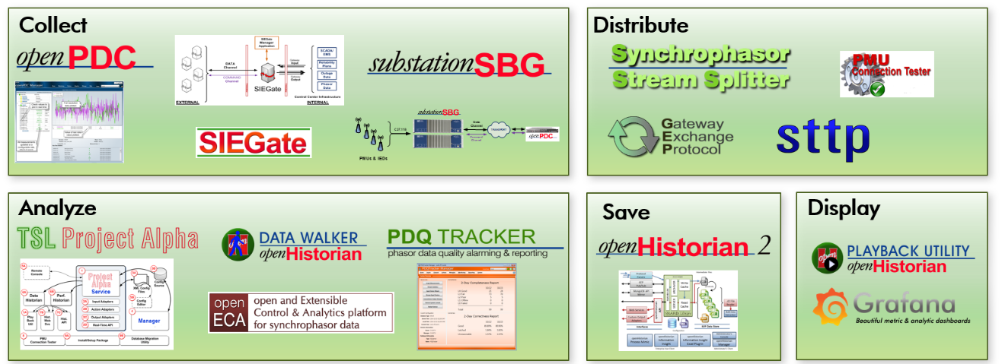

Figure 3. GPA’s Synchrophasor Data Products

* **openPDC** – The open source Phasor Data Concentrator has been in production use worldwide since 2004. The software platform exists as a high-performance data concentrator platform for managing streaming synchrophasor and other time-series data in real-time.
* **SIEGate** – The Secure Information Exchange Gateway is a security-centric appliance designed to be deployed at the edge of an infrastructure for diverse types of data exchange. The platform exists to reliably exchange information necessary to support real-time operations, including time series data, notifications, and file-based data.
* **substationSBG** – The substation Secure Buffered Gateway couples the features of a PDC, historian and a gateway to form a purpose-built, high-availability data gateway for use in substations with the ability to recover data to a central repository after a communications outage. As both a substation PDC with a local data historian and a phasor gateway, it enables secure, reliable communication of data from the substation to the control center and is commonly deployed on fan-less substation computers.
* **Stream Splitter** – The Stream Splitter is used to generate multiple data streams from a single synchrophasor stream source. This service-based application consumes an incoming stream of data (e.g., from a substation with limited bandwidth where sending multiple streams would be impractical) then redistributes the stream where needed, including the ability outbound data across security zones in high-to-low trust order.
* **GEP and STTP Protocols** – The Gateway Exchange Protocol and the Streaming Telemetry Transport Protocol (on track to become IEEE 2664) were developed by GPA through DOE funded efforts for the exchange of streaming time-series data and associated metadata using publish-subscribe methodologies and data compression techniques.
* **Project Alpha** – Project Alpha is a complete application solution template for creating a time-series processing application based on GPA's Grid Solutions Framework. Project Alpha is designed to speed development, debugging and deployment of new real-time streaming data analytic applications built as plugin adapters.
* **openECA** – The open and Extensible Control & Analytics platform is a DOE funded system designed to reduce the cost and accelerate the development and deployment of data analytics, real-time decision support tools, automated control systems and off-line planning systems that incorporate streaming time-series data, e.g., synchrophasor data.
* **Historian Data Walker** – This tool is an offline application designed to run through an openHistorian 2.0 archive at high-speed over a provided time range and requested set of data, operating on the queried results in time-sorted order with a user supplied algorithm or function.
* **PDQ Tracker** – The Phasor Data Quality Alarming and Reporting system is a high-performance, real-time data processing engine designed to raise alarms, track states, store statistics, and generate reports on both the availability and accuracy of streaming time-series data, e.g., synchrophasor data. Working with any vendor’s PDC and synchrophasor infrastructure, the tool produces periodic reports on data completeness and correctness; creating emails when data quality problems are detected.
* **PTPSync** – The Precision Time Protocol (PTP) Synchronization Service is a Window service application that implements PTP, as defined in IEEE 1588, to synchronize clocks over a network in the sub-microsecond range. The high accuracy makes the service ideal for synchronizing clocks for time-sensitive systems like the openPDC and substationSBG.
* **PMU Connection Tester** – Used universally in the power industry, the Phasor Measurement Unit Connection Tester is used to validate, test and troubleshoot connections and data streams from phasor measurement devices as well as graphically visualize the received synchrophasor data in real‐time. Most all phasor data protocols are supported.
* **STTP Connection Tester** – The Streaming Telemetry Transport Protocol Connection Tester is used to validate that a subscription-based connection using STTP is working as expected. It can also be used to validate filter expressions that can be used to select a set of points in hosted STTP publishers.

GPA’s disturbance monitoring products are shown in Figure 4.

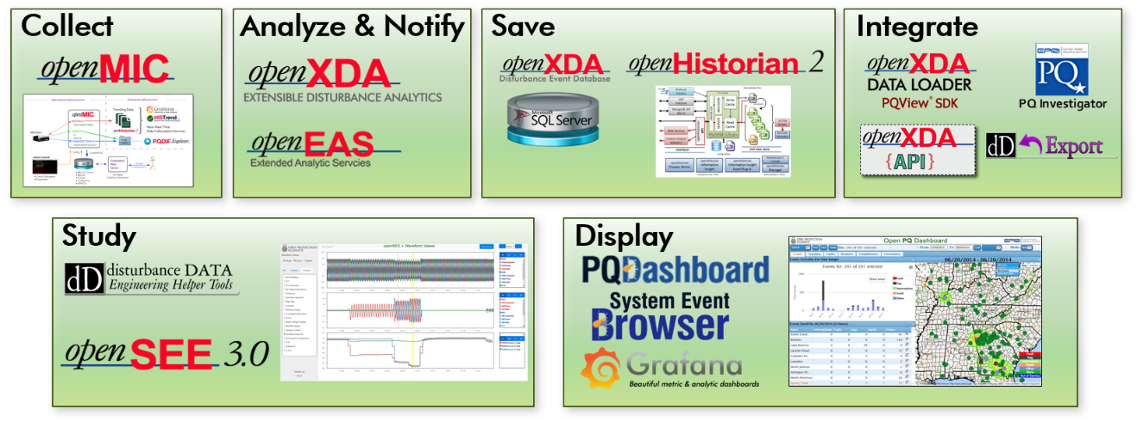

Figure 4. GPA’s Disturbance Monitoring and Power Quality Products

* **openMIC** – The open source Meter Information Collector downloads data from DFRs and other substation devices, polling these field devices on a user-defined schedule and organizing the downloaded data into a user customizable folder structure. openMIC is capable of interrogating multiple substation devices simultaneously via IP or Modem (RAS & FTP). Administrators define schedules (including as-fast-as-possible) and specify the output location for data on a device-by-device basis.
* **openXDA** – The eXtensible Disturbance Analytics application automatically processes and analyzes event files from disturbance monitoring equipment such as DFRs and power quality monitors. Supporting industry standard formats such as COMTRADE and PQDIF as well as many native vendor-specific formats, openXDA runs as a back-office service watching for new event files or changes in event data within meter polling databases. openXDA produces emails and raises alarms based on meter data quality and/or the nature of the system event that triggered the meter. Among the automated analytics included are single- and doubled-ended fault location and breaker timing.
* **openXDA System Center** – While not shown separately from openXDA in Figure 4, this web-based tool is used to manage configuration and metadata for openXDA, PQDashboard, OpenMIC, and any future disturbance product. The tool also integrates data from other external configuration sources, e.g., Maximo and PQView.
* **dD Tools** – The openXDA service includes a self-hosted web site where the Disturbance Data Tools (dD Tools) application is hosted. These web-based displays include openXDA and Open PQ Dashboard configuration pages and well as data editing and visualization pages.
* **openEAS** – The Extended Analytic Services for openXDA is a Visual Studio development template for a Windows Service that embeds externally developed code libraries, e.g., a DLL produced from MatLab, within a sandboxed platform that obtains input data from openXDA and stores analytic results to openXDA for display in other tools.
* **openSEE** – The open source System Event Explorer is a browser-based waveform display tool that is used to view waveforms and investigate events that are stored in the openXDA database. openSEE can display multiple waveforms simultaneously. A phasor data windows is available so that users can easily resolve phase angles. The system is URL-driven so that a link to openSEE can be embedded in emails to enable recipients to view the same display as seen by the sender, including current zoom level and analytic.
* **Open PQ Dashboard** – The Open PQ (Power Quality) Dashboard is a web-based, enterprise information center for disturbance data which provided displays to quickly find and understand disturbances on the electric system. The Open PQ Dashboard is the visualization layer for data contained in the openXDA database. Dashboard displays include geospatial map-views and highly discernable annunciator panels for operation centers.
* **SE Browser** – The System Event Browser is a web-based tool waveform display and analytics tool used to view summaries of disturbance data recorded by DFRs, Power Quality meters, relays and other substation devices that are stored in openXDA. This tool compliments the Open PQ Dashboard with a list-based view into event data instead of aggregated-views as provided in the Open PQ Dashboard.

The **openHistorian** is a GPA solution that spans both GPA product lines. The openHistorian is a back-office system designed to efficiently archive SCADA, synchrophasor and other time-series process control data to support real-time grid operations and post-operation analysis.

The openHistorian is optimized to store large volumes of time-stamped data quickly and efficiently. While it is API compatible with TVA’s internally developed DatAWare historian, the engine in the GPA openHistorian was completely re-written by GPA in 2014. The new openHistorian data storage engine is based on a B+ Tree and has been observed to have significantly better performance, for both reads and writes, than DatAWare, eDNA or OSIsoft PI.

The openHistorian implements lossless data compression resulting in small data storage requirements while retaining all the nuances in the data. Lossless compression rates vary based on the nature of the processes monitored, but as a rule of thumb, about 424 million floating point values are saved per Gigabyte of storage.

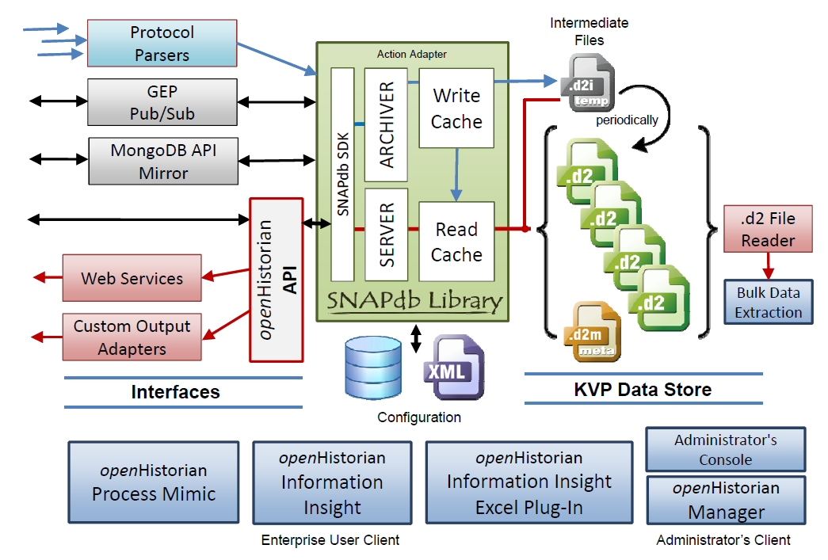

Figure 5. openHistorian Components

Features of the openHistorian include:

* A NoSQL-based data storage implementation with enhanced lossless compression optimized for efficient storage and quick extraction of high-volume data
* Data files are ACID compliant creating a durable, consistent file structure resistant to data corruption
* Both real-time and web-based request/reply APIs exist to serve data to real-time applications and visualization tools
* Grafana server is automatically included with the installation and deeply integrated with the openHistorian self-hosted web server and security system
* System supports data backfilling and out of sequence data insertion
* Extreme time precision, down to 100 atto (10-16) seconds
* The tuple-based key and value pair data storage system supports most any data type or structure
* Tight integration with GPA’s Grid Solutions Framework and the performant GEP and STTP protocols
* Adapter-based service implementation allows input plugins from any data source

# Business Solution

In this section, GPA describes the solution proposed to meet the short- and long-term requirements for management of the data necessary to support the Transmission Asset Performance Center and to meet the functional and non-functional requirements provided by TVA in Attachment 5.

### The GPA Proposed Solution -- openADI

GPA’s proposed solution for the Asset Data Aggregation component is called openADI (Asset Data Integration) Tool Suite, and it is specifically designed to give TVA an opportunity to use best-in class condition determination analytics for all maintainable transmission assets. It is based on and will reuse multiple components already developed by GPA for the openXDA suite of products that are in production use supporting TVA’s disturbance monitoring analytics.

Figure 6 shows the GPA proposed architecture in more detail. The **openADI Tool Suite** consists of four components, which are used to easily connect multiple analytics to asset condition data sources and then integrate the results provided by these analytics to the fifth component – the Asset Performance Center visualizations. The four openADI tool suite components are:

1. openADI Data Validation & Loader Service – Connections and interfaces to source data systems and to analytics requiring data from these sources is maintained by the Data Validation and Loader Service. It provides a platform to position the data for analytics and is designed to be easily extended to include additional source data systems and analytics. It also provides some data validation functionality to ensure data quality and integrity for all connected analytics.
2. openADI Results Service – As individual analytics produce result values, the Results Service captures these results to assure that they can be easily used within the Transmission Asset Performance center and by other TPS&S and enterprise systems.
3. The openADI Database – The openADI Database is a secure data store for any metadata needed in the Data Validation and Loader Service and the Results Service. The Database also provides historian functionality for analytic results as they are collected by the Results Service and allows the user to store extended asset information as necessary.
4. openADI System Center – Configuration of the openADI Tool Suite is performed through System Center. It provides metadata management to other openADI components and handles any changes to this metadata.

The fifth component, which is not part of the openADI Tool Suite, is shown in Figure 6 as the Transmission Asset Performance Center’s “Integrated Visualizations”.

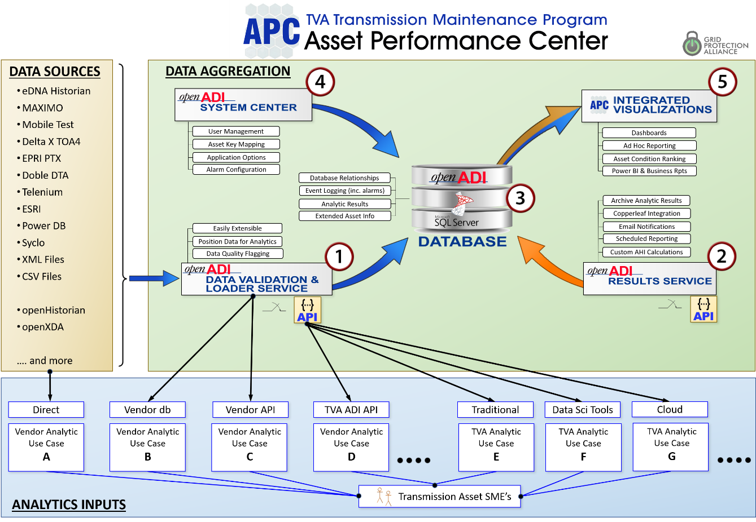

Figure 6. GPA Proposed Components and Input Integration Options for the APC

Each of the four components in the GPA proposed solution are described in detail in the sections that follow.

#### 1 - openADI Data Validation & Loader Service

The openADI Data Validation and Loader Service, or “openADI Loader”, provides aggregation of all information necessary for the maintenance program that is a function of an individual asset. The services connect to existing TVA data sources to obtain measurements and properties, such as eDNA points, Asset information from Maximo, etc., and can store additional Asset information, such as photos, documents or values in the Database Service. Because the service has access to the data, it can do some data validation based on custom defined rules to check for engineering reasonableness.

The primary function of the openADI Data Validation and Loader Service is to connect analytics to asset condition data sources like eDNA, Delta X and Maximo.

##### openADI Loader – DATA VALIDATION

The purpose of the data validation aspect of the openADI Data Validation and Loader Service is to check data for engineering reasonableness. Based on pre-defined rules such as all voltages are within 20% of nominal, the data is flagged using a data quality flag. For any analytic producing results based on flagged data, the Results Service will flag the results indicating that these results may not be reliable.

The openADI System Center allows the user to define these data validation rules based on standard deviation and mean as well as fixed limits. The rules can be applied to certain measurement types, such as all voltages, or to individual points from specific data source systems.

##### openADI Loader – SOURCE DATA INTEGRATION

GPA has extensive experience in connecting to TVA data systems. These include systems that house asset nameplate information such as Maximo and FAWG and systems that are used to house asset measurement information such as eDNA. A short list of the ten systems, which were cited in the solicitation as likely sources of asset condition data, is provided below along with other data source formats and sources. In addition, for each of the data sources, GPA briefly summarizes our experience connecting to them. As mentioned earlier in this proposal, data source integration may be able to be jump started by leveraging the TPS Information Model – See Appendix F.

###### eDNA Historian

The eDNA Historian provides access to SCADA points, such as breaker status, voltage and currents. GPA has already developed software that interfaces with TVA’s Transmission instance of eDNA, which is in use in the openXDA deployed at TVA’s power quality group. This data is timeseries data with a point every few seconds. Because it is possible to request historic data from the eDNA historian, it is not necessary to store this data in the openADI Database.

###### Maximo

Maximo can provide a number of different data sources. Because Maximo is considered TVA’s Asset Registry System it can be used to obtain nameplate information. This type of data does not change over time and can be requested when it is needed, which means it does not have to be stored in the openADI Database.

In addition, TVA uses Maximo to record asset inspection results. The openADI Data Validation and Loader Service can use this to obtain inspection results including historic and most recent inspection forms and pictures uploaded during TVA’s asset inspection process.

GPA has also developed software that interfaces with TVA’s Transmission instance of Maximo. This was done as part of the work for TVA’s power quality group to obtain nameplate information from Maximo.

###### Mobile Test

Mobile Test is a TVA developed front-end application that connects to Maximo. If required, GPA can develop an API for the openADI Data Validation and Loader Service to connect to Mobile Test. However, since Mobile Test connects to Maximo and saves most of its data input to Maximo, the data will be available to openADI through the connection to Maximo without additional work. Since the data is stored in Maximo it does not have to be saved in the openADI Database.

###### Delta X TOA4

TOA4 provides results from transformer gas analysis. Since Delta X provides an API to exchange data with other systems, the openADI can obtain the results on a periodic basis. TOA4 also has its own database storing the gas analysis results, and the API allows the openADI to request historic data, therefore, the data does not have to be stored in the openADI Database.

###### EPRI PTX

The EPRI Power Transformer Expert Software is transformer condition analysis software developed by EPRI and used by TVA to support transformer analysis. The software collects a number of datapoints about transformers and provides assessments of the transformer’s degradation.

GPA has worked with EPRI before and based on previous experience with EPRI developed software a custom interface is likely to be needed to connect to the EPRI PTX software. In addition, GPA believes that most of the data collected by the PTX software, such as nameplate information, is likely to be available from other TVA data sources.

###### Doble Test Assistant Software (DTA)

The standard Doble DTA software uses a Doble Database which is difficult to access by third party applications. Depending on the specific configuration at TVA, it will be necessary to access Doble DTA data through a custom interface. GPA included the development of this interface in this proposal, but further discussions are necessary to determine the technical specifications of this interface.

###### Telenium

Telenium collects data about communication assets at TVA. Because communication assets are usually on a significantly faster replacement cycle than electric power system assets, this represents a challenge to the APC and the value of implementing a connection to Telenium is not fully understood by GPA.

Depending on the specific configuration at TVA it might be necessary to develop a custom interface to collect data from Telenium. GPA has included the work to build such interface as an optional item in this quote, but further discussions are necessary to determine the technical specifications of this interface.

###### ESRI

GPA has experience in connecting to the ESRI suite of geospatial tools at TVA. GPA’s openXDA system installed at TVA makes use of some of ESRI tools to help find the proximity of lightning strikes to individual transmission lines – among other use cases.

###### Power DB

PowerDB provides a collection of data from maintenance and testing activities related to TVA’s Battery fleet. Because PowerDB can store all of its information in a SQL database it is possible for openADI to connect to the PowerDB’s database and obtain a copy of the information. GPA has implemented similar approaches to interface with other TVA systems, such as SMART-FAWG, in the past. Because PowerDB has its own database the data does not have to be stored in the openADI Database.

###### Syclo

Syclo is a mobile application that can provide additional data to asset health analytics. Syclo has been acquired by SAP, and it has been integrated into the SAP Software Suite.

Without additional information about TVA’s configuration of the application it is not possible to determine the requirements to connect to this application or the SAP Software Suite if necessary. GPA has included an initial guess of the work required to build a custom interface to connect to Syclo as an optional item. However, without further discussion it is not possible to determine the technical specifications of this interface.

###### XML and CSV Files

GPA products, such as the openPDC and openXDA deployed at TVA, include the capability of reading XML and CSV formats as necessary. This includes structured files containing timeseries data and nameplate information. The openADI Validation and Loader Service includes the same underlying file processors and is able to ingest CSV and XML files.

In addition, GPA and EPRI have developed the PQDS file format, a CSV based format to contain measurement data and metadata. The openADI Validation and Loader Service can also ingest the PQDS format. The openADI Validation and Loader Service also has the capability to ingest CSV and XML files based on a custom structure to allow the user to define their own data-format. The input files can be stored in the openADI Database or retrieved from an external file share as necessary.

###### openHistorian

The openHistorian provides phasor data from TVA’s PMU network. Because the openPDC and the openADI are both GPA products, tight integration between them is possible. The openHistorian already has a number of interfaces to connect to visualization tools, such as Grafana, similar to the APC integrated visualizations, and any phasor data stored in the openHistorian can be made available to the openADI Validation and Loader Service.

###### openXDA

The openXDA is a platform for processing event and trending records from disturbance monitoring equipment such as digital fault recorders (DFRs), relays and power quality meters. GPA has deployed an instance of the openXDA in TVA’s power quality group and can provide an API to make the results available to the openADI Data Validation and Loader Service. GPA has also previously developed some asset health indication based on breaker trip coil current timing and implemented these within the openXDA.

###### AZURE API

A number of GPA products, including the openHistorian and the openPDC, already have an Azure API included. This API allows the user to easily connect the systems to AZURE and use the data to develop cloud analytics.

The openADI Data Validation and Loader Service also includes an Azure API, allowing TVA to develop and use Azure based cloud analytics within the proposed architecture.

##### openADI Loader – SOURCE DATA INTEGRATION WITH ANALYTICS

In Figure 6, seven use cases are shown to highlight the different implementation approaches that are likely to be necessary to successfully implement best-in-class analytics. The data integration layer of the openADI Tool Suite, will be tasked with implementing reliable, maintainable data interfaces regardless of the level of existing integration capability for these tools. Specifically, these integration use cases are:

|  |  |  |  |
| --- | --- | --- | --- |
| Analytics Source Data Use Case | API | Custom Interface | Configuration Location |
| 1. Vendor connects directly to asset monitors in substations | N/A | N/A | Vendor App |
| 1. Loader service pushes data directly to vendor db or files | None | Yes | Sys Center |
| 1. Loader services uses a vendor-provided API | Provided by vendor | Yes | Sys Center |
| 1. The analytics vendor performs input integration using ADI API | ADI Loader API | No | Sys Center |
| 1. TVA developed applications use ADI API | ADI Loader API | No | Sys Center |
| 1. TVA data scientists use condition data for local analytics | ADI Loader API | No | Sys Center |
| 1. Condition data provided to cloud-based analytics | ADI Azure API | No | Sys Center |

Table 1. Use Cases for Providing Asset Condition Data to Analytics

In addition, the openADI Data Validation & Loader Service is storing information about the asset monitoring process in the Database Service. This includes a log of which asset health analytics is using what data and the associated data quality. This feature can be used by SME’s to determine the reliability of specific asset health analytics and provide visibility into the dataflows in the system.

#### 2 - openADI Results Service

The openADI Results Service provides aggregation of the asset health analytics results. The service connects to the asset health analytics and collects all outputs of these analytics. The Results Service stores these results in the openADI Database. Because the service has access to all asset health analytics results it can be used for alarming and notification based on these results. It provides Transmission Asset SMEs with the ability to set alarm limits based on asset health analysis and send out email notifications to designated personnel. In addition, the Results Service also provides the ability to schedule and distribute asset health reports.

Because the Results Service has access to the results of all analytics it can also be used to compute an aggregated Asset Health Index (AHI). This AHI can be distributed to other systems, such as Copperleaf, to allow external systems to get an estimate of the assets health without having to deal with multiple analytic results.

In Figure 7, six use cases are shown to highlight the most likely implementation approaches to successfully implement best-in-class analytics. The results layer of the openADI Tool Suite will be tasked with collecting the results of the analytics, alerting and reporting of these results and computing an aggregated AHI.

The most common configurations to interface the Results Service with the analytics are:

|  |  |  |
| --- | --- | --- |
| Analytics Results Use Case | API | Custom Interface |
| 1. Interface is developed using vendor-provided database or files | None | Yes |
| 1. The interface uses a vendor-provided API | Provided by vendor | Yes |
| 1. The analytics vendor performs results integration using the openADI API | ADI Results Service API | No |
| 1. Results provided by a TVA-developed application | ADI Results Service API | No |
| 1. Results provided from TVA data scientists running local analytic tools | ADI Results Service API | No |
| 1. Results provided from TVA cloud hosted analytics | ADI Results Service API | No |

Table 2. Use Cases for Obtaining Results Data From Analytics

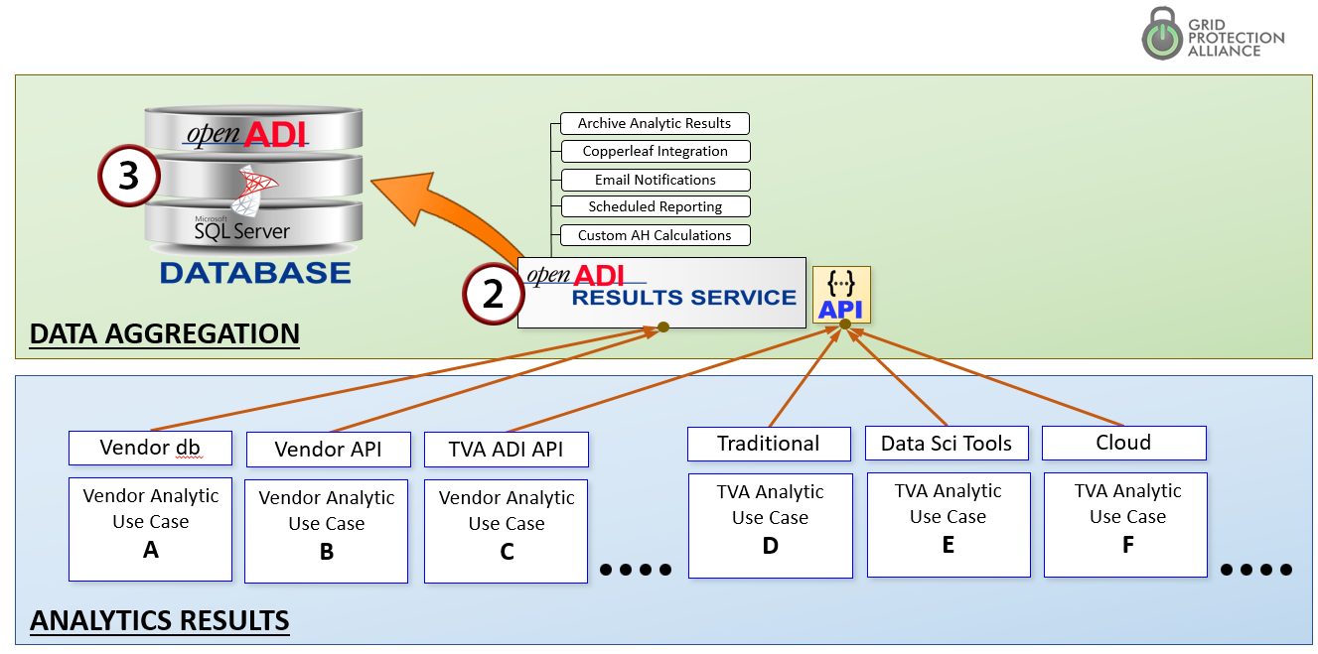

Figure 7. Results Integration Options for the APC

#### 3 - openADI Database

Similar to openXDA that is currently installed at TVA, the openADI will feature a database system based on MS SQL Server for most metadata and an openHistorian datastore for timeseries data.

The openADI Database also provides a data store for any additional asset information that should be attached to assets but does not reside in a data source system connected to the openADI Data Validation & Loader Service. In addition, the openADI Database is responsible for logging all events in the openADI, which includes the use of data in any analytics to track data flows.

#### 4 - openADI System Center

openADI System Center is a web-based application that allows the user to manage configuration of all components in this architecture. It provides user management to all other openADI components. Through integration with active directory services it enables TVA to manage access to asset monitoring data and asset performance analytic results based on TVA credentials. It allows TVA to specify access rights for specific users as well as roles based on job title and job description within Active Directory.

openADI System Center also provides a single place to manage asset key mappings within the proposed architecture. This means any measurements or property from the data sources, including, but not limited to eDNA points, transformer oil analysis results from TOA4, asset age from Maximo etc., can be mapped to an individual asset based on its key in TVA’s main asset registry system. By keeping this mapping current TVA can ensure any asset performance analytic has access to the data it needs to perform analysis of a specific asset.

#### 5 - Transmission APC Integrated Visualizations

While GPA is not proposing visualization as part of Asset Data Aggregation, GPA has included support hours in this proposal so that GPA can provide services to assist TVA with the visualization tools that would be of most value for the Transmission Asset Performance Center.

To be relevant and effective, GPA believes that the Transmission APC should be as much virtual as it is physical with the ability to project asset health to any TPS&S employee that needs this information as well as to those in TPS&S client organizations.

In the requirements spreadsheet (Attachment 5), GPA has indicated that we can meet all mandatory requirements for asset data aggregation – including those relating to visualization. However, GPA believes that the preferred visualization tools will be a mix of displays provided by vendor analytics, displays provided by general visualization tools such as Power BI and Grafana (See Appendix F), and customized browser-based displays that join maintenance condition data as well as analytic results in ways that yield the most meaning for Transmission APC users. These custom displays are likely to be most needed to integrate TVA developed analytics with vendor-provided results. Some of the TVA-developed analytics nearing production implementation are (1) breaker timing vs. specification based on waveform analysis and (2) transformer health based on the S/N ratio trends from phasor measurements.

Should TVA wish GPA to be a major provider of visualizations, GPA can provide displays for all data associated with an asset in the openADI. This includes measurements, results of asset health analytics and properties of the asset as well as information about the asset’s history, such as recent maintenance and inspection reports. Through integration with TVA’s Asset registry and work order system (Maximo), these visualizations can also allow the user to create work orders and attach pertinent information to those work orders.

### 1 Project Organization and Staffing

GPA staff has the experience, skills and knowledge necessary to provide TVA high-quality, reliable software solutions. As shown in Attachment 4, the GPA Detailed Staffing Plan, GPA has both the staff and depth-of-bench to capably provide project deliverables on time and within budget.

The information provided below summarizes information from Attachment 4 as well as Attachment 3, GPA Resumes.

##### Project Management

Russell Robertson will be overseeing this project with the scheduling and status reporting assistance from Rick Driggans. The GPA Team has experience in managing large development and deployment projects – both while at TVA and as based on the on-time delivery of the four multi-million-dollar awards from DOE that GPA has received over the last 7 years.

##### Implementation and Integration

The GPA Team has expert experience in providing services to integrate information through a broad range of data integration techniques. This includes data integration with data historians like eDNA and with relational data systems – including MS SQL Server, and Oracle. GPA has implemented web-service based APIs for its products and has provided services to both utilities and vendors of priority utility software to develop APIs.

##### Application and Subject Matter Expert Expertise

Key members of the GPA Team have decades of combined experience in development, operation and support of transmission data collection systems as well as transmission analytic applications. With the recent addition of Dr. Christoph Lackner, GPA also has deep technical depth in computation science as well as methods to develop complex analytic engines.

##### IT Infrastructure Support

The GPA Team has worked with numerous IT support staffs in the installation, test and turn-up of production operating systems. We understand server, data base and web-server administration. We understand the relationships between network configuration and system performance. GPA has worked closely with multiple utility’s security teams to deploy GPA products in both CIP-critical and enterprise environments.

##### Application Quality Assurance and Testing

The GPA Team has led and participated in the system quality assurance testing, both as the recipient of the system (while Team members were at TVA) and as the provider of systems.

##### Security

The GPA Team has won two awards from DOE’s Cybersecurity for Energy Delivery Systems (CEDs) Program. Through this experience, GPA staff are knowledgeable of best-in-class security practices and in the development of systems that implement these practices.

### 2 Functional Requirements

GPA has provided a detailed response to the functional requirements in Attachment 5, GPA Response to the TVA Requirements Workbook. This section contains a short summary of the responses in that workbook.

##### Administration

With a history of developing real-time systems to be deployed on CIP-critical networks, GPA appreciates the need for disciplined administration and governance that include separation of duty and highly formalized change management procedures. GPA also understand the burden that can be placed on SMEs of administration and configuration of systems for support and expanding asset base. openADI System Center is proposed by GPA to simplify and reduce the burden of this administration.

##### Architecture

As described in the proposed architecture in Section IV of this document, the openADI Tool Suite is capable of interoperating with the multiple external[2] systems that TVA has included in the functional requirements. The architecture proposed by GPA is designed to be easily extendable to other data sources and additional systems – at minimum effort. Note that this architecture is recommended based on GPAs experience in providing other integration services to TVA for several of the same external systems.

##### Analytics and Share Findings

GPA is not bidding on the analytics portion of this RFP per se (although GPA has already implemented several small transmission asset health determination analytics at TVA). Even so, two major points. First, TVA has included a number of functional requirements in Asset Data Aggregation related to real time dashboards, reporting and data sharing which are common to analytics. GPA is experienced at developing these visualizations and will enjoy providing these services to TVA. Second, the proposed openADI suite of tools was developed with what GPA sees as the critical requirement to make analytic results easily sharable and usable – by other analytics, within the Transmission APC, and by other TPS&S and enterprise TVA systems.

##### Supplier Support

As a developer of open source software, one of GPA’s primary sources of revenue comes from supporting and maintaining our products. We believe we have a good track record at providing responsive, high-quality support for the GPA products currently installed at TVA. Due the agility that comes from being a small business, our extensive experience with TVA systems and close proximity to the Chattanooga Office Complex, we are confident that GPA can provide TVA exceptional O&M support during both the post-installation (warranty period) phase and operational phase of this project.

### 3 Technical Requirements

GPA has provided a detailed response to the technical, or non-functional, requirements in Attachment 5, GPA Response to the TVA Requirements Workbook. This section contains a short summary of that response.

##### Administration

The proposed openADI suite architecture can meet all the non-functional requirements enumerated by TVA. OpenADI will interface with Active Directory to manage authentication of users. All existing GPA projects, as well as the proposed openADI suite, include copious logging to provide audit trails for security forensics and for diagnosing and resolving system issues.

##### Architecture

The GPA proposed solution is designed to execute on TVA hardware that is virtually “on premise” from the network layer perspective. This proximity from the network layer perspective is important to allow easy interoperation with the source data systems. However, this does not preclude some points of interface for openADI being isolated from local networks – including being “in the cloud” – as TVA may prefer for some vendor-provided or some TVA-developed analytics. In addition, GPA can provide support for setting up failover systems for the openADI so that it can be a high-availability implementation as deemed necessary by TVA.

All components of the proposed architecture are designed to either be web-based services accessed through a web-browser, or back-office server systems designed to run with minimal user interaction. While a mobile application is not part of the proposed architecture per se, the web-based APIs proposed by GPA can be easily used to support mobile apps and externally accessible web pages.

##### Data Management

The focus of the proposed architecture is to provide a single, open and easy-to-use repository for transmission asset health related data through the openADI database. However, this data does not need to be physically stored within the database. In cases where the source data is well structured and the source system is sufficiently performant, openADI would only maintain a reference to source data (or perhaps maintain a reference in conjunction with TPS-IM – See Appendix F). OpenADI will include copious logging of data flow volume and timing to enable detailed monitoring of data flows to assure that all data aggregation requirements can be met.

To address scale issues (both in the number of data sources, the volume of data needed from some of these sources, and the potential number of analytics) architecturally openADI is recommended as the gateway for analytics interaction with source data systems so that openADI and monitor and maintain common links across multiple analytics. This common link also allows source data to be validated prior to being provided to the analytic and avoids each analytic having to be configured to provide this functionality independently.

##### Analytics

GPA is not bidding on the analytics portion of this RFP per se. However, GPA would like to point out that a number of technical requirements of the analytic portion can be addressed by the GPA proposed architecture. Since openADI is proposed to be the repository for asset health from multiple analytics, it makes it possible for the openADI Results Service to automatically notify Transmission employees of abnormal or off-normal conditions. See Appendix C, Alarming and Automated Notifications. In addition, the openADI Integrated Visualizations can provide a single window view into TVA’s asset health monitoring system.

##### Share Findings

GPA recommends that Transmission APC Integrated Visualizations component of the proposed architecture (Item 5 in Figure 6 on page 16) be based on multiple visualization platforms -- some custom provided by individual analytics and some from general platforms such as Power BI or based on Grafana. See Appendix B, Visualization using Grafana. Grafana is an open source visualization tool that includes large parts of the functionality required by TVA.

In addition, GPA is planning on developing a new data trending tool in partnership with EPRI and TVA in FY 2020 which includes some of the functionality needed for the Transmission APC.

##### Security

GPA has extensive experience in assuring that its software is intrinsically secure and in management of user authentication and in role-based permissions for applications. GPA offers the service (which is not included as part of this proposal) to provide monthly code reviews and issue security alerts and patches for software installed on CIP-critical networks.

While other methods of providing user authentication can be implemented, GPA recommends that the openADI suite of products interoperate with TVA’s Active Directory (AD) for user authentication.

Since the openADI is proposed to be installed virtually “on premise”, many of the technical requirements related to cloud storage and any requirements to Vendor’s IT data storage systems are not applicable. All data in the openADI database will be stored on TVA systems and no data will leave TVA at any point. However, openADI can support interfaces to external systems, such as those in the cloud, should TVA elect to implement Transmission APC components there.

##### Integration

The purpose of openADI is “integration centric” and it is based on a number of extendable API’s and custom interfaces to integrated with other TVA systems.

##### Network

The proposed solution resides fully on TVA networks. The proposed architecture was designed in keeping with best practices to not unduly burden the data transport layer.

##### Storage

The proposed architecture minimizes the data stored within the openADI database to that information that cannot be dynamically obtained from source data systems within the performance requirements demanded by the individual analytic platforms. Whenever possible the data is queried directly from the source system, minimizing the storage requirement.

##### Testing

GPA recommends TVA set up development, acceptance and production environments to ensure any updates to the system are thoroughly tested by TVA personnel before promoting new functionality or updates to production.

### 4 Work Requirements

GPA will support delivery of all items requested by TVA including those listed in the TVA-provided Work Requirements document (Attachment 6).

GPA has valued the TVA Delivery Expectations Document (DED) process as a useful vehicle to finalize the documentation of requirements immediately preceding the start of development of a software deliverable to TVA. We hope that this DED process can be used in this project, and we have shown DEDs as the trigger for GPA beginning work in the project schedule.

GPA hopes that in working with TVA that some of the planning and project coordination documents can be combined to reduce project overhead while continuing to meet all TVA requirements.

### 5 O&M Support Requirements

GPA has provided a detailed response to the O&M Support requirements in Attachment 5 and Attachment 7. This section contains a short summary of that response.

##### Providing O&M Support

GPA has deployed multiple products at TVA, including the openPDC and the openXDA. As part of these production installations, GPA has been providing O&M support to TVA including Level 2 and Level 3 Help desk support. GPA is confident that all requirements detailed in Attachment 7 can also be met. See Appendix G for more details on standard GPA product support services.

##### Meeting Performance Service Level Requirements

As detailed in Attachment 7, GPA is confident that the operation and maintenance support requirements can be met. All standard GPA support contracts, including those with TVA, guarantee an initial response from GPA within 2 hours during business hours. GPA is confident that the performance targets in Attachment 7 can be met with the resources available.

##### Continuing Knowledge Transfer

As part of the deployment of other GPA products GPA has also provided continued knowledge transfer including on-site training and extended documentation where necessary. If necessary, GPA can also provide web-based training for TVA personnel. GPA estimates approximately 16 hours of training for IT and subject matter experts combined will be sufficient for TVA to manage the openADI and take over day to day administration of the system.

If desired, GPA can support changes and adjustment to TVA procedures to optimize workflows for the openADI users as part of the maintenance contract.

### 6 Project Schedule

GPA has provided a Microsoft Project schedule in Attachment 8, and this section summarizes that proposed schedule.

GPA sees the role of the Asset Data Aggregation provider as one of meeting TVA’s need to integrate specific analytics once they are selected and scheduled for installation by TVA.

Some analytics may be easy to integrate, and some may be difficult. In addition, as Asset Data Aggregation work progresses it should also grow progressively easier to integrate new analytics. Therefore, the schedule shown below in Figure 8 is only representative of a process that would be followed for each analytic. The schedule is blocked in “units” in Figure 8 where for fixed-price budgeting purposes it was assumed that a unit was comprised of one analytic that required integration with two different condition data sources.

In practice, GPA proposes that within the context of the overall Asset Data Aggregation Design that the integration of specific analytics be defined and scoped individually through use of TVA’s Delivery Expectations Document (DED). GPA has used this process in another TVA project and has found this structured process to work well. In practice, it will also be possible for GPA to work on multiple DEDs simultaneously rather than a strictly serial process as shown in Figure 8.

GPA also appreciates its role of being an important point of interaction with the analytics vendor’s technical staff to define the nature of the data to be exchanged and to align GPA’s activities and proprieties with the schedule for analytic delivery.

GPA is confident that we can meet TVA’s Minimum Viable Product date of October 1, 2020 for analytics for batteries and breakers. As part of this delivery, the beta product for the openADI Data Validation and Data Loader Service and the openADI database will be delivered to TVA.

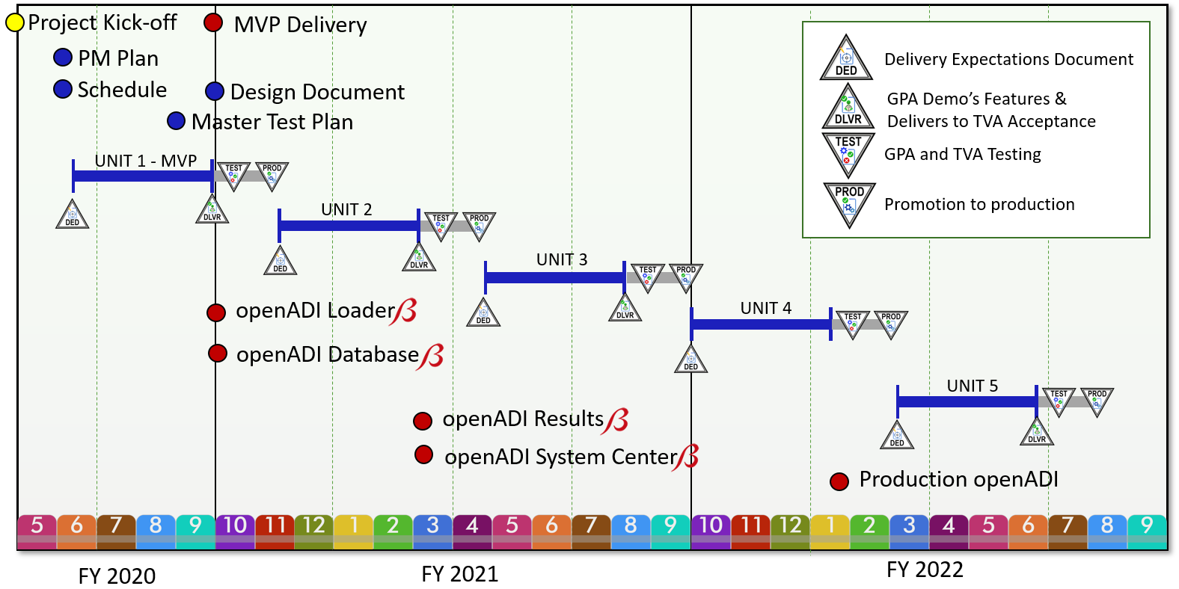

Figure 8. High Level Project Schedule

# Certification Letter

January 31, 2020

Thomas L. Kuhnert

Tennessee Valley Authority  
Supply Chain – Sourcing, MR 5F-C

1101 Market Street

Chattanooga, TN 37401

**Re: TVA Solicitation 99419, “Asset Data Aggregation and Condition Analytics Tools”**

Mr. Kuhnert,

Regarding the subject solicitation,

* GPA has arrived at prices and cost data independently, without consultation, communication, or agreement with any other party including but not limited to other offerors or competitors.
* Prices and cost data submitted by GPA have not been knowingly disclosed, directly or indirectly, to any other party including but not limited to other offerors or competitors. GPA agrees not to disclose the prices and cost data submitted to TVA prior to the award of a contract unless otherwise required by law.
* GPA has and will not attempt to induce any other person or firm to submit or to not submit a price proposal on this solicitation for the purpose of restricting competition.

Sincerely,



F. Russell Robertson

Vice President, Grid Solutions

Grid Protection Alliance, Inc.

# Proposal Pricing and Cost

GPA has provided two pricing workbooks as attachments to this proposal. GPA is prepared to move forward with the required fixed-price quote (Attachment 11) should TVA like GPA to do so. However, GPA has also included an alternative proposal that is T&M based that meets TVA requirements at a significantly lower cost than that provided by the fixed-price proposal.

In GPA’s T&M quote, or alternative proposal (See Attachment 12), GPA will work collaboratively with TVA to determine the preferred integration option for a specific analytic from both TVA technical and business perspectives, and then GPA will implement that option. With this alternative GPA proposal, TVA can buy as little or as much Data Aggregation service support from GPA as is needed based on the capabilities of the analytic platform and its internalized integration functionality as well as the degree to which TVA may wish to directly participate in this integration/aggregation effort – as may be the case for cloud-based analytics. The Asset Data Aggregation are lower under the alternative proposal as a result of the reduction of financial risk to GPA from the rather large uncertainties in the specific information needs of the individual best-of-breed analytic packages that will ultimately be selected by TVA.

To manage TVA risk under the alternative GPA proposal, GPA can deliver the software components of the project at a mutually agreed upon fixed price to be determined at the time the DED is developed for an individual software component – e.g., a new data source or a new analytic.

GPA is also willing to discuss and thoughtfully consider other pricing models suggested by TVA or re-evaluate the current fixed price cost should more be known to reduce uncertainty and GPA financial risk.

# Small Business Contracting Plan

No project subcontracts are planned. GPA is a small business.

## Appendix A: The MIT License

Copyright © Grid Protection Alliance

Permission is hereby granted, free of charge, to any person obtaining a copy of this software and associated documentation files (the "Software"), to deal in the Software without restriction, including without limitation the rights to use, copy, modify, merge, publish, distribute, sublicense, and/or sell copies of the Software, and to permit persons to whom the Software is furnished to do so, subject to the following conditions:

The above copyright notice and this permission notice shall be included in all copies or substantial portions of the Software.

THE SOFTWARE IS PROVIDED "AS IS", WITHOUT WARRANTY OF ANY KIND, EXPRESS OR IMPLIED, INCLUDING BUT NOT LIMITED TO THE WARRANTIES OF MERCHANTABILITY, FITNESS FOR A PARTICULAR PURPOSE AND NONINFRINGEMENT. IN NO EVENT SHALL THE AUTHORS OR COPYRIGHT HOLDERS BE LIABLE FOR ANY CLAIM, DAMAGES OR OTHER LIABILITY, WHETHER IN AN ACTION OF CONTRACT, TORT OR OTHERWISE, ARISING FROM, OUT OF OR IN CONNECTION WITH THE SOFTWARE OR THE USE OR OTHER DEALINGS IN THE SOFTWARE.

## Appendix B: Visualization Using Grafana®

The Grafana platform is proposed as a candidate platform to be among the data visualization solutions that support the Transmission Asset Performance Center. Grafana can be used for asset maintenance health trending and as a tool to monitor and alarm on issues from source data systems. A GPA-provided dashboard for the TPS&S Network Operations Center is in production use by the NOC monitoring real-time data streams from synchrophasor measurement devices in substations. It alarms on issues requiring NOC operator attention.

Grafana is a fast, highly scalable, open source solution for time-series data visualization, monitoring and end user data analysis. The system is designed around a well-defined, simple to use interface based on simple metrics to make sense of massive amounts of data. Over the past few years, Grafana has become the de facto, go to software used by enterprises for time series analytics.

Grafana can visualize, explore and alert on data from many different databases and cloud services. Each database or service type is accessed from a *data source*. Grafana connects with a large set of data sources such as Azure, Graphite, Prometheus, InfluxDB, ElasticSearch, SQL Server, MySQL, PostgreSQL, etc. Data sources also include those that are built by the community.

With Grafana, custom dashboards are created using widgets called *panels* used to display specific metrics over a set timeframe. The Grafana dashboard, constructed with a set of arrangeable panels, is where the system brings everything together. Panels included with Grafana by default include a graph, single statistic, table, heatmap and free-text panels, each highly customizable. The available panels also include an extensive set of community-built plugins used to graphically display data in any conceivable fashion.

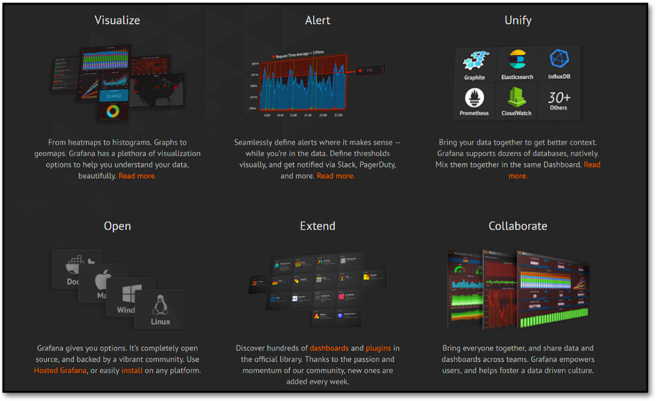

GPA has developed custom Grafana data sources for the openHistorian and OSI-PI that are officially published on the Grafana plugin repository. These data sources use advanced Grafana APIs for deep and rich integration with shared GPA framework interfaces, including alarming and security. Using these APIs, the openHistorian comes preinstalled with an instance of Grafana that is tightly integrated with openHistorian managed security and the Grafana instance being exposed through the self-hosted web interface.

In addition to custom data sources, GPA has developed several Grafana panel plugins to support monitoring of production systems using GPA software, including geographical device maps, phasor clock charts and custom alarm panels.

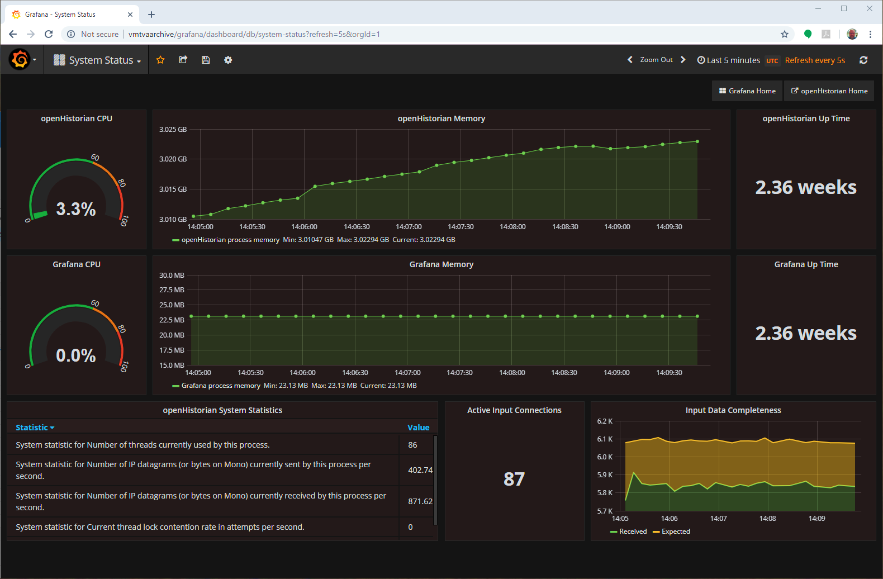 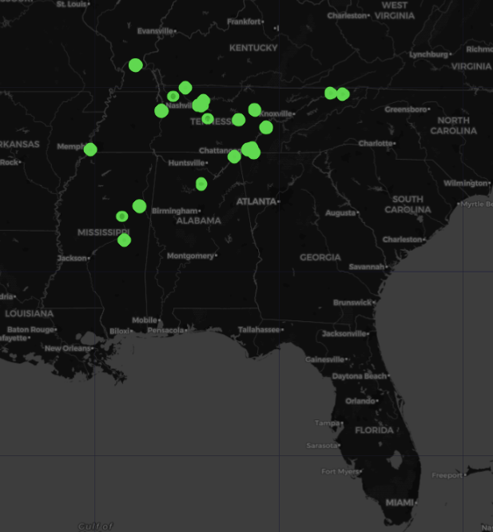

Examples of Grafana Dashboards in Use with Synchrophasor data

The value of Grafana comes in its ability to combine data from disparate data sources with highly discernable, easy to comprehend visualizations providing historical, current-moment and prescient business intelligence. Dashboards are easy to develop, even by non-IT users. Existing dashboards can be customized for a specific user, setup as templates, implemented with annotations for event and alarm correlation, and be easily shared between users.

Grafana is being rapidly extended by the community at large through the development of data source and panel plugins. Additionally, the community posts custom dashboards that can be used as a starting point for new dashboards. Grafana is also free and open source, so installation requires no license fees – it is a low-cost solution.

With most work offloaded to querying of remote data sources, Grafana itself has minimal hardware impact, as such, a single Grafana instance will scale to an extremely high number of displays. Even so, being a web-based application means that Grafana can be easily deployed across a load-balanced cluster to scale up to most any sized deployment, including Internet scale.

GPA believes that Grafana is an excellent candidate tool for aggregation of asset, maintenance and condition-based data visualizations as well as a platform to assist with monitoring of information flows and maintenance actions.

For more information on Grafana, See <https://grafana.com>

## Appendix C: Alarming and Automated Notifications

A full-featured alarming engine is included within the GPA code base, and it is part of many GPA applications, such as the openHistorian. Importantly for this RFP, the alarms that can be created using the GPA alarming engine can be sophisticated. This sophistication is necessary to avoid alarm flooding, chatter and persistent false alarms.

Using the GPA tools, alarms can be created based on non-symmetric limits, a timer can be used to delay raising an alarm, and hysteresis can be applied to postpone alarm clearing as seen in the figure below. Alarms can be set to trigger based on measured data or calculated values. Alarms can also be raised based on a threshold of comparison to other measured values. Any number of set points can be established for a value. In many cases, six set points are needed: unreasonable data high, alarm high, warning high, warning low, alarm low, unreasonable data low.

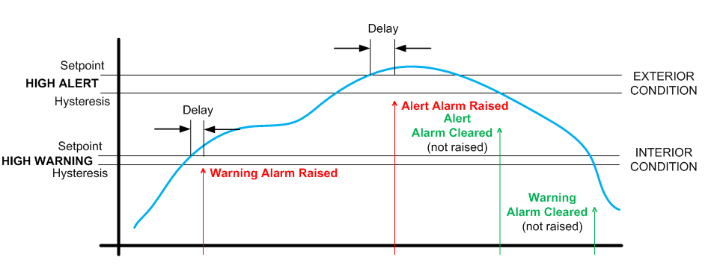

GPA’s Alarming Engine Includes Ability to Set Delays and Incorporate Hysteresis

#### Off-Normal Alarming

Off-normal alarming can be especially useful in detecting that “something has changed” even though the data is well within acceptable operating limits.

GPA has delivered systems where either automatically (e.g., once per month) or based on ad-hoc manual changes, custom alarm triggers are set as a function of a deviation from that which is considered to be normal for a measurement. (Hence “off-normal” rather than “abnormal.”) Off-normal alarms can be statistically based from historical data or can be based on insights provided by subject matter experts.

For power quality trend data alarming, GPA has implemented statistically based alarms that are a function of hour-of-the-week, with alarms that are automatically determined based on a four standard-deviation band from what’s expected for a particular hour, e.g., 8 AM on a Monday, for a particular metering location.

Off-normal alarming can become quite sophisticated and GPA’s alarming engine can handle many of these approaches. However, unique cases such as the hour-of-the-week alarm mentioned above which has 168 high and low set points for each measurement requires code-based implementation.

#### Alarm Integration

It is often necessary for multiple systems to be aware of both a measurement value as well as the settings associated with its alarm values. The GPA alarming engine exposes all alarm values, and associated alarm settings, through web-based APIs for external systems integration.

When used in conjunction with a system that supports time series functionality, alarms can also be exposed as time series values that can be consumed by a real-time system, e.g., over the IEEE 2664 Streaming Telemetry Transport Protocol (STTP), for instantaneous alarm event responses.

#### Automated Notifications

Several GPA products include the ability to send automated emails based on an alarm being raised. These emails are highly customizable and are based on an XML template that can be easily modified by the user. A sample template is provided below:

GPA’s XSL Transform Editor for Creating E-Mail Templates

## Appendix D: The Value of Sandboxed Analytics

APIs alone are not likely enough to support automated analytics for the Asset Performance Center. GPA believes that a structured framework is necessary to reliably run analytics developed by numerous parties while assuring overall system reliability and security.

Early on in the development of automated systems to process waveforms and notify line and electrician crews of the location and cause of system events, GPA was presented the challenge of accommodating experimental research that add new analytics. Often these “experiments” were developed by research institutions with expert academic engineering and scientific sills but limited IT knowledge. The platforms for development of these experiments – such as MATLAB -- also tended to be fragile and not be well-aligned with the features necessary for production-grade deployments. To make this work even more complex, commonly these experiments involved intellectual property not owned by the utility or by GPA. Rather, this IP was more sensitive than could be protected by an NDA so that the owning institution desired to have no disclosure of the functionality provided within an innovative computational “black box”.

The GPA solution was to create a structured application development framework called openEAS (Extended Analytic Services) where each third-party analytic is implemented as a separate Windows service that can safely run or fail independently of the primary production service. openEAS works by providing a wrapper for the third-party developed software (typically a DLL) providing inputs to the software, invoking the software and consuming the results from it. The primary disturbance analytics automated service, openXDA, is designed to flexibly support numerous separately running openEAS analytics.

The key for smooth operation of openEAS is in management of its interaction with the data layer, the openXDA database. From the openXDA database, the openEAS service receives the trigger to execute -- based on source waveform data, based on openly published analytic results that are available from standard openXDA analytic services, or based on custom parameters that must be computed by the openXDA service. Once triggered, openEAS writes the results from the third-party analytic to the openXDA database so that these results can be included in disturbance visualization tools like the open PQ Dashboard or System Event Browser. Finally, openEAS logging is integrated with openXDA so that any performance or operational issues with third-party analytics can be diagnosed and corrected.

GPA provides instructions on use of openEAS and these instructions have been sufficient to allow the independent development of openEAS services by both researchers and by TVA to “bolt on” additional automated processes to openXDA.

For this RFP, the automation analog to GPA’s openXDA solution is the combination of (1) the openADI Data Validation and Loader Service that would pick up and trigger specific third party analytics based on newly available source data and (2) the openADI Results Service that would include logic for automated notification of “poor asset health” based on the results of perhaps multiple analytics.

## Appendix E: The GPA Gemstone Library



The GPA Gemstone Library is a collection of reusable code elements based on work that started with development of the openPDC at TVA in 2004. These libraries represent a focused re-envisioning and re-engineering of the best code, i.e., the "gems", from the GPA Grid Solutions Framework (GSF) which have been in use since 2010 in all GPA products, in numerous other open source projects and by multiple electric utilities worldwide.

The GPA Gemstone Libraries contain a diverse collection of well documented code useful for any development project with hundreds of class libraries that extend or expand the functionality provided with .NET. In addition, the Gemstone Library includes tools and protocol parsers that are useful for the electric power industry. This functionality includes code for handling PQDIF, COMTRADE, EMAX, SEL Event Files, Modbus, DNP3, IEEE C37.118, IEEE 1344, IEC 61850-90-5, UTK F-NET, SEL Fast Message, MMS, FTP, eDNA, OSI-PI, openHistorian, MongoDB, Kafka, InfluxDB, Grafana, and Azure Event Hub, among many others.

The GPA Gemstone Library is built using .NET Core -- specifically targeting the long-term support (LTS) Version 3.1 which was released in December 2019. The .NET Core framework is open source, and it has been developed by both Microsoft and the open source community. The key benefits of .NET Core over the standard .NET frameworks are performance, easier updates, simpler maintenance and deployment, cross-platform implementation and improved support for cloud-based development, e.g., Azure.

Importantly for this RFP, .NET Core is also a robust and feature-rich framework for development of high-performance APIs, common applications, advanced data and analytic processing systems, and web-based applications using ASP.NET Core, as highlighted by the figure below. See the URL, shown in the image above, for more information about the features and use of Gemstone.

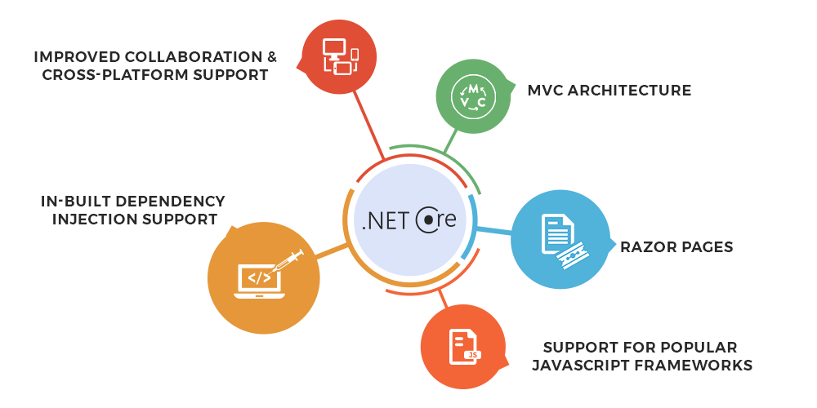

## Appendix F: The TPS Information Model

The figure below is from an internal TVA presentation made by Russell Robertson in January 2005. The TPS Information Model was envisioned at that time to be a “master link” among the major transmission information domains of (1) work management which focuses on assets, (2) short and long term planning as well as protection which focuses on the electrical characteristics of the transmission system and (3) operations which requires real-time awareness of the state of the system. Also shown in this figure are the anchor information systems (and there may now be others, e.g., outage management) which must be drawn together to have full integration among these three information domains. Purposely not shown are other important dimensions to information integration that are outside TPS&S functional control, but which are important for full data integration such as GIS and Document Management.

While we understand that the TPS-IM vision of 2005 has not been fully implemented, GPA believes that the functionality provided by those parts of TPS-IM that have been implemented within TPS&S provides a major jump start to the asset data aggregation requested by this RFP. We think that TVA’s experience over last the 15 years of maintaining TPS-IM also provides the Transmission APC with a relevant and important case study for asset data integration. It’s often said that initially connecting systems is “just a little hard work” – and we think this is true. However, the day-to-day maintenance that is required to assure that these link tables are up to date is often difficult to manage as new assets come into service and as old assets are retired.

Having a common location to maintain these master links like TPS-IM assures that TPS&S only has to maintain these links once – and not multiple times for multiple systems.

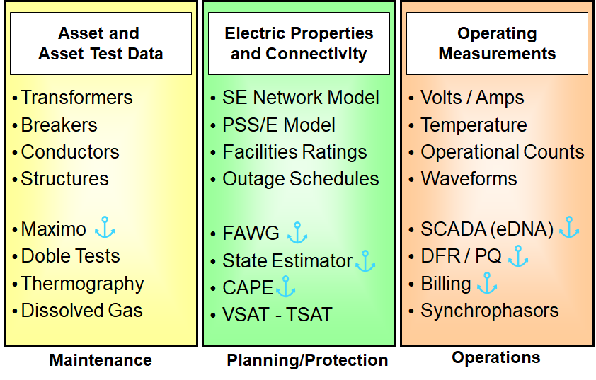

The TPS Information Model Draws Data Together Across Transmission Domains

## Appendix G: GPA Standard Annual Maintenance Services

With an annual product maintenance agreement, GPA agrees to:

* Provide support for any number of product installations to support centralized or control center operations, including test and acceptance instances of the product at multiple data center or control center locations.
* Provide notice of significant bug fixes and new product releases.
* Provide support for the application of patches or the migration to new versions of the product.
* Make GPA staff available for consultation and problem resolution.
* Provide access to a private, problem-reporting web site (separate from GPA's public, open-source problem reporting) to open maintenance tasks and allow tracking of these tasks to completion.
* Establish a process to escalate problem resolution, should it be necessary.
* Grant the maintenance contract owner a priority voice in establishing a ranking list for new features to be included in subsequent product releases.

#### Business Day Support (10 hours x 5 days)

* GPA personnel will be available for e-mail and telephone support during normal GPA business hours which are Monday through Friday, 8:00 a.m. until 6:00 p.m., eastern time, with the exclusion of six holidays -- New Year’s Day, Memorial Day, Fourth of July, Labor Day, Thanksgiving, and Christmas.
* During GPA business hours, GPA on-call staff will respond immediately, whenever possible; but, in any event, GPA staff will reply within 30 minutes by telephone call or  
  e-mail to acknowledge receipt of a support request and initiation of work on the issue.
* A 24 hours x 7 days support telephone number will be provided for hours outside of those covered by the 10 hours x 5 days maintenance services. GPA will endeavor to provide this after-business-hours support (subject to the availability of GPA personnel) at 150 percent of GPA’s standard consulting rates with a 4-hour minimum charge.

#### Full Time Support (24 hours x 7 days)

* Includes all GPA Business Day Support services.
* Additionally, GPA personnel will be available 24 hours x 365 days via a direct mobile number and will respond within 15 minutes. Problem investigation will begin immediately.

1. Under the MIT license, TVA has flexible rights to use GPA OSS software in any manner TVA may choose – including creation of derivate products in partnership with other vendors.
2. External to the Transmission APC. These systems include Maximo and eDNA among others.