Arizona Public Service
AUTOMATIC EVENT RETRIEVAL SOFTWARE TEST PROCEDURE
This test procedure is intended for the use of APS System Protection engineers to test and evaluate the vendor Proof of Concept’s (POC) ability to meet the Business Functional Requirements (BFRs) of the Automatic Event Retrieval Software (AERS) as defined in the APS AERS Request for Proposal (RFP).

ENGINEER__________________________________________________ DATE _________________________

This test procedure is intended for the use of APS System Protection engineers to test and evaluate the end-user functionality of Grid Protection Alliance’s (GPA) Proof of Concept (POC) to automatically retrieve, store, analyze, and provide push notifications of event and transient records from digital relays and fault recorders to a defined set of users. GPA’s POC includes installation and configuration of the OpenMIC application and OpenXDA suite of tools in the SCADA lab environment.

It is assumed that any/all hardware & software from Grid Protection Alliance has been installed and configured in the APS CIP & non-CIP test environments. Additionally, it is assumed that connectivity to the SCADA lab relays identified in the test plan below has been successfully established and tested such that evaluation of the POC may commence.

REFERENCES
References listed below are available from the “Automated Event Collection & Fault Location” Microsoft Teams channel Documents>General>RFP>POC
- POC Contact List
- APS AERS BFR’s
- APS Vendor Bid matrix (System Protection version)
- Vendor RFP
- Vendor Pilot Scope
- How To - DFRs.html guide

TOOLS NEEDED
- 2xDoble test kits
- 1xSEL-4000 Relay Test System (RTS)
- Laptop with SEL-C662 USB serial cable
- A stopwatch or other means of timing
- Tesla Control Panel Software

SCADA LAB RACK LAYOUT

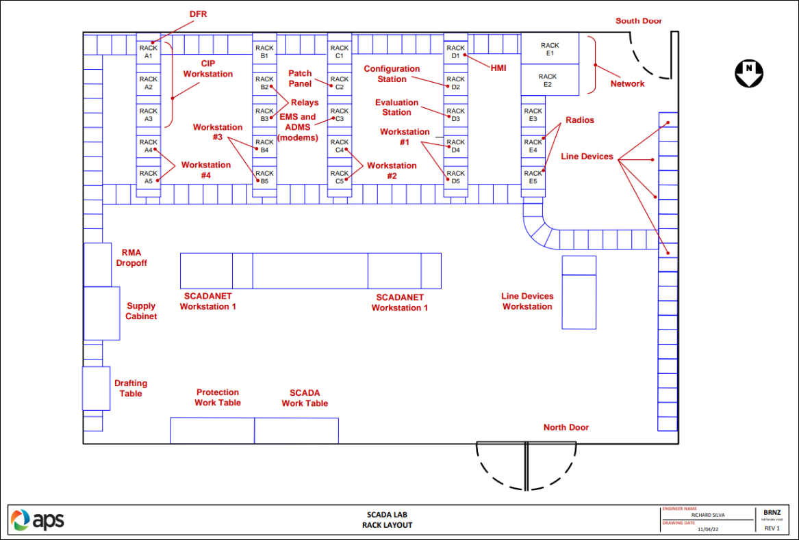

SCADA LAB AERS POC INTEGRATION DIAGRAM

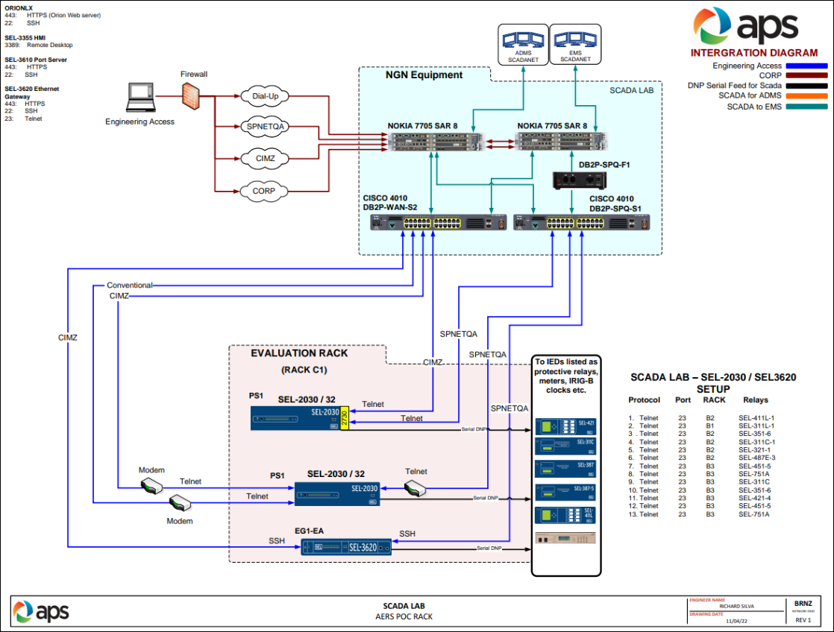

SCADA LAB RELAY SETUP/INVENTORY
The SCADA inventory table below has been reorganized to best mirror a standard substation tree hierarchy within APS’s asset & setting repository in Enoserve PowerBase.
SCADA LAB SEL-2030/SEL-3620 SETUP
 | PROTOCOL | RACK | CIRCUIT | RELAY | PART # | FIRMWARE
1 | Telnet | B2 | 230kV Remote Line | SEL-411L-1 | 0411L1X6X5B6CCXH474XXXX | SEL-411L-1-R125-V1-Z015003-D20191210
2 | Telnet | B3 | 230kV Remote 2 Line | SEL-421-4 | 04214415XXXX4H25XXXXX | SEL-421-4-R326-V0-Z027014-D20181210
3 | Telnet | B3 | 230kV Breaker Failure | SEL-351-6 | 035160H3554XX1 | SEL-351-6-R405-V0-Z010006-D20120203
4 | Telnet | B2 | 230-69kV XFMR DIFF 2T3-R1 | SEL-487E-3 | 0487E3X411XXB4X4H72424X | SEL-487E-3-R321-V0-Z114103-D20220523
5 | Telnet | B3 | 230-69kV XFMR PH BU 2T3-R6 | SEL-311C | 0311C00H23254X1 | SEL-311C-R114-V0-Z006004-D20130307
6 | Telnet | B1 | 69kV Remote Line | SEL-311L-1 | 0311L1HC04254X4XX | SEL-311L-1-R412-V0-Z105006-D20101112
7 | Telnet | B2 | 69kV Remote 2 Line | SEL-311C-1 | 0311C10HH4E54X1 | SEL-311C-1-R508-V2-Z104101-D20190111
8 | Telnet | B2 | 69kV Remote 3 Line | SEL-321-1 |  | SEL-321-1-R525-V656124pb-Z001001-D20000721
9 | Telnet | B2 | 12.47kV Feeder | SEL-356-1 | 035162C4E54XX1 | SEL-351-6-R516-V2-Z106105-D20190111
10 | Telnet | B3 | 12.47kV Feeder 2 | SEL-451-5 | 0451561EXB0X4H274XX2X | SEL-451-5-R326-V0-Z029014-D20220523
11 | Telnet | B3 | 12.47kV Feeder 3 | SEL-751A | 751A61A0X1A72850230 | SEL-751A-R421-V0-Z013003-D20200619
12 |  |  |  | Tesla DFR 4000

TEST PLAN SEQUENCING
Perform all test plans in each of one the engineering access type configuration listed:

- CIP Access (SPNETQA)
  - Network
  - Dial-up
- NON-CIP Access (CORPORATE, CIMZ)
  - Dial-up
  - Type 6 (SEL-3620)
  - Type 7 (SEL-2030)

PREREQUISITES
_____1. System Protection engineer to apply test settings to all relays listed in the SCADA LAB SETUP table above.

_____2. System Protection engineer to update relay(s) firmware to match current standard relay firmware locks.

ESTABLISH COMMUNICATIONS WITH THE VENDOR SOFTWARE IN THE SPNETQA 1A NETWORK ENVIRONMENT

_____1. Log into SPNETQA environment head end, TBD by Controls Engineering.

_____2. Open the GPA OpenMIC software and launch the openXDA suite of tools including, openXDA System Center, Notification Pages, PQ Dashboard, PQ Browser, openSEE, and miMD. Enter login credentials as provided by GPA

TEST PLAN: SCHEDULED POLLING STRESS TEST
The intent of this test plan is to stress-test the bandwidth of the APS communication infrastructure in an ideal environment. In addition, this plan shall test the functionality of the software to poll, store, and provide push notifications of event records in high volume scenarios.

_____1. Create a new “APSTEST” substation. Match the tier hierarchy in the SCADA inventory table.

_____2. Manually poll the “APSTEST” substation.

_____3. Create a 5,10, and 30 -minute polling schedule.

_____4. Manually trigger an event report (ER) for all connected relays (1-12).

_____ Pulse OUT101 via the “CNTRL” front panel push button.

_____ or Connect to terminal session and enter “TRI” command in access level 1.

_____ or trigger the 52a status form field in the SEL-4000 RTS software.

_____ For TESLA DFR 4000 trigger fault from Control Panel software.

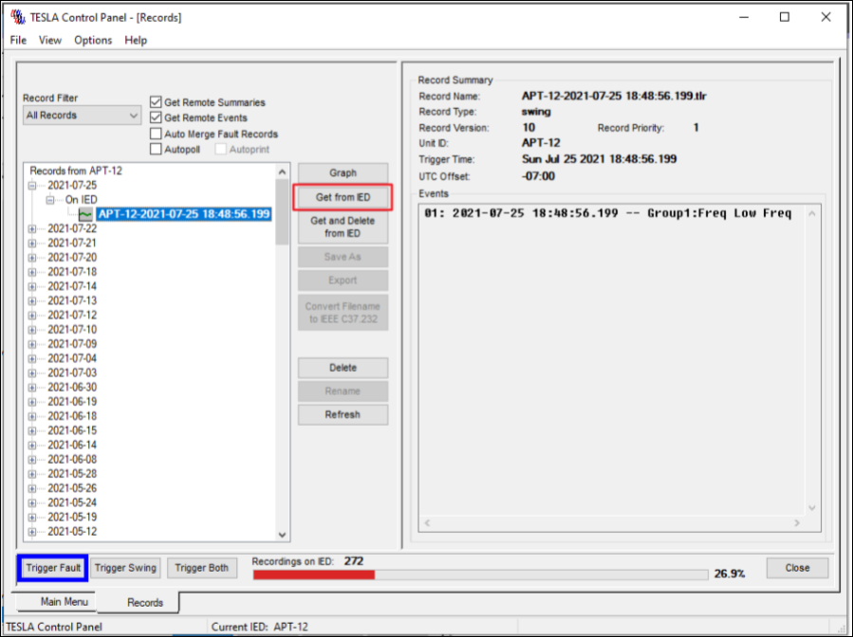.

_____5. Start a stopwatch and record time duration for the openMIC software to populate all associated relay event data.

_____ Record the type(s) of event data captured by openMIC.

_____ Target status.

_____ Sequence of Events (SOE) data SER.txt file.

_____ Fault reports HIS.txt file.

_____Oscillography files .eve (SEL Syncrowave) file.

_____6. Record the time taken for openXDA to send the associated event notification(s).

TEST PLAN: EVENT COLLECTION & NOTIFICATION
The intent of this test is to simulate differing fault conditions on the relays to model the performance of the software in various “real world” scenarios.

As part of this test different fault event types shall be simulated according to the table below.
Relay Type | Fault Type
Line Relay(s)  XFMR BU Relay  Feeder Relay | L-L Fault w/ no trip  SLG evolving to DLG Fault w/ trip
XFMR Diff Relay | L-L Fault w/ trip  SLG Fault w/ trip

_____1. Enable the 5-minute polling schedule.

_____2. Connect to SEL-4000 RTS software.

_____3. Run the simulated fault types as listed above in the RTS software.

_____4. Record and review the type(s) of event data captured by the BlueFrame software.

_____ Target status

_____ Sequence of Events (SOE) data SER.txt file

_____ Fault reports HIS.txt file

_____Oscillography files .eve (SEL Syncrowave) file

_____5. Review the associated event notification(s).

TEST PLAN: SOFTWARE STABILITY
The intent of this test plan is to test the stability of the software in a real-world scenario in which a user is connected and interrogating a relay during a schedule poll cycle.

_____1. Connect to relay 1 & 12 and read an event file during a scheduled polling window.

TEST PLAN: EXTERNAL TRIGGER EVENT COLLECTION & NOTIFICATION
The intent of this test plan is to test the functionality of the software to poll relays from an external trigger event such as a change in breaker status. Such a strategy would reduce the schedule poll interval and alleviate bandwidth on the system. This is not a test of a proposed external trigger infrastructure. At present no external trigger methodology has been defined by APS. This would need to be investigated further with the vendor.

_____1. Connect to relay 1 & 12 and change the external trigger state.

_____2. Start the stopwatch and record the time duration for openMIC to collect the relay event data from the external trigger input.

_____3. Record the time taken for openXDA to send the associated event notification(s).

TEST PLAN: SIMULATED FAULT COLLECTION AND ANALYSIS, AND NOTIFICATION
The intent of this test plan is to test the functionality of the software to perform two-terminal fault analytics to provide an increased level of fault location accuracy. To do so the software requires mapping of local and remote relays for each transmission line. At present no mapping methodology has been defined by APS. This would need to be investigated further with the vendor.

As part of this test the different fault types according to the table below shall be simulated within the line relays.

Fault Type | Fault Location
3-PH, 3 Ohms Fault Resistance | Close-in to Local End
L-L, 3 Ohms Fault Resistance | 50% to Remote End
SLG, 3 Ohms Fault Resistance | Close-in to Remote End

_____1. P&C technician to connect Doble tests kits to line relays 1 & 2.

_____2. P&C technician to import fault simulation.ss1 file.

_____3. P&C technician to run simulated fault per the table above.

_____4. Manually prompt openMIC to collect the associated relay event data.

_____5. Review the email notification from openXDA for fault location accuracy.

TEST PLAN: SYSTEM MONITORING AND ALARMING NOTIFICATION
The intent of this test plan is to test the functionality of the software to monitor and alert a defined set of users to a relay connectivity issue.

_____1. Disconnect the serial cable to Remote Access port on relay 1 & 12.

_____2. Start the stopwatch and record the time duration for openMIC to send the connectivity alert notification.

_____3. Run the connection troubleshooting functionality within openXDA to determine the root cause.

_____4. Disconnect the serial cable to Remote Access port on the SEL-2030 & SEL-36.

_____5. Start the stopwatch and record the time duration for openMIC to send the connectivity alert notification.

_____6. Run the connection troubleshooting functionality within openXDA to determine root cause.

AERS BFR’s

_____1. Complete the Business Functional Requirements table below based on observations made above.

_____2. Apply a weighted score to System Protection RFP Bid Matrix “Functional & Non-Functional Requirements” criteria.

_____3. Complete the Functionality table below based on observations made above.

_____4. Apply a weighted score to System Protection RFP Bid Matrix “Functionality” criteria.

BUSINESS FUNCTIONAL REQUIREMENTS | GPA | NOTES
Recording device event data retrieval to include HIS, targets, SOE, and Oscillography
Event data can be delineated
Fault location analytics using two terminal fault location
Push notifications via email and text message of event data and fault location to a defined set of users
Can event notification be configurable (information displayed)
Can event notifications be sent to different groups based on type/identifier (e.g. feeders)
System monitoring and alarming of available/unavailable relays.
Does notification include relay data files
Generate and track maintenance ticket for associated connectivity issue
Troubleshoot connectivity issues
Push notifications via email and text message of inaccessible IED alarms to a defined set of users
The AERS can poll relays based on an external trigger
The AERS can organize data into folders based on a descending hierarchy of substation
The AERS can enable specific applications to be launched from the software directly, i.e. SEL Synchrowave
The AERS can enable search/filtering of past events based on any of the available data
The AERS can enable multiple users to connect concurrently
The AERS can send a report of all captured event data by the following day
The AERS can send notifications within a maximum 10 mins
Weighted Score

UNCTIONALITY | GPA | NOTES
Software ease of use
Difficulty reconfiguring parameters: add/remove relay
Difficulty reconfiguring parameters: add/remove/modify user security rights
Time taken to access fault data
Time taken to connect to relay terminal session
Time taken to launch external software applications such as SEL Synchrowave
Difficulty identifying IED’s with connectivity issues
Ability to generate and track IED connectivity work orders
Software stability
Weighted Score

