1. **General Architecture**

Eaton EMCB devices are set up to communicate with the Eaton API as well as the EMCB Manager application. Figure 1 shows how these systems fit together with the cloud hosted openXDA EMCB integration.

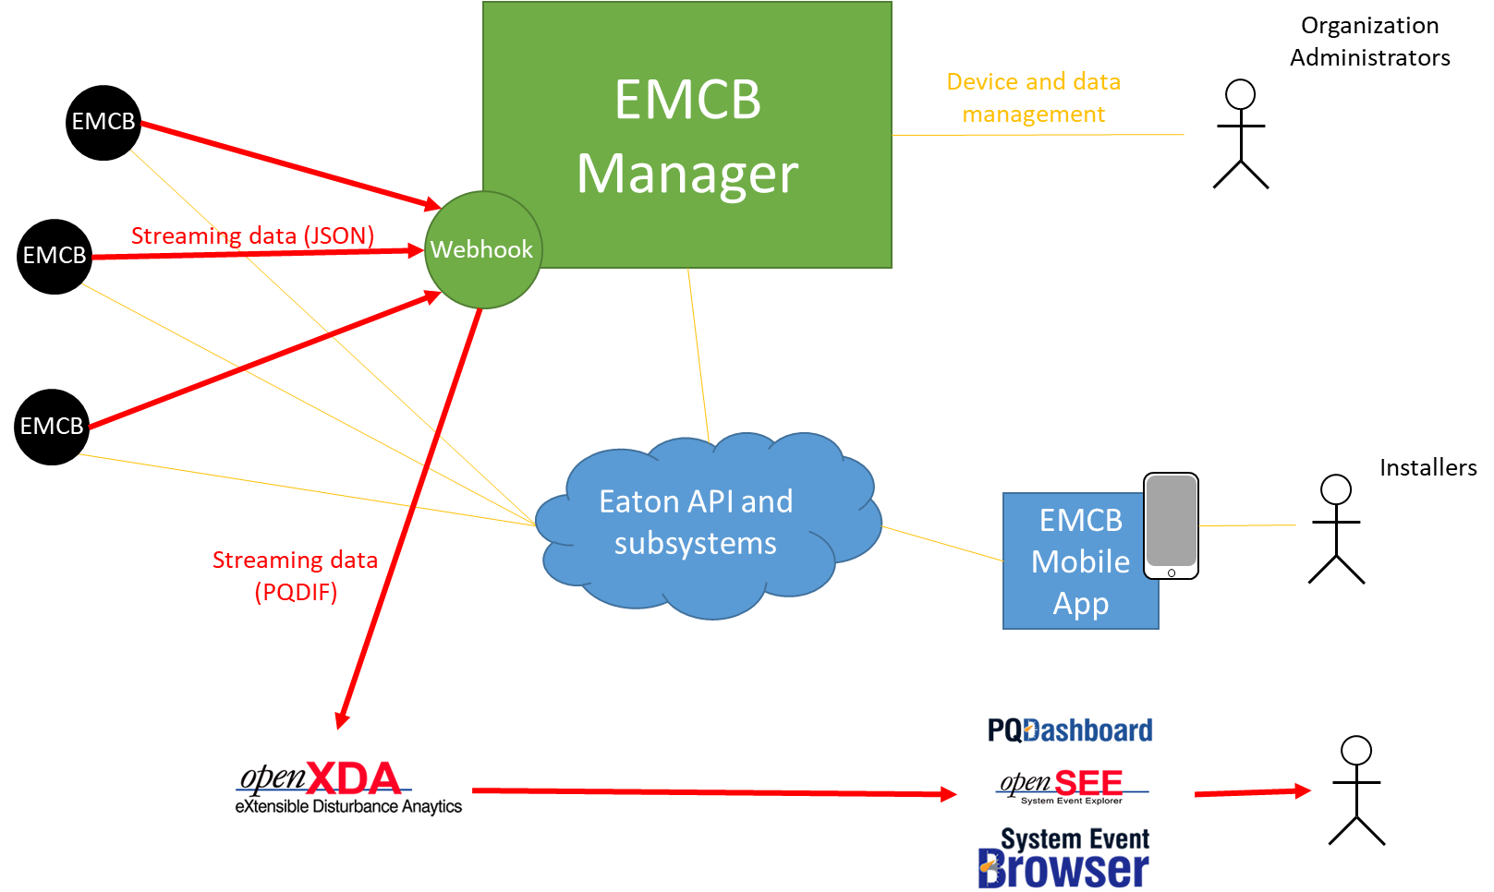

Figure 1: Architecture diagram of a system using the EMCB Manager and openXDA

Once an Installer has set up the EMCB device to communicate with the Grid Protection Alliance Organization, the data is streamed into the openXDA EMCB demonstration system and all data and analytic results are distributed to users via GPA’s visualization tools as introduced in the following Sections.

1. **Overview openXDA Suite of Tools**

The openXDA suite of tools consists of several related applications that can be deployed on premise or in the cloud. Figure 2 shows an overview of these applications.

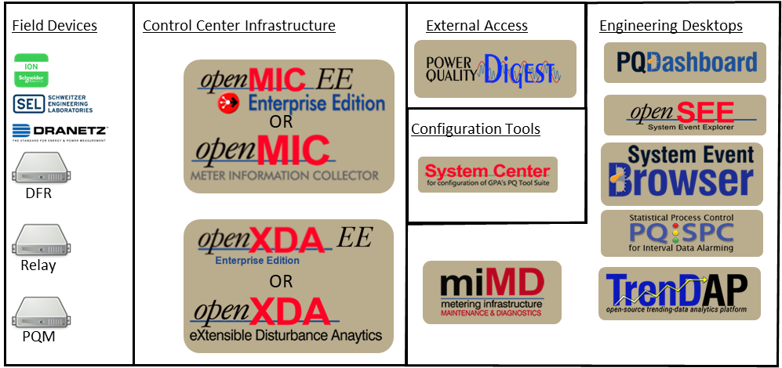

Figure 2: openXDA Suite of Tools

Together with EPRI the cloud-hosted version of the openXDA was extended to include the ability to directly ingest data from EMCB devices. This data is then processed through the openXDA data processing pipeline described in Section III, before it can be visualized in various detail through the applications described in Sections IV, V and VI.

1. **openXDA**

The openXDA application can retrieve event waveform data as well as PQ interval data from the EMCB device as described in Section I. Once the data is retrieved it is processed through the data processing pipeline. For interval data this includes:

* Collecting daily statistics
* Triggering configured alarm thresholds as appropriate
* Collecting data completeness information
* Collecting data quality information, including identifying latched values and engineering reasonability checks

For event waveform data pipeline this can include:

* Event identification
* Event cause probability identification
* Event classification
* Sag/Swell analysis
* Identification of related events recorded by other devices
* Other relevant event analysis

Further information on the analytic capabilities can be found in [1-4].

Once the data analysis is concluded all results and the original data are available for visualizations in the openXDA suite of tools Visualization applications. PQ Dashboard can give the user a wide area overview as shown in Section IV, SE Browser provides an overview of systemwide events as described in Section V, and OpenSEE provides detailed analysis for waveform events as shown in Section VI.

1. **PQ Dashboard**

The open PQ Dashboard allows users to view event and disturbance counts in a time range for their entire system or a subset of the system (called Asset Groups), broken down by EMCB Device.

Figure 3: PQ Dashboard Events tab

The Map features the location of devices and can display a heat map of disturbances to aid in analysis of time-correlated events. These heat maps can also be “animated” to watch how a disturbance spreads throughout the system.

Figure 4: PQ Dashboard map showing the geographical distribution of events

PQ Dashboard also contains visualizations and details relating to data completeness and correctness measures as described in Section III.

Figure 5: PQ Dashboard Data Correctness report

1. **SEBrowser**

SEBrowser allows for a more in-depth search of events with filters to drill into time, event type, and more. The Event Preview Pane, shown in the bottom right of Figure 5, provides details on a selected event with a variety of configurable widgets to view available data in a way that is relevant to the user.

Figure 6: SEBrowser Event Search and Event Preview Pane

SEBrowser also contains a configurable Magnitude Duration chart to plot events as well as one or more standard curves.

Figure 7: SEBrowser Mag-Dur Chart

1. **OpenSEE**

OpenSEE can visualize and analyze a single event in much greater detail. The user can choose relevant waveforms to chart and compare them to other time-correlated events or perform a growing list of ad-hoc analytics. Popup Data Tools show additional information on the waveform, including tooltips for selected points, phasor charts, and analytic information. Links to OpenSEE can be shared with other users and enable detailed analysis and collaboration between engineers.

Figure 8: OpenSEE including ad-hoc analytics and phasor chart

[1] S. Wills, C. Lackner, R. Robertson, A. Murphy, “Benefits of integrating DFR and PQ data with an asset information model that includes mapping to Planning Models, SCADA Historians, GIS databases, and Asset Management Systems,” *Georgia Tech Fault and Disturbance Conference*, May 2021  
[2] C. Lackner, B. Ernest, A. Murphy, “Use of DFR and PQ Data for Automated Restrike and Trip Coil Energization Analysis,” *Georgia Tech Fault and Disturbance Conference*, May 2021

[3] S. Wills, C. Lackner, A. Murphy, “Fault Location Analysis using PQ and DFR Data with GIS Integration,” accepted for *Georgia Tech Fault and Disturbance Conference*, May 2023

[4] G. Santos, W. Ernest, C. Lackner, A. Murphy, “Use of DFR and PQ Data for Automated Restrike and Trip Coil Energization Analysis,” accepted for *Georgia Tech Fault and Disturbance Conference*, May 2023