July 11, 2024

Mr. Leonardo Latuf
GE Vernova
4756 Rod. SC-401
Florianopolis, SC 88032-005 Brazil

RE: Maintenance Support Services for Grid Protection Alliance, Inc., Products

Dear Mr. Latuf:

Per your request, this is a quote for Grid Protection Alliance, Inc., (GPA) to provide a software license and annual support services to GE Vernova and their client(s) for the openPDC. As discussed, this license is valid for any number of instances within an operating environment (such as Substation Level).

The services to be provided by GPA are described in the attached Product Maintenance Sheet.
Support Services Pricing

Standard business day support (10 hours x 5 days a week) for the openPDC software license and annual support services is $15,000 USD.

Payment is due within 30 days of the contract signing or start date with an annual cost of $15,000 USD.

GPA has the technical experience and capability to quickly meet GE Vernova’s support needs for these products and to provide enhancements to them as your synchrophasor systems mature.

We look forward to this opportunity to provide support services to GE Vernova. This offer is valid until September 30, 2024. If you have any additional questions, please do not hesitate to get in touch with me at (570) 637-7161 or clackner@GridProtectionAlliance.org.
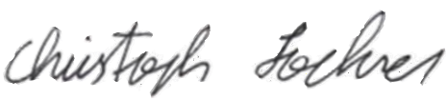
11-Jul-2024
Quote Authorization: Date:
Dr. Christoph Lackner, Operating Officer and Lead Engineer
Grid Solutions | Grid Protection Alliance, Inc.

Please sign, date, and return this quote to accept.

Quote Acceptance: Date:

