Problems with new install of XDA 3.0

1. Email not processing properly. Incorrect meters associated with faults.
2. 
3. Cannot create meter in system center. Add screen pops up the disappears – will need to check browser dev tools
4. Calculating fault distance incorrectly for SEL relays should have fault distance of 4.36 miles 
5. Not calculating presenting fault distance and other information in email
6. 
7. Pqview just spins when loading – Assuming this is the PQView Sites page in System Center, this page is being removed.
8. Screen blanks when clicking “fault”on the opensee preview from sebrowser - 1353
9. Fault button gives runtime error in opensee - 1330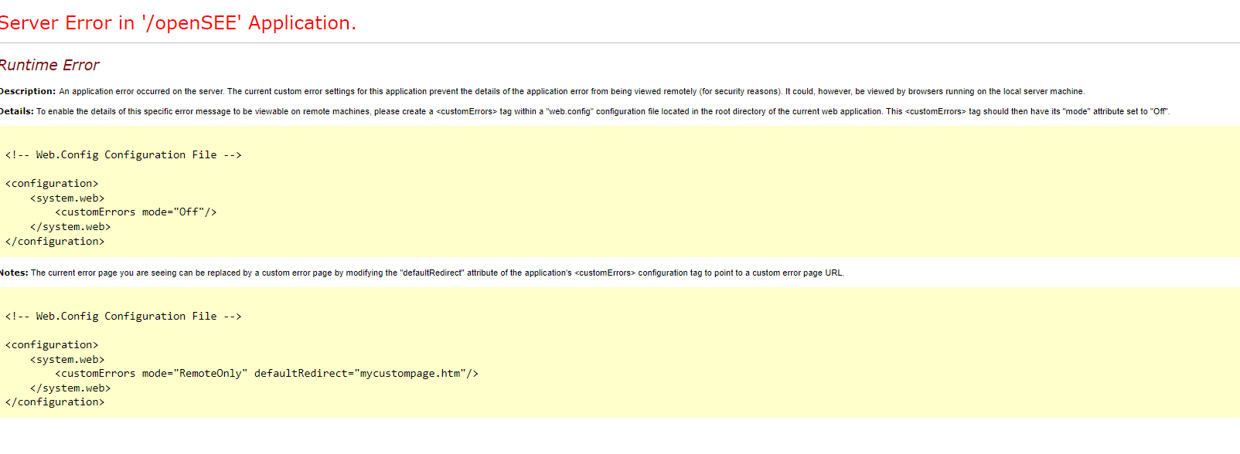
10. Show correlated sags in Opensee produces flashing banner – 1262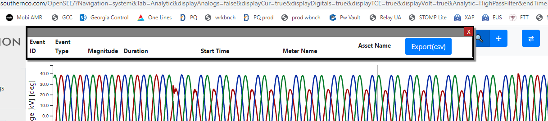
11. There doesn’t seem to be much on the event notifications page. I remember more. – it appears as though you are not an admin

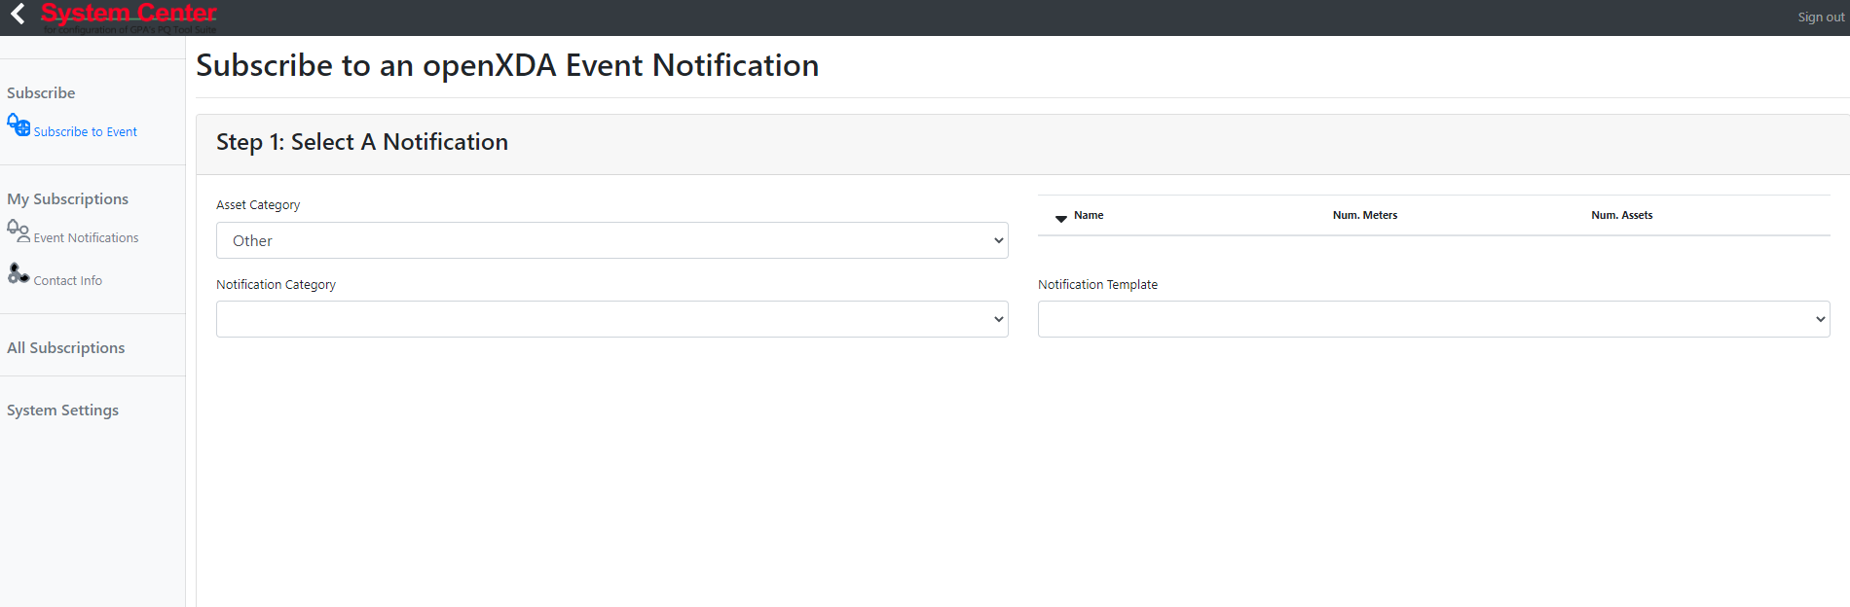

1. Events seem to be processing only as “fault” or “other” – Will need to look at 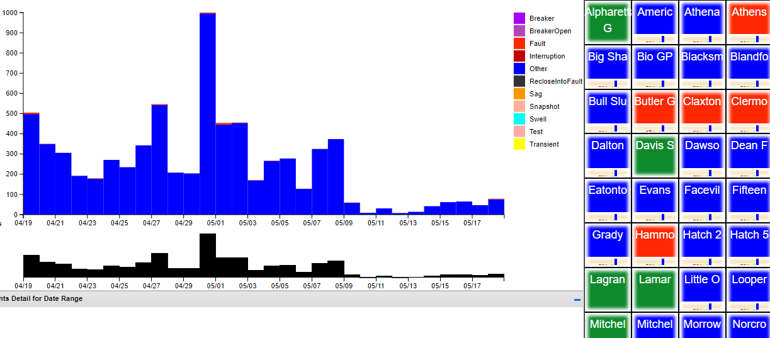
2. The preferences for waveform display are not being saved. They default to RMS each time. – Fix in progress.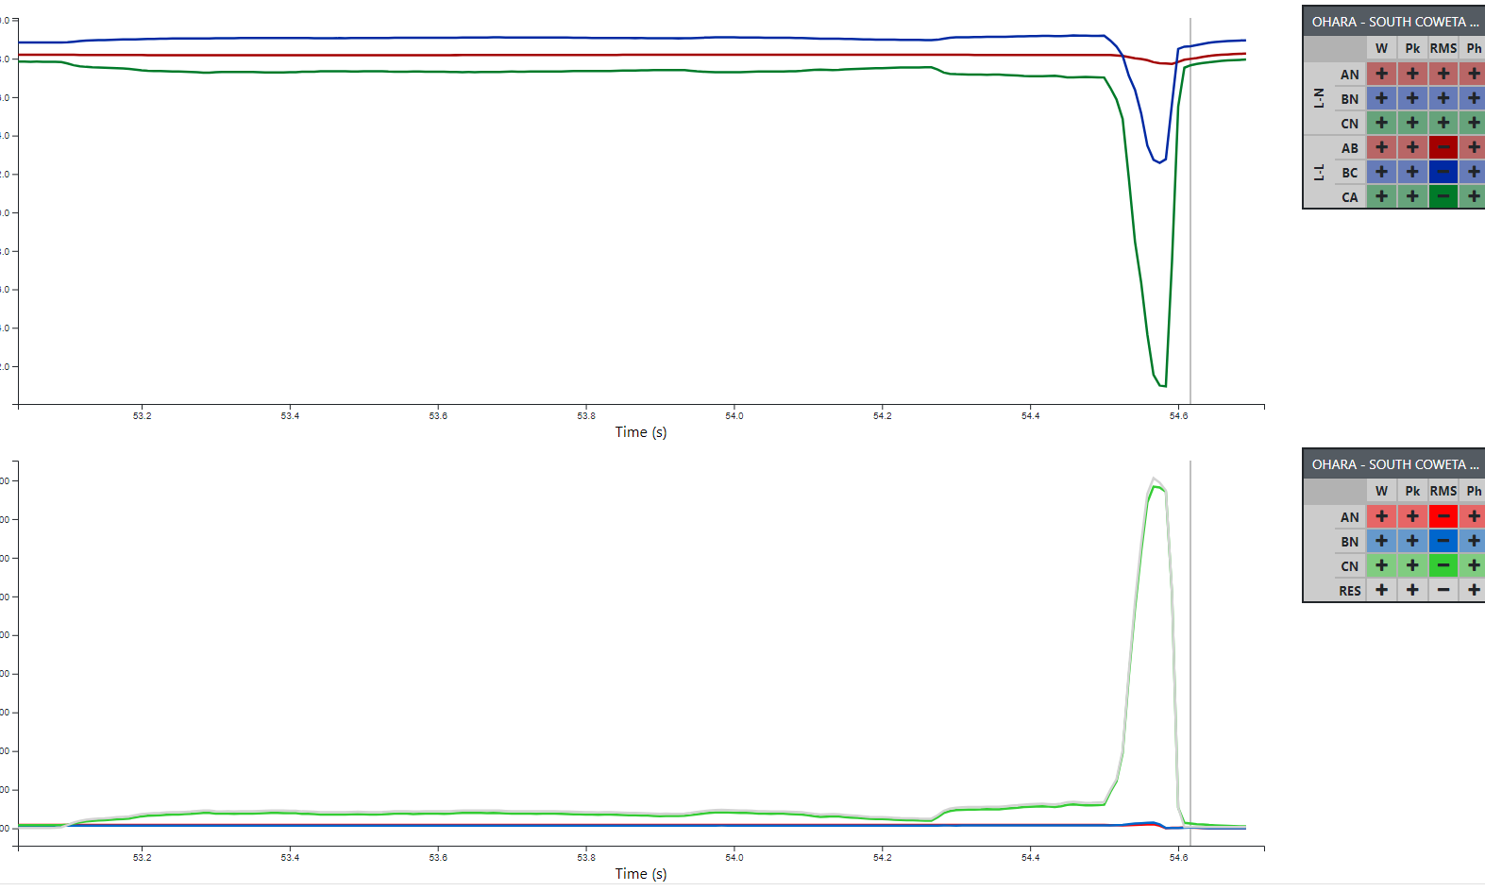
3. The faults are not selectable in the lower menu for faults shown in the upper menu.
4. 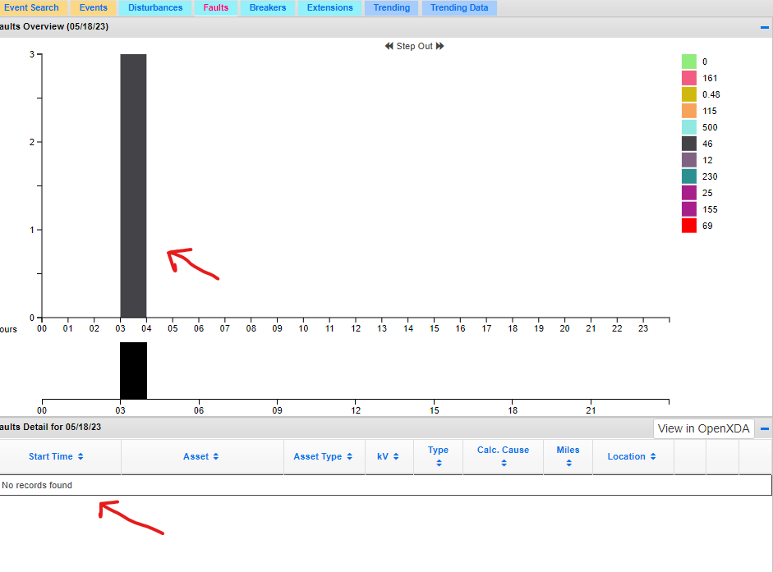
5. END