Grid Protection Alliance, Inc., Partner Agreement
(“AGREEMENT”)

THIS Partner AGREEMENT (this “Agreement”) is made and entered into as of the date last signed by the parties below (“Effective Date”), by and between Grid Protection Alliance, Inc., a Delaware Corporation, having a principal place of business at 1100 Market Street, Suite 906B, Chattanooga, TN 37402 (“Grid Protection Alliance” or “GPA”), and the partner identified below (“Partner”).

PARTNER:
Name: Lifescale Analytics, Inc.
Address: 1915 Hwy 36 West
City: Roseville State: MN Zip: 55113
Phone Number:(763) 561-4990
Fax Number: None
Contact Email: info@lifescaleanalytics.com
TERRITORY:
- Utility and Energy Industry
PRODUCTS:
- GPA Open XDA Product Suite and all other associated products
MAINTENANCE AND SUPPORT SERVICES:
- GPA, or its authorized support partners, will provide product support in the form of annual maintenance/software subscription in accordance with GPA’s End User Agreements.
PRICING:
- Prices for the Support Services are based on GPA’s then-current applicable pricing (Exhibit A). GPA will provide 50 percent (50%) of Gross Revenue for the First Year to Partner of any New Clients. Applicable preferred discount provided to Clients will be mutually agreed upon in writing by the parties.

IN WITNESS WHEREOF, the parties’ authorized representatives have executed this Agreement as of the Effective Date.

Grid Protection Alliance, Inc. Partner:

Name: Christoph Lackner  Title: Operating Officer  Date: January 26, 2022 | Name: ______________________________________  Title: ________________________________________  Date: _______________________________________

DEFINITIONS
- “Affiliates” means, with respect to a corporation or other entity, any entity or person that directly or indirectly controls, is controlled by, or that is under common control with that corporation or entity. For purposes of this definition, “control” shall mean ownership of greater than 50% of the voting securities of the corporation or entity.

- “Agreement” refers to and includes this Systems Integrator Partner Agreement, the General Terms and Conditions, and the Exhibits, all of which taken together govern the rights and obligations of GPA and Partner.

- “Bundled Solution” means combinations of copies of Software, Maintenance and Support Agreements, and Partner Products sold to End Users as single packages as described on Exhibit A.

- “Contract Year” means a year beginning on the Effective Date of this Agreement and on each anniversary of the Effective Date thereafter during the Term of this Agreement.

- “D&E Copies (Demonstration & Evaluation)” mean the copies of GPA Products provided to Partner.

- “Development License” means the license of Software used in, and limited to, the development of Partner Solutions.

- “Documentation” means the operating instructions, user manuals, read me files, and all technical information and reference materials, in whatever form, provided by GPA and found at GridProtectionAlliance.org and any applicable GitHub repositories, publicly available and owned by GPA.

- “Effective Date” means the date first written above.

- “End User” means a customer of Partner that licenses Partner Products and Bundled Solutions for use in its internal business operations and not for distribution or relicense. End Users shall not include Partner itself or its Affiliates.

- “End User Evaluation License” means the license of Software used by Partner to enable the End User to evaluate Partner Products.

- “Partner Solutions” means the computer hardware, software, or services that Partner provides to produce the Bundled Solution.

- “Software” means GPA's software products in object code form and related product documentation, each as more fully described in this Agreement as identified in Exhibit A, and any updates and modifications to such products that may be provided by GPA from time to time.

- “Sublicense Annual Subscription Fees” means the fees payable by Partner in connection with each sublicense of the Software granted by Partner as part of the licensing of the Partner Solution.

- “Support” means end user technical support, software diagnosis, and software problem analysis and resolution provided over the telephone, via e-mail, or by other remote electronic means, and the provision of Updates, bug fixes, and other related services, as described at GridProtectionAlliance.org

- “Territory” means the geographical region and/or market segment described in Agreement in which Partner has rights to distribute and implement Partner Solutions.

- “Updates” means maintenance releases, improvements, and enhancements to the Software or Documentation, which are generally, provided by GPA to current maintenance customers. Updates do not include those releases for which GPA charges a separate or additional fee.
- LICENSE AND DELIVERY

- Development License. GPA will provide to Partner the Software listed in Agreement. The Software shall be used by Partner for internal development purposes only and shall not be used to run the internal operations of Partner or for the benefit of any third party, nor shall the Software be provided to any third party (except as set forth in Section 2(b) below).

- Distribution of Licenses. During the term of this Agreement and subject to its terms and conditions, GPA grants to Partner a non-exclusive right to market, distribute, and sublicense the Software that is Open Source or covered under GPA’s standard Enterprise Edition Licensing to End Users within the Territory, provided that Partner may market, sublicense, and distribute the Software combined with Partners Standard Consulting Services, and /or as part of a Bundled Solution to its End User

- Qualified Opportunities. During the term of this Agreement and subject to its terms and conditions, Partner may refer potential customers to GPA, for GPA to sell directly to, using the Opportunity Registration Form provided in Exhibit B to this Agreement). If (i) such referred opportunity has not already been registered as a direct sales or otherwise referred opportunity; and (ii) GPA determines in its sole discretion that such opportunity otherwise meets all of GPA’s then-current standard opportunity registration requirements, then such opportunity is a “Qualified Opportunity.” In the event that (a) Partner refers a Qualified Opportunity to GPA, (b) such Qualified Opportunity executes an agreement to purchase any of GPA’s products, and (c) Partner reasonably assists and supports GPA through the applicable sales cycle, (each, a “Qualified Sale”) then GPA shall pay Partner the amounts according to the Pricing in this Agreement. For clarity, GPA will only pay Partner for Qualified Sales to net new name customers and not applicable to ongoing renewals or for anything else.
- Demonstration and End User Evaluation Licenses. Partner may make a reasonable number of copies of the Software for the purpose of demonstrations or evaluation at Partner locations and at trade show, user group, or seminar presentations or by Partner sales representatives. Partner also may install up to the number of copies of the Software set forth in the Agreement at an End User locations for End User evaluation. Demonstration and End User evaluation copies of the Software may not be rented, leased, transferred, distributed or assigned by Partner in any manner.

- PARTNER OBLIGATIONS

- GPA Attribution; Compliance. Partner shall not remove or alter any copyright, trademark, patent or other proprietary notices contained in the Software. Partner shall provide GPA with a reasonable number of copies of the Partner Products and any related documentation and collateral upon request with the right to use such products solely to verify compliance with this provision and the licensing restrictions contained in this Agreement.

- GPA Reputation and Goodwill. Partner agrees to use GPA’s correct product names and trademarks for the Software, solely in accordance with GPA’s trademark and branding guidelines, and shall not knowingly make false or misleading representations with regard to the Software or GPA. Partner further agrees to conduct business in a professional manner and act in good faith with respect to the Software and the good reputation of GPA.

- MARKETING ACTIVITIES

- Publicity. Neither party will issue any public announcement nor publish any materials that reference or discuss the other party or its products without the prior written consent of the other party. Partner shall not disclose the terms of this Agreement to any third party without the prior written consent of GPA.

- Joint Marketing. In addition to the marketing benefits and requirements outlined in this Agreement, during the term of this Agreement, Partner and GPA may mutually agree from time to time to engage in joint marketing activities which promote their products including seminars, press announcements, trade shows, user groups or other events.
- SUPPORT and services

- GPA Support to Partner’s End Users. GPA will provide Support, including all Updates for Software, directly to End Users, solely to the extent described in GPA’s then-current support and maintenance terms and solely while all applicable fees have been paid for each license subscription term. Partner shall require all End Users to first contact GPA for all support and maintenance requests. GPA shall not be responsible for providing Support with respect to Partner Products. Any error or other problem arising from an End User’s use of Partner Products shall be referred to Partner, and GPA shall have no further obligation with respect to such error or problem.

- FEES AND PAYMENT

- Direct License Annual Subscription Referral Fees. When an End User prefers to license and contract directly with GPA and not purchase through the Partner, GPA shall pay to Partner an amount equal to Direct License Annual Subscription Referral Fee of 50 percent (50%) of the first year maintenance and support agreement as specified Exhibit A, of the annual subscription fees actually paid to GPA by each End User for the first year, within sixty (60) days of payment received by the End User.

- Terms of Payment. All payments made hereunder shall be in U.S. Dollars. Partner shall pay GPA in full within thirty (30) days of the date of receiving payment from End User.

- Audit. At any time, GPA may, upon five (5) days written notice and not more than once in each 12-month period, examine Partner's books and records related to the amounts due to GPA. Such examination may be done, at GPA's expense, by GPA or its certified public accounting firm, provided, however, that if any such audit uncovers one or more underpayments in excess of five percent (5%) of the total amount determined by the audit to be payable to GPA for the audit period, Partner shall immediately reimburse GPA for the full costs of such audit and the amount of underpayment, if any, uncovered during the course of the audit.

- TERM AND TERMINATION

- Initial Term. This Agreement and the licenses granted under it shall remain in effect from the Effective Date of this Agreement shall automatically renew for subsequent one-year terms unless terminated in accordance with the terms of this Agreement.

- Termination for Cause. Either party may terminate this Agreement by giving written notice to the other party if such other party fails to perform or comply with this Agreement or any provision hereof. Such termination shall be effective, in the case of non-payment of fees by Partner, ten (10) days after delivery by GPA of written notice. In all other events, termination shall be effective thirty (30) days after written notice from the non-breaching party unless the occurrence giving rise to the right of termination and its adverse effects have been cured to the reasonable satisfaction of the non-breaching party prior to the expiration of such thirty (30) day period. The right to cure shall not apply to a failure to achieve minimum annual quotas.

- Termination without Cause. After the Initial Term, either party may terminate this Agreement at any time without cause by providing the other with notice as set forth in this Agreement.

- Bankruptcy. This Agreement shall terminate automatically if (i) Partner files or has filed against it a petition under any applicable law relating to insolvency or the protection of creditors, (ii) Partner makes an assignment for the benefit of creditors or (iii) a receiver or similar official is appointed for all or a substantial portion of Partner's assets.

- Effects of Termination. Upon termination of this Agreement for any reason, all rights and licenses granted under this Agreement shall terminate and revert to GPA, except that sublicenses of the Software granted by Partner to End Users in accordance with this Agreement as of the date of termination will remain in effect in accordance with their terms and conditions. Upon termination of this Agreement for any reason, Partner shall (i) cease using all Demonstration and Development Licenses and Documentation; (ii) cease issuing any End User Evaluation Licenses, sales literature and other written information and materials supplied by GPA pursuant to this Agreement or which contain GPA’s trademarks; (iii) cease issuing new sublicenses of Software; (iv) return to GPA all copies of the Software, sales literature and other written information and materials supplied by GPA pursuant to this Agreement or which contain GPA’s trademarks; and (v) no longer identify or hold itself out as an authorized partner or distributor of the Software.
.
- CONFIDENTIAL INFORMATION

- “Confidential Information” means all information related to the business of GPA or Partner (“the disclosing party”) that may be obtained by GPA or Partner (“the receiving party”) from any source as a result of this Agreement, provided that if written, the information is clearly identified as proprietary or confidential, and if oral, shall be followed by a written summary of such oral communication within fifteen (15) days of the date of disclosure. Confidential Information includes (but is not limited to) source code, algorithms, concepts, pricing information, business methods, business and technical plans, research and test results, including the results of any performance or benchmark tests or evaluation of the Software. Information relating to End Users is Confidential Information. Confidential Information does not include information that the receiving party can demonstrate through written documentation (i) is or becomes publicly available through no act or omission of the receiving party; (ii) the disclosing party discloses to a third party without restriction on further disclosure; (iii) is rightfully disclosed to the receiving party by a third party without restriction on disclosure; (iv) is independently developed by the receiving party without access to the disclosing party’s Confidential Information; or (v) is previously known to the receiving party without nondisclosure obligations.

- Nondisclosure. Each party agrees that it will not disclose to any third party any Confidential Information belonging to the other party without the other party's prior written consent. Each party agrees that it will not use the Confidential Information of the other party except as authorized in the Agreement. Each party further agrees that it will maintain the confidentiality of all Confidential Information of the other party and prevent the unauthorized disclosure or use of any Confidential Information by its clients, customers, employees, subcontractors or representatives. In no event shall any party use less care to maintain the Confidential Information of the other party than it uses to maintain the confidentiality of its own similar non-public information. Each party further agrees to notify the other in writing of any misuse or misappropriation of the other party’s Confidential Information that may come to its attention.

- IDEMNIFICATION

GPA will defend and settle at its own expense, and will indemnify Licensee/Partner for any damages or expenses including reasonable attorneys’ fees resulting from, any action brought against the Licensee/Partner by an unaffiliated third party to the extent that it is based on a claim that the Software infringes any U.S. patent issued as of the date of the Agreement, or any copyright or trade secret of a third party in any jurisdiction in which Licensee/Partner is licensed by GPA to use or distribute the Software, provided that: (i) GPA is promptly notified in writing of the claim; (ii) GPA has sole control of the defense and any negotiations for its settlement; and (iii) Licensee/Partner provides GPA, at GPA’s expense, with all reasonable assistance, information, and authority necessary to perform the above.

Licensee/Partner will indemnify GPA for any and all damages, settlements, reasonable attorneys’ fees and expenses based on any action brought against GPA to the extent that it is based on a claim based on misrepresentations made by Licensee/Partner about the performance or operation of the Software that differ from those found in GPA’s Documentation and marketing material, provided that: (i) Licensee/Partner is promptly notified in writing of the claim; (ii) Licensee/Partner has sole control of the defense and any negotiations for its settlement; and (iii) GPA provides Licensee, at Licensee’s/Partners expense, with all reasonable assistance, information, and authority necessary to perform the above.

FOR ANY BREACH OF THE Software WARRANTY DESCRIBED ABOVE, LICENSEE’S ENTIRE REMEDY AND GPA’S ENTIRE LIABILITY SHALL BE LIMITED TO REPAIR OR REPLACEMENT of the SOFTWARE OR, IF SUCH REPAIR OR REPLACEMENT IS INADEQUATE AS A REMEDY OR, IN GPA’S OPINION, NOT COMMERCIALLY REASONABLE, TO A REFUND OF THE LICENSE FEES paid for the Software.

NEITHER GPA NOR LICENSEE WILL BE LIABLE, UNDER ANY CONTRACT, TORT, STRICT LIABILITY OR OTHER THEORY, FOR ANY SPECIAL, PUNITIVE, INDIRECT, INCIDENTAL OR CONSEQUENTIAL DAMAGES INCLUDING, BUT NOT LIMITED TO, LOSS OF OR DAMAGE TO DATA, LOSS OF ANTICIPATED REVENUE OR PROFITS, WORK STOPPAGE OR IMPAIRMENT OF OTHER ASSETS, WHETHER OR NOT FORESEEABLE AND WHETHER OR NOT A PARTY HAS BEEN ADVISED OF THE POSSIBILITY OF SUCH DAMAGES. EXCEPT AS stated IN SECTION 5 ABOVE, IN NO EVENT SHALL GPA’S LIABILITY under the agreement EXCEED THE TOTAL AMOUNT ACTUALLY PAID TO GPA BY LICENSEE UNDER THE AGREEMENT.

- Taxes. All fees charged by GPA and payable by Licensee are in U.S. dollars and do not include taxes. If GPA is required to pay any sales, use, value-added or other taxes based on transactions under this Agreement (other than taxes based on GPA’s income), such taxes shall be billed to and paid for by Licensee.

- Export. Licensee acknowledges that the Software, the Confidential Information of GPA and all Documentation and other technical information delivered pursuant to the Agreement (collectively, “Technical Data”) are subject to export controls under U.S. laws including but not limited to the Export Administration Act and the regulations promulgated thereunder. Licensee agrees to (a) comply strictly with all legal requirements established under these controls, (b) cooperate fully with GPA in any official or unofficial audit or inspection that relates to these controls, and (c) not export, re-export, divert, transfer, or disclose directly or indirectly, any Technical Data to any country, or to the nationals of any such country, which the U.S. government determines is a country to which such export, re-export, diversion, transfer, or disclosure is restricted, without obtaining the prior written authorization of GPA and the applicable U.S. government agency. Any breach of this provision shall be considered a material breach of the Agreement.

- Force Majeure. Neither party shall be responsible for any delay in its performance due to causes beyond its reasonable control.

- Assignment. Licensee may not assign, delegate or otherwise transfer the Agreement or any of its rights or obligations to a third party and any such attempted transfer shall be void. Notwithstanding the foregoing, Licensee may assign, upon written notice to the GPA, its rights and obligations under this Agreement to the surviving corporation in any merger or consolidation to which it is a party or to any entity which acquires all or substantially all of its capital stock or assets, provided that such entity is not a competitor of GPA. GPA may freely transfer and assign this Agreement.

- Amendment and Waiver. Any waiver, amendment or modification of any provision of this Agreement must be in writing. No waiver or consent shall constitute a continuing waiver or consent or commit a party to provide a waiver in the future except as specifically set forth in writing. The failure of either party to exercise any right provided for by this Agreement shall not be deemed a waiver of that right.

- Notices. All notices and other communications required or permitted under this Agreement shall be in writing, addressed to the Chief Financial Officer of the party being notified at its address first written above, and shall be deemed given: (a) upon receipt when delivered personally, (b) upon confirmation of receipt following delivery of registered or certified mail, return receipt requested, or (c) upon delivery by a recognized overnight courier service which provides confirmation of delivery.

- Attorneys’ Fees. If either party to this Agreement shall bring any action, suit, counterclaim, appeal, arbitration or mediation against the other regarding the terms of this Agreement, the losing party shall pay to the prevailing party a reasonable sum for attorneys’ fees and costs as determined by the Court, arbitrator or mediator.

- Authority to Sign. Each person signing this Agreement represents and warrants that he or she is duly authorized and has legal capacity to execute and deliver this Agreement. Each party represents and warrants to the other that the execution and delivery of this Agreement and the performance of such party’s obligations have been duly authorized and that the Agreement is a valid and legal agreement binding on the party and enforceable according to its terms.

- Governing Law. This Agreement shall be deemed to have been made in, and shall be construed under, the laws of the State of Tennessee without regard to its conflicts of laws provisions. Licensee agrees that the federal or state courts of Tennessee shall have the sole and exclusive jurisdiction over the matter.

- Survival of Obligations. The following obligations will survive termination of the Agreement for any reason: (a) all obligations relating to non-use and nondisclosure of Confidential Information; (b) all obligations relating to indemnification and protection of proprietary rights; (c) all obligations to make payments of amounts that are or become due under this Agreement prior to termination; (d) all obligations regarding maintenance of records for tracking sublicense fees owing to GPA; and (e) all provisions regarding the limitations of warranty, remedy and liability.

- Severability. Wherever possible, each provision of the Agreement shall be interpreted in such a way as to be enforceable and valid under applicable law. If any term or provision of this Agreement is determined to be illegal, unenforceable, or invalid in whole or in part for any reason, that provision shall be stricken from this Agreement and shall not affect the legality, enforceability or validity of the remainder of this Agreement.

- Entire Agreement. The Agreement, including the General Terms and Conditions and attached Exhibits, constitutes the entire agreement between the parties, and supersedes all prior oral or written agreements or communications with regard to the subject matters described. No additional or conflicting term in a purchase order or other document shall have any effect on the terms of this Agreement.

EXHIBIT A

Grid Protection Alliance Product Suites and Pricing

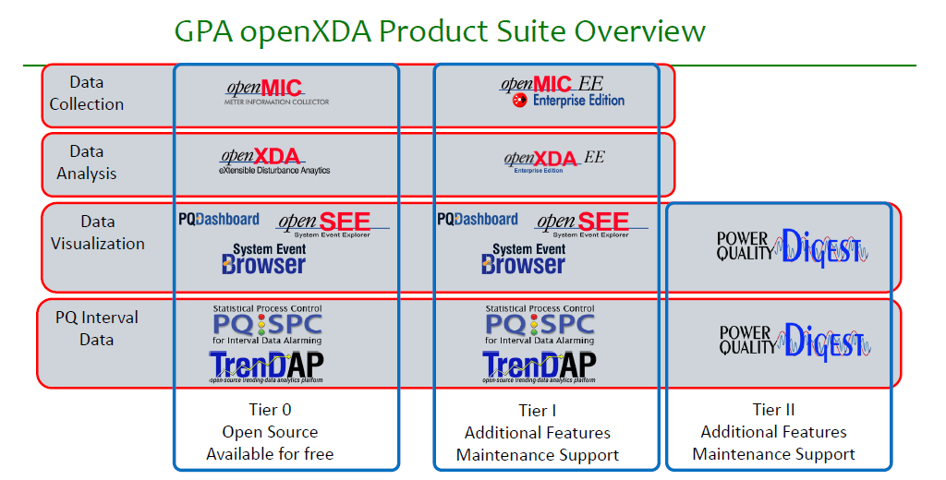

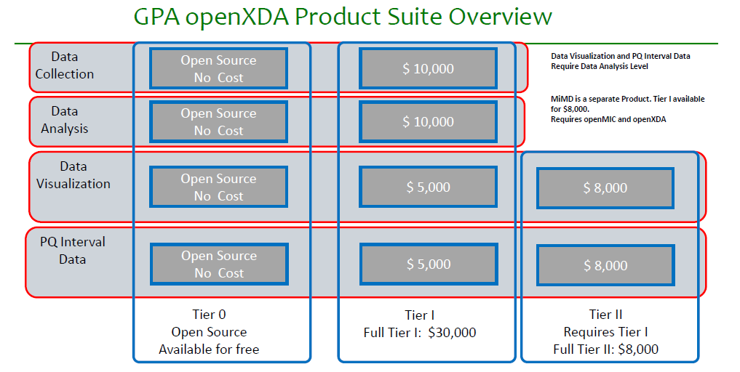
EXHIBIT B

opportunity registraton FORM

Prospect Company Name __________________________________________________

Prospect Address __________________________________________________

__________________________________________________

__________________________________________________

Prospect Email/Phone/Fax __________________________________________________

Prospect Primary Contact Name __________________________________________________

Prospect Primary Contact Title __________________________________________________

Prospect Functional Area __________________________________________________

Date of Initial Prospect Contact __________________________________________________

Requester Contact/Location __________________________________________________

Anticipated Purchase Amount __________________________________________________

Description of Opportunity __________________________________________________

__________________________________________________

__________________________________________________

__________________________________________________

__________________________________________________

__________________________________________________

Anticipated Purchase Date __________________________________________________

GPA Sales Manager Approval __________________________________________________

Extension Date (if approved) __________________________________________________

Accepted by:

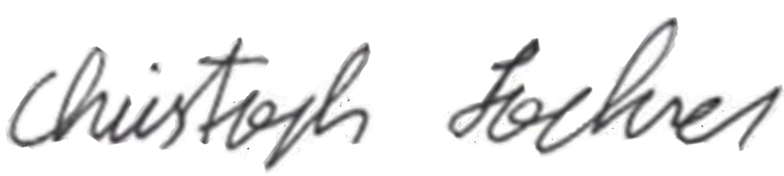
Partner: GPA:

__________________________________ ___________________________________
Authorized Signature Authorized Signature

Name: _____________________________ Name: Christoph Lackner

Title: _____________________________ Title: Operating Officer

Date: _____________________________ Date: January 26, 2022

