May 23, 2025

Mr. Guido Coletto
cc: Mr. Cosimo Pisani
Terna Rete Italia SpA
Via Attilio Benigni 21
00156 Roma, Italy

RE: Maintenance Support Services for Grid Protection Alliance, Inc., Products

Dear Mr. Coletto:

Per your request, this is a quote for Grid Protection Alliance, Inc., (GPA) to provide annual support services to Terna for Stream Splitter, described below. In addition, this quote includes hours for the development of a custom solution capable of handling 3 kHz SEL C37.118 modified streams.

Coverage

This agreement covers an additional instance of Stream Splitter for maintenance and support

Terna’s existing agreement covers a single instance of openPDC through October 16, 2025.

Terna is granted a perpetual, non-exclusive, non-transferable license to use the latest version of the software released during the term of this agreement at no cost. Support is provided for the deployment of new versions and patches during the term of this agreement.
The services to be provided by GPA are described in the attached Software Support & Maintenance Agreement Terms & Conditions.

Operating Environment

This agreement is valid for one (1) operating environment, where an “operating environment” is defined as one or more instances monitoring the same data in the same context (e.g., Substation vs. Control Room, Transmission vs. Distribution, etc.), and an “instance” is defined as a separate installation (e.g., failover clusters; production, acceptance, and test; etc.).

Pricing

One (1) year of business day support for the openPDC annual support services is priced at $2,500 USD. Payment is due within 30 days of the contract signing or start date.

Time and Materials

GPA will provide time and materials development hours toward the development of a custom solution capable of handling 3 kHz SEL C37.118 modified streams. GPA proposes forty (40) hours of development time at previously established GPA labor rates to complete this.

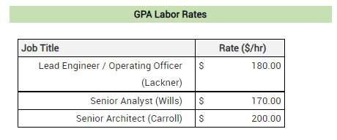

All work will be performed by J. Ritchie Carroll (Senior Architect), Stephen Wills (Senior Analyst), or Dr. Christoph Lackner (Lead Engineer). Terms of payment are net 30 days.

GPA has the technical experience and capability to quickly meet Terna’s support needs for these products and to provide enhancements to them as your synchrophasor systems mature.

We look forward to this opportunity to provide support services to Terna. This offer is valid until August 30, 2025. If you have any additional questions, please do not hesitate to get in touch with me at (570) 637-7161 or clackner@GridProtectionAlliance.org.

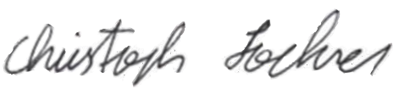
23-May-2025
Quote Authorization: Date:
Dr. Christoph Lackner, Operating Officer and Lead Engineer
Grid Solutions | Grid Protection Alliance, Inc.

Please sign, date, and return this quote or issue a purchase order to accept.

Quote Acceptance: Date:

