openFLE
open source Fault Location Engine
Software ID Number

Add NQA Logo from Auto Text for NQA Reports.(Select Insert>AutoText)

openFLE
open source Fault Location Engine
Software ID Number
Software Manual, September 2012

DISCLAIMER OF WARRANTIES AND LIMITATION OF LIABILITIES
INSERT APPROPRIATE DISCLAIMER AUTOTEXT FOR EPRI.

Acknowledgments
The following organization(s), under contract to the Electric Power Research Institute (EPRI), prepared this report:
Grid Protection Alliance
1206 Broad Street
Chattanooga, TN 37402
Principal Investigator
F. Robertson
Organization 2
Address 2
City, State Zip
Principal Investigator
I. Last
This report describes research sponsored by EPRI. <In most cases, reports should indicate EPRI only as the “sponsor.” If there is a desire to acknowledge funders, insert the following sentence: EPRI would like to acknowledge the support of the following organizations: [list]>.
Insert any additional acknowledgment statements here.

Software Description
The openFLE software analyzes input event files in COMTRADE or PQDIF format, combined with power system parameters, to produce a distance to the fault along the specified line.
Description
The openFLE software is an open source project. It is managed on a CodePlex website at http://openfle.codeplex.com and is available free of charge under the Eclipse Public License.
Benefits and Value
The openFLE software offers the following:
- The ability to read data files in IEEE standard COMTRADE or PQDIF formats with no proprietary vendor software
- The ability to analyze waveform data from input files combined with system parameters to determine a fault presence, type, and distance
- Can be incorporated into data retrieval processes for automated fault location
Platform Requirements
- Windows Server 2008, Windows 7, Windows XP, or Windows Vista
- 800 MHz processor
- 512 MB of memory
- 5 MB of free hard drive space
- .NET Framework 4.0 installed or allowed to be installed
Keywords
List the keywords here.

Additional Front Matter Section(s)
To create additional Front Matter sections such as this, place the cursor to the left of the paragraph mark at the beginning of the previous Section Break format marker, select Insert Break, choose Section Break Types Odd Page.
Type the desired Front Matter Section Title and hit Return twice. Highlight the Front Matter Section Title and apply Section Title Only style.
Place the cursor to the left of the second paragraph mark, begin typing text, and then apply Body Text style to the text.
Subheading (apply EPRI Subheadings style)
Any subheadings created in Front Matter Sections (other than the Product Description/Report Summary) must be styled with EPRI Subheadings Style.
To delete this section, highlight the Section Title through and including the section break below and hit the Delete key.
If the report contains a Product Description or Report Summary, place it here, followed by any other appropriate Front Matter material such as a glossary.

Contents
1 Introduction 1-1
2 Installing the OpenFLE 1-2
Installation of EPRI Software at Client Site 1-2
If you experience difficulties accessing the application 1-2
System Requirements 1-2
Installation Procedure 1-3
3 Using the OpenFLE 1-1
Tutorial 1-1
Running the openFLE Manager 1-1
Input fields and controls in the Manager window 1-3
Folders 1-4
Fault Detection 1-6
Fault Location 1-7
Units 1-8
Fault Detection and Fault Location Algorithm drop down selections 1-9
Control Buttons 1-11
Closing the openFLE Manager 1-13
Stopping the openFLE service 1-14
Perform Fault Location 1-14
1 References and Bibliographies 1-1
References 1-1
Bibliography 1-1
Glossaries and Indexes 1-1
Glossaries 1-1
Indexes 1-1
A Example of input xml file A-1
This is the XML Event File Definition (system parameter file) for Example Event A-1
B Examples of output files in results folder B-2
CycleData - This is a portion a “cycleData” output file. B-2
This a portion of a measurement Data output file. B-3
Log File – this is the openFLElog file B-3
Results File – this is the Example_openFLEresults.xml file B-4

List of Figures
Figure 2-1 Extract openFLE Install Package 1-2
Figure 2-2 openFLE Install Package Destination 1-3
Figure 2-3 Start openFLE Installation 1-3
Figure 2-4 openFLE Installer: Download .NET Framework 4.0 Error 1-4
Figure 2-5 .NET Framework 4.0 Download Web Page 1-4
Figure 2-6 Microsoft Suggestions 1-5
Figure 2-7 File Download 1-5
Figure 2-8 .NET Framework 4.0 Installer: Download Progress Window 1-6
Figure 2-9 .NET Framework 4.0 Installer: Initialization Progress Windows 1-6
Figure 2-10 .NET Framework 4.0 Installer: Welcome to Setup Window 1-6
Figure 2-11 .NET Framework 4.0 Installer: Download and Install Progress Windows 1-7
Figure 2-12 .NET Framework 4.0 Installer: Setup Complete Window 1-8
Figure 2-13 openFLE Installer: Welcome Window 1-10
Figure 2-14 openFLE Installer: Select Installation Folder Window 1-11
Figure 2-15 openFLE Installer: Browse for Folder Window 1-12
Figure 2-16 openFLE Installer: Confirm Installation Window 1-12
Figure 2-17 openFLE Installer: Installation Progress Window 1-13
Figure 2-18 openFLE Installer: Exit the Installer Confirmation 1-14
Figure 2-19 openFLE Installer: Installation Interrupted Window 1-14
Figure 2-20 openFLE Installer: Installation Complete Window 1-15
Figure 2-21 The openFLEManager.exe 1-16
Figure 3-1 OpenFLEManager.exe 1-1

Mandatory Software installation Information
Both software statements below (and their titles) need to be inserted into the Installation section of the software manual.
Installation of EPRI Software at Client Site
EPRI develops software using a number of third party software products and tools that run on various operating systems and server platforms. Reports from the software industry suggest there are known security issues with some products and systems. EPRI recommends that, if you are using EPRI software, you review its use with your Information Technology (IT) department and their overall strategy to ensure that all recommended security updates and patches are installed as needed in your corporation. If you have any concerns please call the EPRI Customer Assistance Center (CAC) at 1-800-313-3774 (or email askepri@epri.com).
If you experience difficulties accessing the application
If you experience difficulties accessing the application after standard installation on Windows XP, Windows Vista and Windows 7, please consult your IT department personnel to have proper access permissions setup for your use. If the problem can not be resolved, please call the EPRI Customer Assistance Center (CAC) at 1-800-313-3774 (or email askepri@epri.com).

Introduction
The OpenFLE automatically processes event files from remote sensing devices, and produces the distance to a fault. Using input data files in either the COMTRADE or PQDIF file format, from disturbance recorders or PQ monitors, and electric network model parameters, openFLE automatically determines if a fault occurred, if so what type of fault, and then the distance to the fault on the effected line. The openPQDIF file parser is used to extract waveform data from input files in the PQDIF format. Once a fault location has been determined, an output file is written in the output folder. When processing is complete the input files are moved to the output folder.
Additional information regarding the openFLE open source project can be found on the CodePlex web site at:
http://openfle.codeplex.com/

Additional information regarding the openPQDIF open source project can be found on the CodePlex web site at:
http://openPQDIF.codeplex.com/

Installing the OpenFLE

Installation of EPRI Software at Client Site
EPRI develops software using a number of third party software products and tools that run on various operating systems and server platforms. Reports from the software industry suggest there are known security issues with some products and systems. EPRI recommends that, if you are using EPRI software, you review its use with your Information Technology (IT) department and their overall strategy to ensure that all recommended security updates and patches are installed as needed in your corporation. If you have any concerns please call the EPRI Customer Assistance Center (CAC) at 1-800-313-3774 (or email askepri@epri.com).

If you experience difficulties accessing the application
If you experience difficulties accessing the application after standard installation on Windows Server 2008, Windows 7, Windows XP, or Windows Vista, please consult your IT department personnel to have proper access permissions setup for your use. If the problem can not be resolved, please call the EPRI Customer Assistance Center (CAC) at 1-800-313-3774 (or email askepri@epri.com).

System Requirements
- Windows Server 2008, Windows 7, Windows XP, or Windows Vista
- 800 MHz processor
- 512 MB of memory
- 5 MB of free hard drive space
- .NET Framework 4.0 installed or allowed to be installed
Before Installation
In order to install openFLE, you must have Administrator privileges. If you do not have Administrator privileges ask your IT department to install the .NET Framework 4.0 for you.
The Microsoft .NET Framework version 4.0 must be installed on your computer if it is not already installed. The openFLE setup program checks for the .NET Framework and, if it is not found, begins its installation. Although you have the option of disallowing the .NET Framework installation, this option is not recommended. The openFLE cannot function without it.
Determine if you have a 32 bit or 64 bit machine and select the appropriate setup file. The installation illustrated is the 64 bit setup—the installation procedure is the same for the 32 bit setup.

Installation Procedure
To install openFLE:
- Right-click on the zip file and select Extract All…
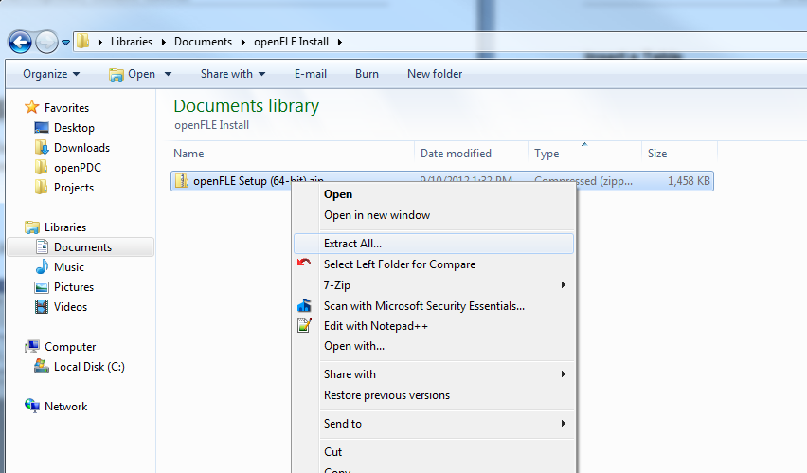
Figure 2-1
Extract openFLE Install Package
- Click the Extract button.
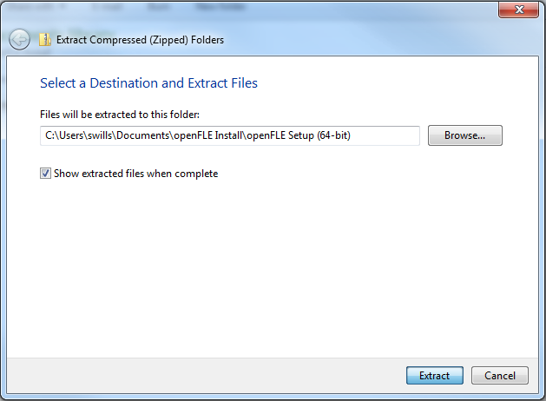
Figure 2-2
openFLE Install Package Destination
- After the files have unzipped, enter the Setup folder and double-click setup.exe to start the installer.
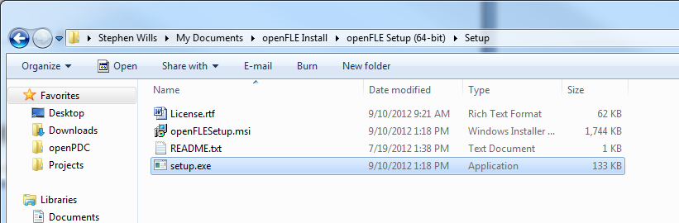
Figure 2-3
Start openFLE Installation
The openFLE setup program begins its initialization process. During this time, it checks to see if the .NET Framework 4.0 is installed. If the .NET Framework is installed, then the openFLE installer displays its license agreement followed by the welcome window (Figure 2-13). Otherwise, an error message (Figure 2-4) is displayed.
Note: If the .NET Framework 4.0 is already installed on your computer proceed to step 13

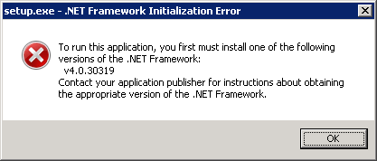
Figure 2-4
openFLE Installer: Download .NET Framework 4.0 Error
- Navigate to the download page for the .NET framework 4.0 located at http://www.microsoft.com/en-us/download/details.aspx?id=17718.
- On the Microsoft .NET Framework 4.0 page (Figure 2-5), click Download to start the download of the .NET Framework 4.0 installer. Note: For best results, allow pop-ups on this page.
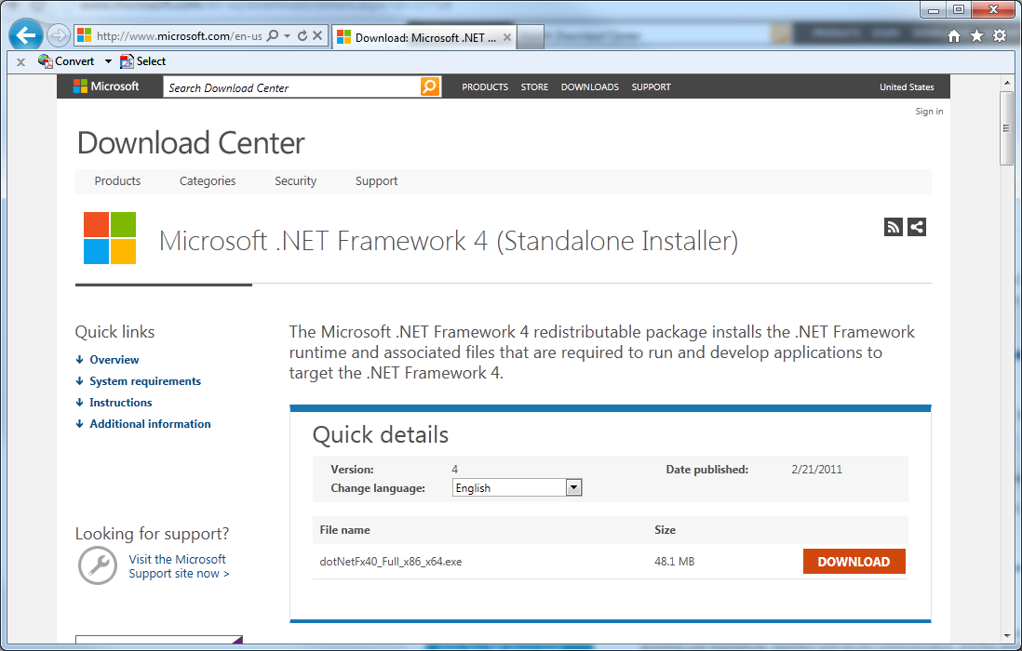
Figure 2-5
.NET Framework 4.0 Download Web Page
- Microsoft offers suggestions for additional downloads that are not needed to run openFLE, if you do not wish to install the additional downloads simply click NO THANKS AND CONTINUE to proceed to the next step.
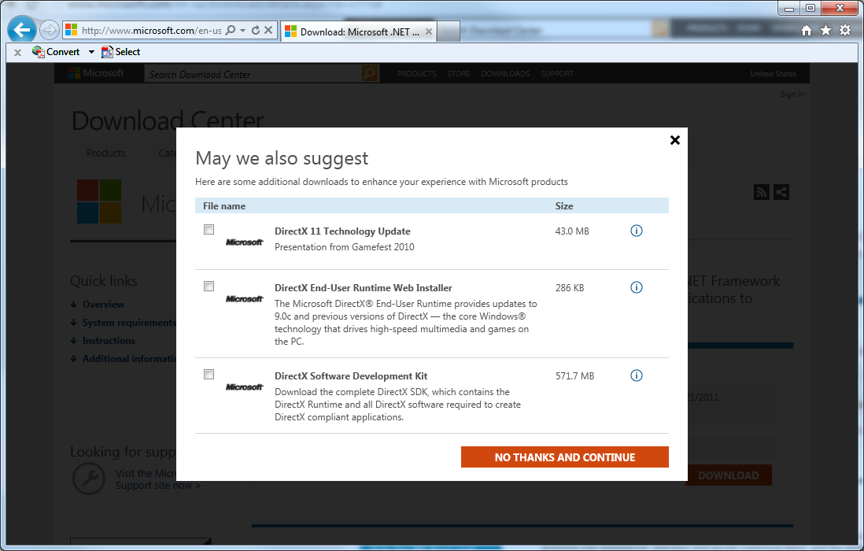
Figure 2-6
Microsoft Suggestions
- Before the download begins, a message appears at the bottom of the screen. Note: The message box in Figure 2-7 is specific to Internet Explorer. In response to a request to download a file, other browsers may behave differently and/or display different messages.
You can click either Run or Save. Click Run to begin the download and installation of the .NET Framework 4.0 software. Note: You can choose to click Save, but these instructions do not include the steps that you must follow for that scenario.
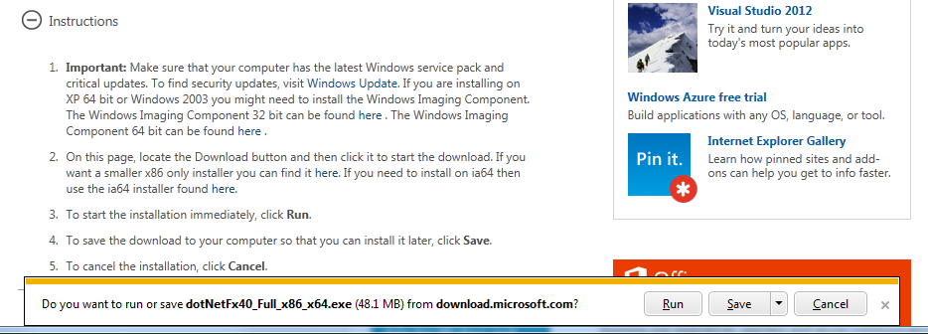
Figure 2-7
File Download
- After you click Run, the file dotNetFx40_Full_x86_x64.exe begins to download.

Figure 2-8
.NET Framework 4.0 Installer: Download Progress Window
- Once the download is complete, the installer will run automatically. As the framework installer initializes, one message box showing a progress bar appears.
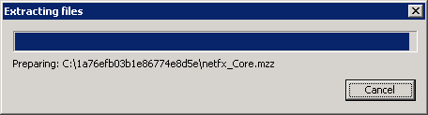
Figure 2-9
.NET Framework 4.0 Installer: Initialization Progress Windows
- After it initializes, the framework installer shows its welcome window, which also contains the license agreement for the .NET Framework 4.0. You must accept the terms of the license agreement before the framework can install.
Click “I have read and accept the license terms.” and then click Install.
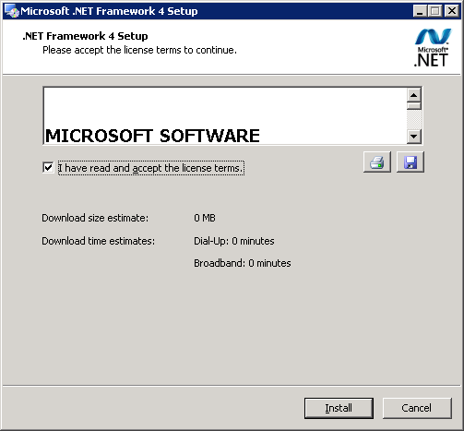
Figure 2-10
.NET Framework 4.0 Installer: .NET Framework 4 Setup Window

- The framework installer begins the process of downloading and installing the .NET Framework 4.0 (Figure 2-11). You may be asked to exit running programs during this process.
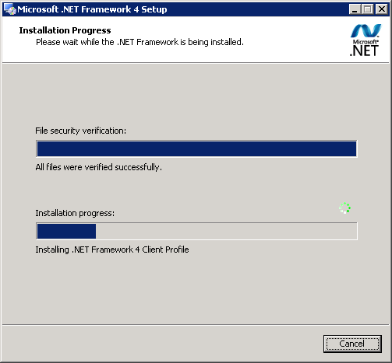
Figure 2-11
.NET Framework 4.0 Installer: Installation Progress Windows
- After the .NET Framework 4.0 is downloaded and installed, the Installation Is Complete window appears (Figure 2-12). Click Finish then you can close the framework installer and return the openFLE installer. If you are asked to restart your computer, please do so before continuing.
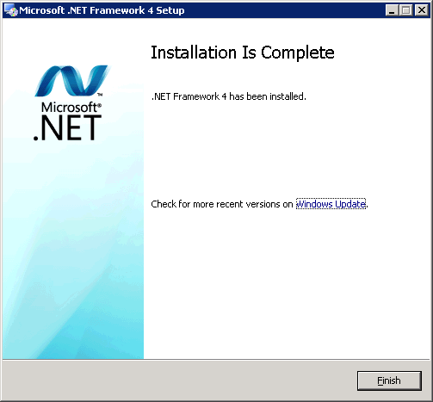
Figure 2-12
.NET Framework 4.0 Installer: Installation Is Complete Window

- To run the openFLE Setup Wizard double-click setup.exe and select Run (Figure 2-13).
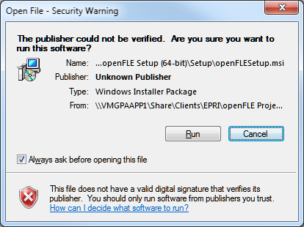
Figure 2-13
openFLE Installer: Run Installation Wizard Window
- To install and use this software, you must agree to the License agreement (Figure 2-14). To continue, select I Agree. If you select I Decline, the installation process will end, and no software will be installed on your computer. You should manually delete the files that were extracted for the installation process. See figure 2-3 for the list of files to be deleted.

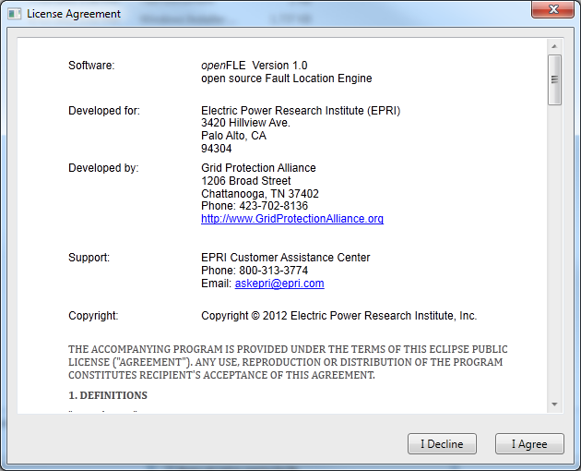
Figure 2-14
openFLE Installer: License Agreement
- The Select Installation Windows is displayed (Figure 2-15). If you prefer to install in another location click Browse to select your preferred installation folder. Otherwise, proceed to step 17.
Note: The Drop and Results folders used for file input and output are created in the installation folder. These locations can be changed through the openFLE Manager.
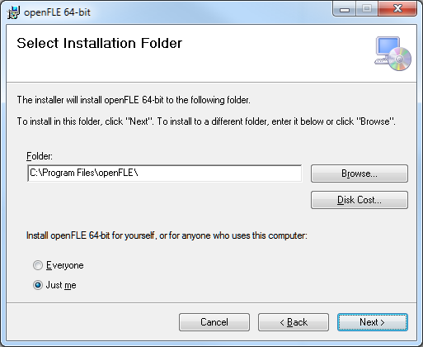
Figure 2-15
openFLE Installer: Select Installation Folder Window
- If you clicked Browse to select a different installation folder, the Browse for Folder window appears (Figure 2-16). If you need assistance selecting an installation folder using this window, contact your company’s IT department.
If you would rather use the originally suggested installation folder, click Cancel.
Once you have decided on an installation folder, click OK to redisplay the Select Installation Folder (Figure 2-15), and click Next.

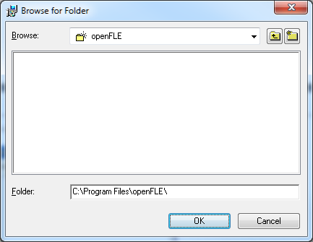
Figure 2-16
openFLE Installer: Browse for Folder Window
- The Confirm Installation window is displayed (Figure 2-17). Click Next to confirm installation.
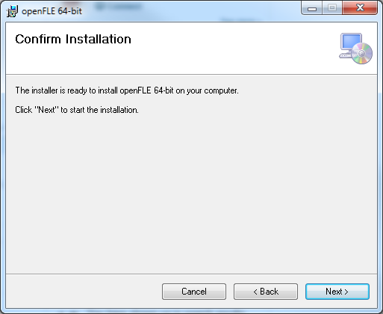
Figure 2-17
openFLE Installer: Confirm Installation Window
- The installer displays a progress window (Figure 2-18). No action is required during the installation process unless you desire to cancel the installation.
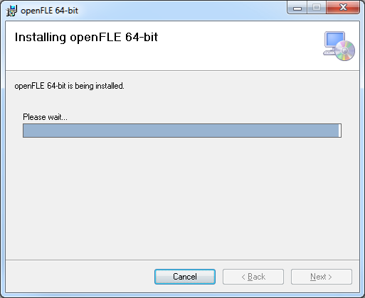
Figure 2-18
openFLE Installer: Installation Progress Window
- Since that this window has a Cancel button, it is possible to exit the installation even though files may have already been copied to your computer.
Note: Do not follow this step unless you want to stop the installation of the openFLE.
If you click the Cancel button shown in Figure 2-18, the window in Figure 2-19 appears. Click Yes to stop installation and exit the installer.
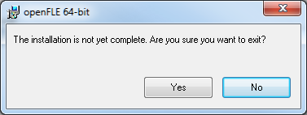
Figure 2-19
openFLE Installer: Exit the Installer Confirmation

- If the installation of the openFLE is interrupted as shown in Figure 2-19, the Installation Interrupted window is displayed (Figure 2-20). Click Close to exit the openFLE installer, and disregard any further instructions in this manual.
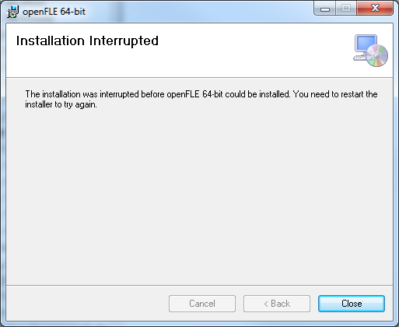
Figure 2-20
openFLE Installer: Installation Interrupted Window
- If in step 18 you elected to let the installer continue, the Installation Complete window will be displayed (Figure 2-21). Click on the Close button to finish the installation.
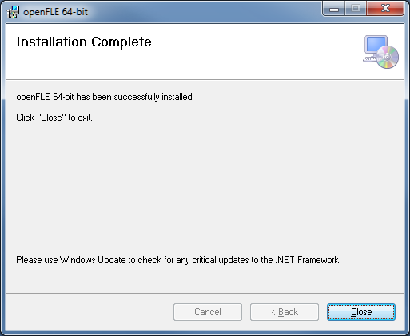
Figure 2-21
openFLE Installer: Installation Complete Window

- After the openFLE is installed, the openFLE service is started automatically and the openFLE Manager can be run by navigating to the installation folder and double clicking on the openFLEManager.exe (Figure 2-22). See section 3 for information on using the openFLE.
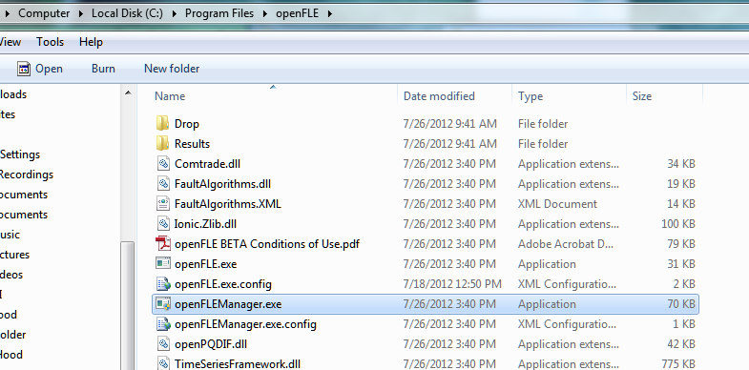

Figure 2-22
The openFLEManager.exe

Using the OpenFLE
The OpenFLE is designed to run as a Windows service that processes files as soon as they are placed in the “Drop” folder, and automatically produces the output files in the “Results” folder.

Tutorial

Running the openFLE Manager
Navigate to the folder where openFLE is installed, (see step 16) and double click the openFLEManager.exe file name. (Figure 3-1).

Figure 3-1
OpenFLEManager.exe
If you are running a beta version of the openFLE, the beta notification window will be displayed each time the openFLE manager is opened (Figure 3-2). If this window appears, click Accept to continue, using the beta software.
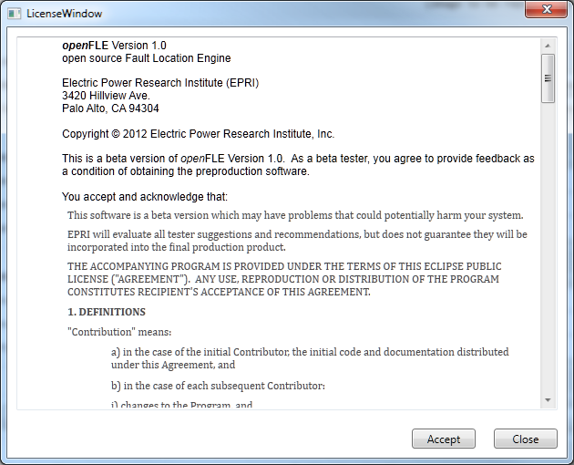
Figure 3-2
OpenFLE: The beta notification window.
The openFLE Manager window will be displayed (Figure 3.-3).
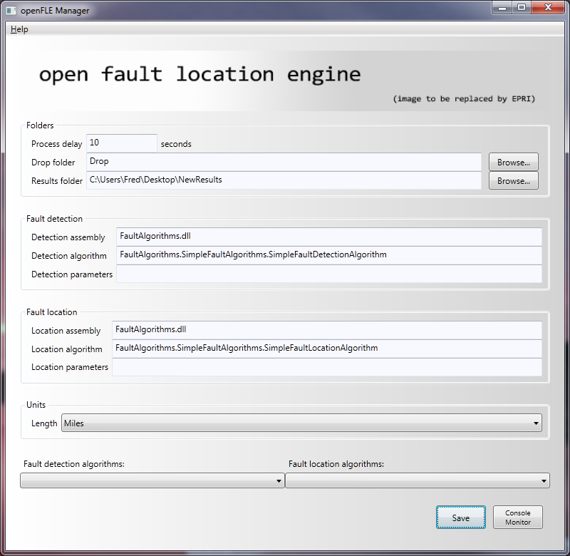
Figure 3-3
OpenFLE: The openFLE Manager window

Input fields and controls in the Manager window
There are three input sections and seven control features, in addition to a “Help > About…” menu item that displays the software version and support information (Figure 3-4).
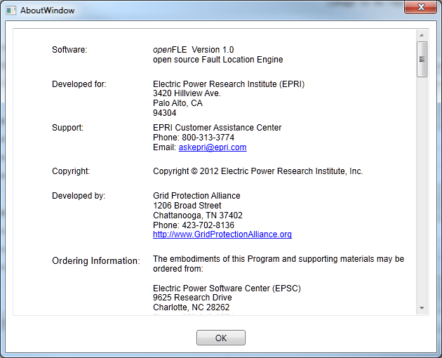
Figure 3-4
OpenFLE: Help About Window
The inputs and controls are described below.

Folders
Input files to be processed must be placed in the Drop folder in groups, where an associated XML parameter file must accompany every event file to be processed. For PQDIF input files the group would consist of an XML parameter file, and a .pqd data file. For simple COMTRADE input files, the group would consist of an XML parameter file, a .cfg file and a single .dat data file. For larger COMTRADE input files, the group would consist of an XML parameter file, a .cfg file, and multiple .DXX files, where the .DXX files are named sequentially .D00, .D01, .D02 etc. Process delay is an input field to specify the length of time in seconds to delay before processing files placed in the Drop folder that include .DXX files (Figure 3.5). This delay only applies to COMTRADE files, when the data files include one or more .DXX files. This input parameter is available to accommodate potential process delays that would cause .DXX files to arrive in the Drop folder with some amount of time between their arrivals. All other files are processed as soon as the input group is complete. For example, if an XML parameter file is placed in the Drop folder, it is ignored by the openFLE service until an associated data file arrives. File groups are identified by their names. Files placed in the Drop folder which are not recognized by openFLE will be ignored and left in the Drop folder.
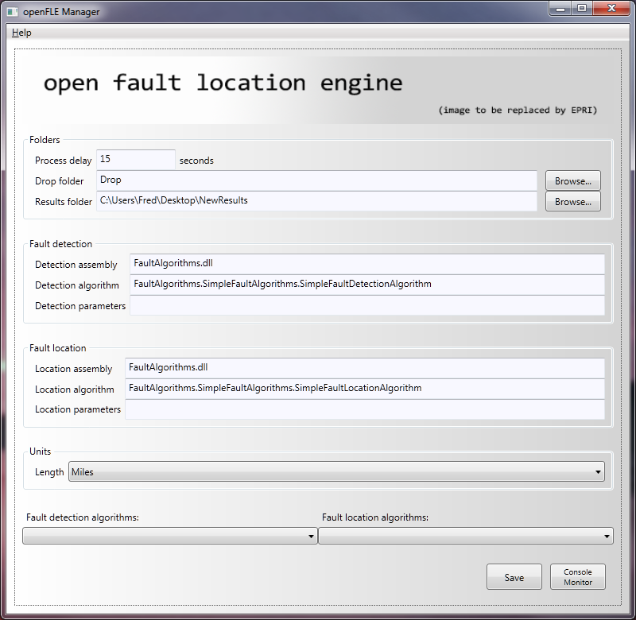
Figure 3-5
OpenFLE: Process Delay
By default a Drop folder and a Results folder are created in the installation directory. The respective names of the folders are Drop and Results. The folder names and locations can be changed as desired. If a name other than the default is used for a folder, the complete path must be entered in the respective Drop folder and Results Folder input fields, either manually or by use of the associated Browse… button(Figure 3-6). Note: The examples shown in Figures 3-5and 3-6 are for illustration only. Your folder path must match your folder structure.
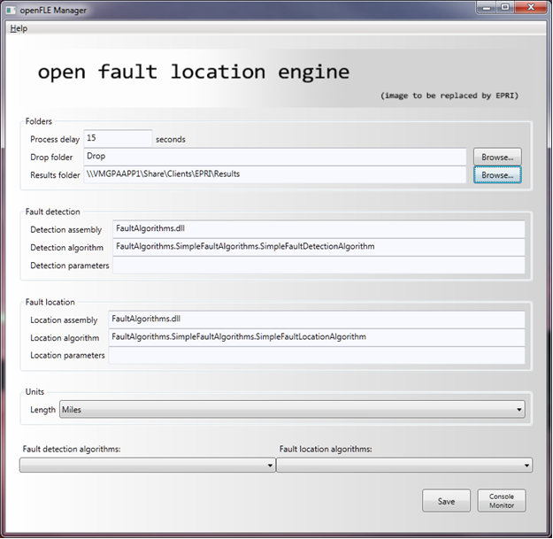
Figure 3-6
OpenFLE: The Manager window showing a modified Results folder path

Fault Detection
The OpenFLE is a platform where multiple detection assemblies, detection algorithms, and detection parameters can be employed. In this release, only one assembly, and one algorithm are available, so the input fields Detection assembly, Detection algorithm, and Detection parameters should remain unchanged (Figure 3-7).
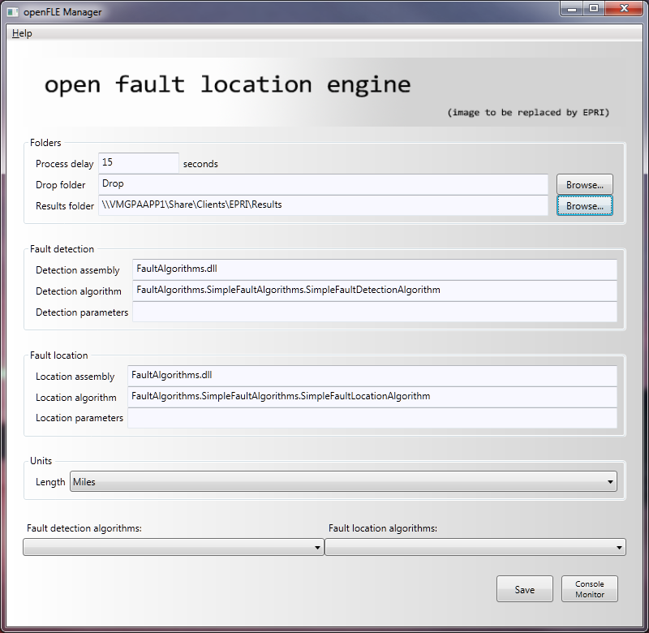
Figure 3-7
OpenFLE: The Manager window with default Fault detection input field contents

Fault Location
The OpenFLE is a platform where multiple location assemblies, location algorithms, and location parameters can be employed. In this release, only one assembly, and one algorithm are available, so the input fields Location assembly, Location algorithm, and Location parameters should remain unchanged (Figure 3-8).
Figure 3-8
OpenFLE: The Manager window with default Fault location input field contents

Units
The unit of measure to describe the line lengths and the calculated distance to fault can be selected from a drop down list (Figure 3-9). Miles are the installed default, but kilometers can be selected. If a change is made using this drop down list, the save button must be used to update the configuration information (Figure 3-11)..
Figure 3-9
OpenFLE: The Manager window showing Units drop down list

Fault Detection and Fault Location Algorithm drop down selections
The drop down list selections called Fault detection algorithms: and Fault location algorithms: are intended to easily facilitate the selection of different options in each category (Figure 3-10). In this project, only one selection is available in each category. The selections available can be used to reset to default, if the input fields are changed inappropriately.

Figure 3-10
OpenFLE: Fault Detection and Fault Location algorithm drop down lists

Control Buttons
There are two control buttons; Save and Console Monitor. The Save button writes the configuration parameters as specified in the input fields, into the configuration file, which is located in the install directory. These saved settings will be used in subsequent executions of the program until new values are saved. A confirmation dialogue box is displayed to indicate that the Configuration changes have been saved successfully. Click OK to dismiss the dialogue box (Figure 3-11).
.
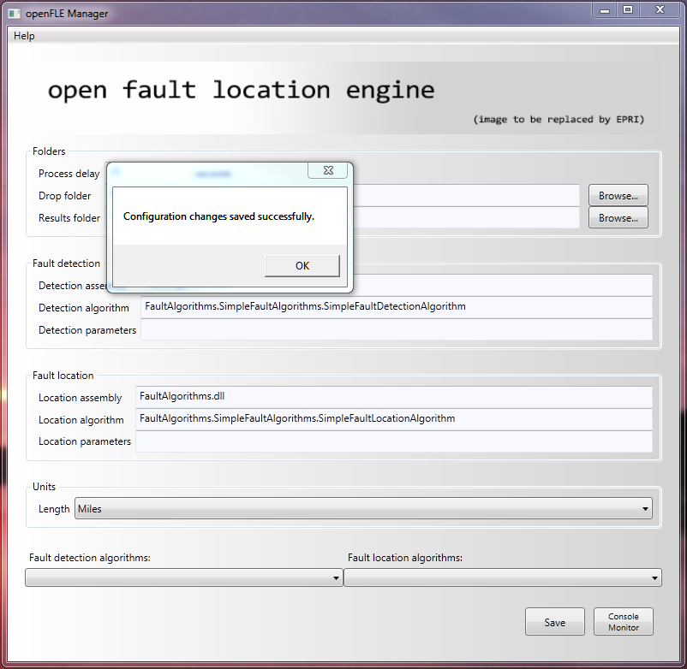
Figure 3-11
OpenFLE: Save Button and confirmation dialogue box.
The Console Monitor button is used to open a window that displays commands as they are executed. When the openFLE Manager is started, the Console Monitor window is closed. The window opened by the Console Monitor button can be closed by clicking on the red X (Figure 3-12).
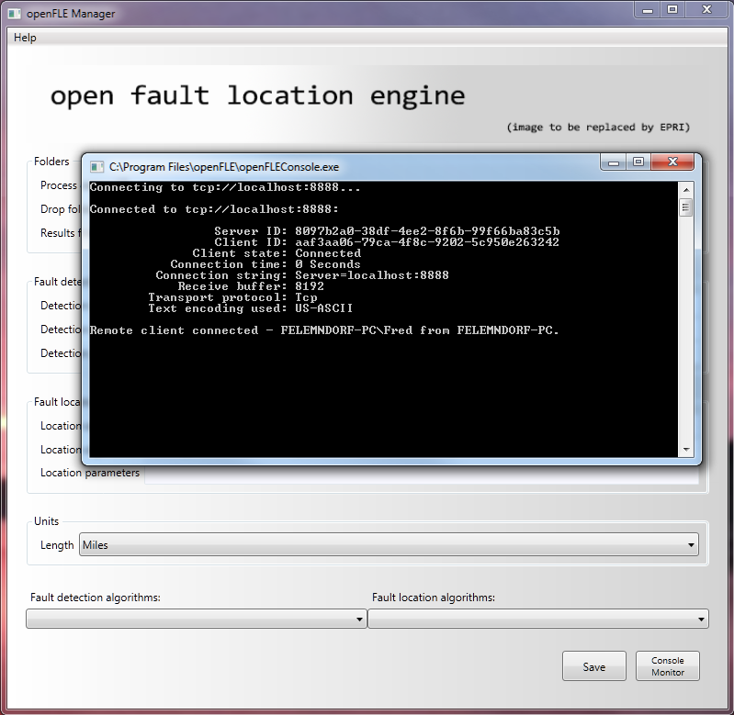
Figure 3-12
OpenFLE: Console Monitor Button, Console Monitor Window, Red X to close.

Closing the openFLE Manager
When no further configuration changes are desired, the openFLE Manager can be closed by clicking on the red X (Figure 3-13).
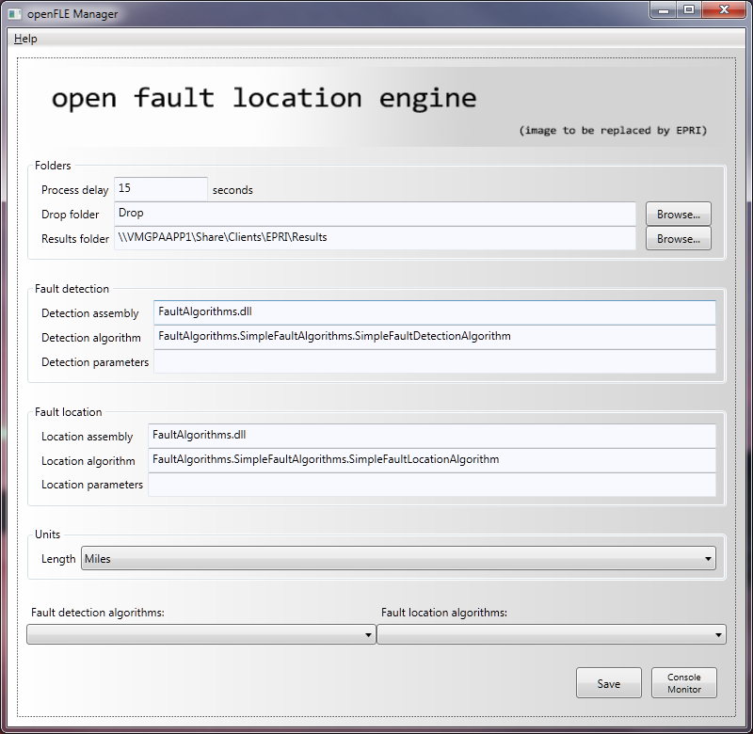
Figure 3-13
OpenFLE: openFLE Manager Red X to close.

Stopping the openFLE service
The openFLE service is started automatically, and runs continuously until it is stopped manually (Figure 3-14).
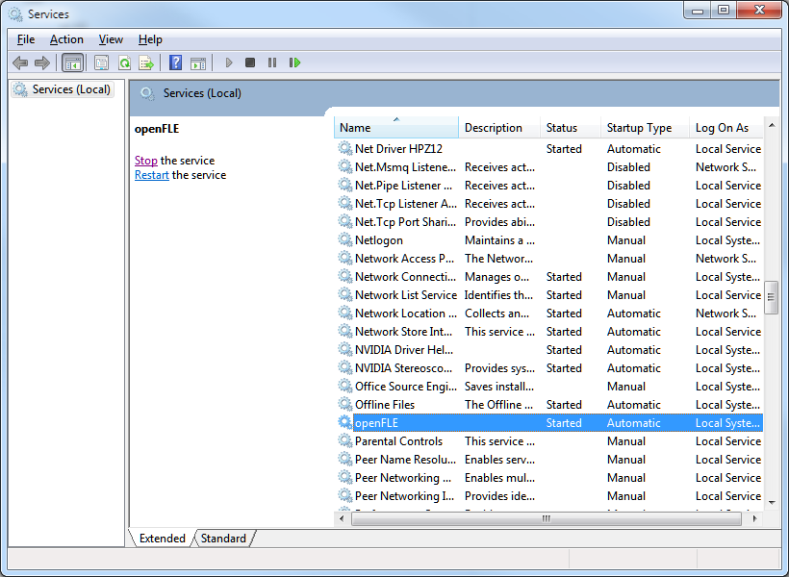
Figure 3-14
OpenFLE: Stopping the openFLE service

Perform Fault Location
To perform a fault location on an input event file, the input data file and the configuration file associated with the faulted line must be placed in the Drop folder specified in the openFLE Manager (Figure 3-5). For this project, an xml file is made available for each input event file. See example showing a complete input file group for event number 5043 ((Figure 3-13). In this example, the data is contained in a simple COMTRADE group.
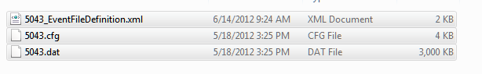
Figure 3-15
OpenFLE: Input COMTRADE and xml files for Event 5043
Once the complete input file group is in the Drop folder, the process begins automatically. When the openFLE successfully processes the input data file, all of the input files are moved to the Results folder with the calculated results files (Figure 3-14).
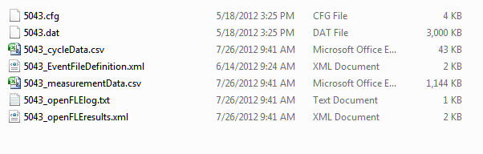
Figure 3-16
OpenFLE: Contents of Results folder after event 5043 processed
An example of the input files for a PQDIF input data file, and the resulting entries in the output folder are shown in Figure 3-15.
Input files placed in Drop folder.
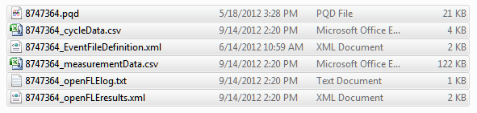
Output files in Results folder.
Figure 3-17
OpenFLE: PQDIF input file example.

References and Bibliographies

References

Bibliography

Glossaries and Indexes
Glossaries and indexes are optional.

Glossaries

Indexes

Example of input xml file

This is the XML Event File Definition (system parameter file) for Example Event
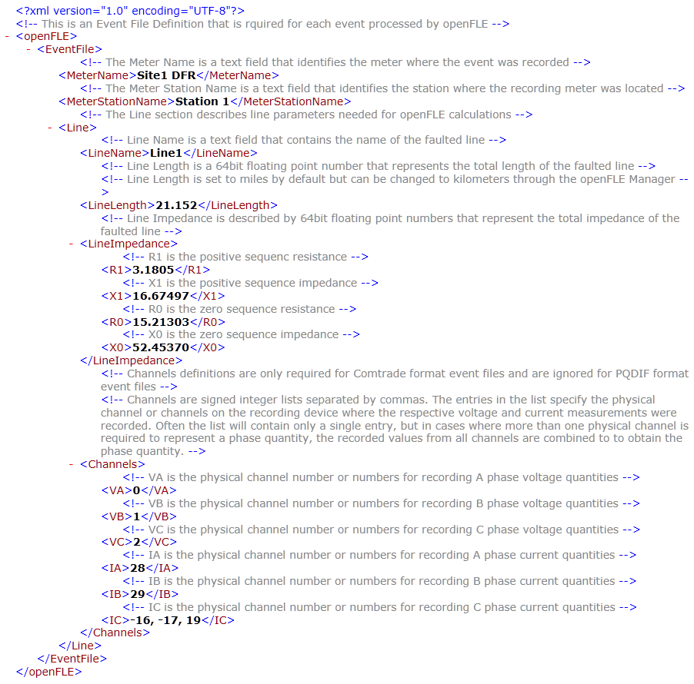
Figure A-1
Example_EventFileDefinition.xml

Examples of output files in results folder
PQDIF - The .pqd output file is the input PQDIF formatted file that has been moved to the output folder after processing. PQDIF is a binary format and cannot be displayed in its native format.

CycleData - This is a portion a “cycleData” output file.
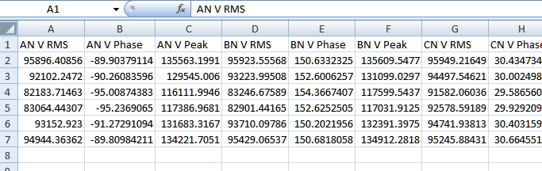
Figure B-1
Example_cycleData.csv

This a portion of a measurement Data output file.
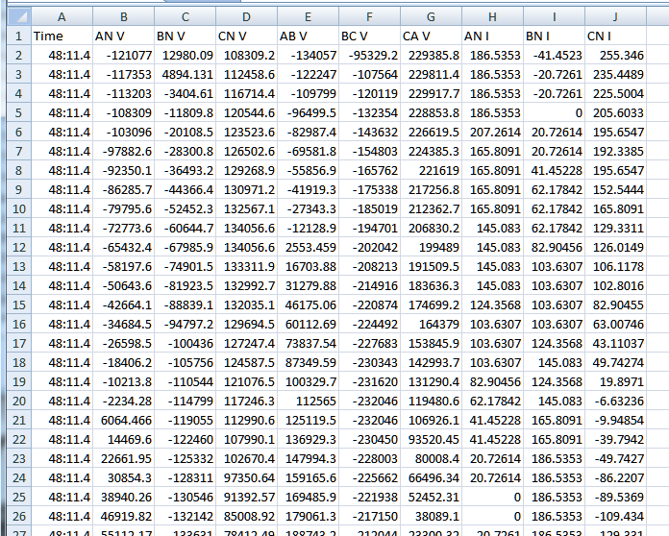
Figure A-2
Example_measurementData.csv

Log File – this is the openFLElog file
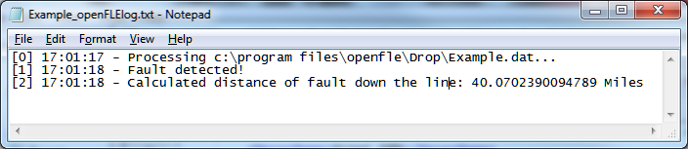
Figure A-4
Example_openFLElog.txt

Results File – this is the Example_openFLEresults.xml file
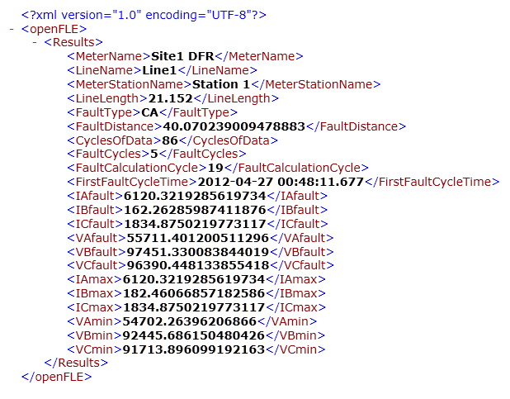
Figure A-5
Example_openFLEresults.xml

© 2012 Electric Power Research Institute (EPRI), Inc. All rights reserved. Electric Power Research Institute, EPRI, and TOGETHER…SHAPING THE FUTURE OF ELECTRICITY are registered service marks of the Electric Power Research Institute, Inc. | 10xxxxx

